NATURE camp 2015
Engines
By: Daniel Tuhy
Description:
In this lesson students will gain a general knowledge of what an engine is and the different types of engines. Students will participate in 3 activities in which they will build 3 different types of engines.

Objectives:
- To understand the definition of an engine
- To learn about the 4 different types of engines
- To discuss some of the environmental impacts of heat engines
- To complete activities that help to cement to concepts of different types of engines

North Dakota state standards:
9-10.1.1.-Explain how models can be used to illustrate scientific principles
9-10.1.4.-Describe the relationship between form and function (e.g., solids, liquids, gases, cell specialization, simple machines, and plate tectonics)
9-10.2.1.-Explain how scientific investigations can result in new ideas
9-10.2.2.-Use appropriate safety equipment and precautions during investigations (e.g. goggles, apron, eye wash station)
9-10.2.3. -Identify questions and concepts that guide scientific investigations
9-10.2.4.-Formulate a testable hypothesis for a simple investigation

Schedule:
9:00am – 9:30am cultural connection
9:30am – 9:45am introduction of engines
9:45am – 10:15am activity #1
10:15am – 10:45am continue PowerPoint
10:45am – 11:00am break
11:00am – 12:00pm start activity #2
12:00pm – 12:30pm lunch
12:30pm – 1:00pm Finish activity #2
1:00pm – 1:15pm finish PowerPoint
1:15pm – 2:30pm activity #3
2:30pm – 2:45pm conclusion
2:45pm – 3:00pm cleanup

Activity #1:
Simple electric motor Activity
Materials:
AA battery
4 paperclips
1 tag board square (8”X8”)
2 lengths of heavy wire, 6” long
24” of 22-24 gauge coated wire
3 round magnets
Electrical Tape
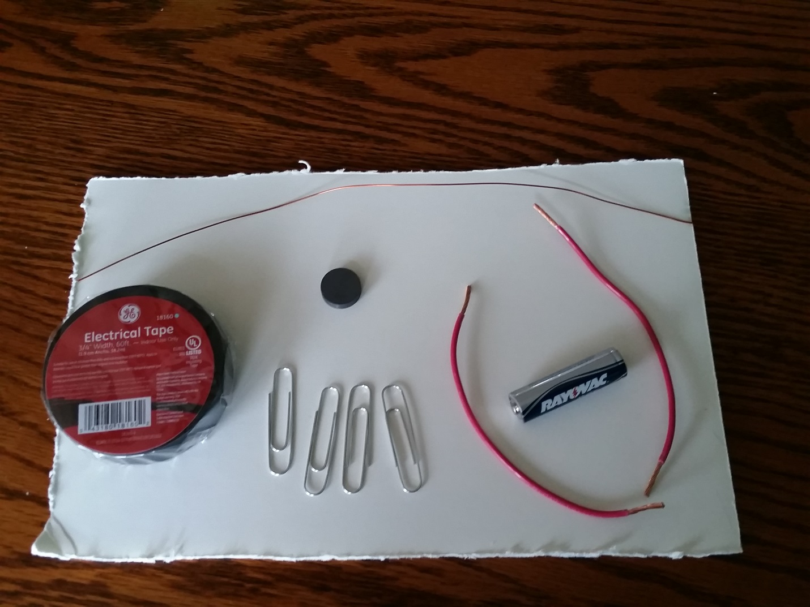

Procedure:
In groups of 2 people, gather all necessary materials. Start by coiling the thin coated wire around the AA battery leaving about an inch of wire sticking out of both sides of the loop.
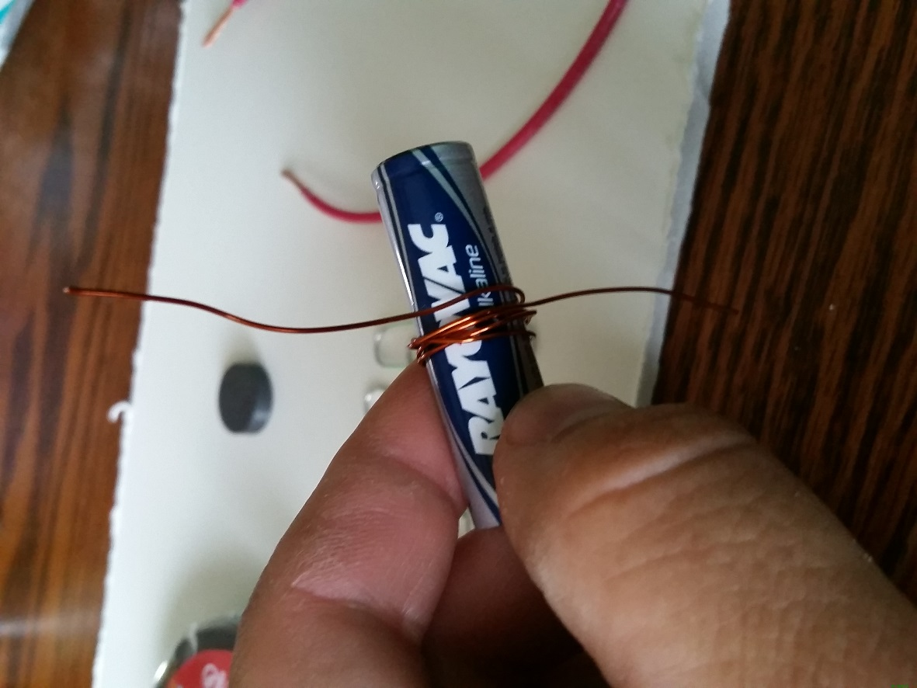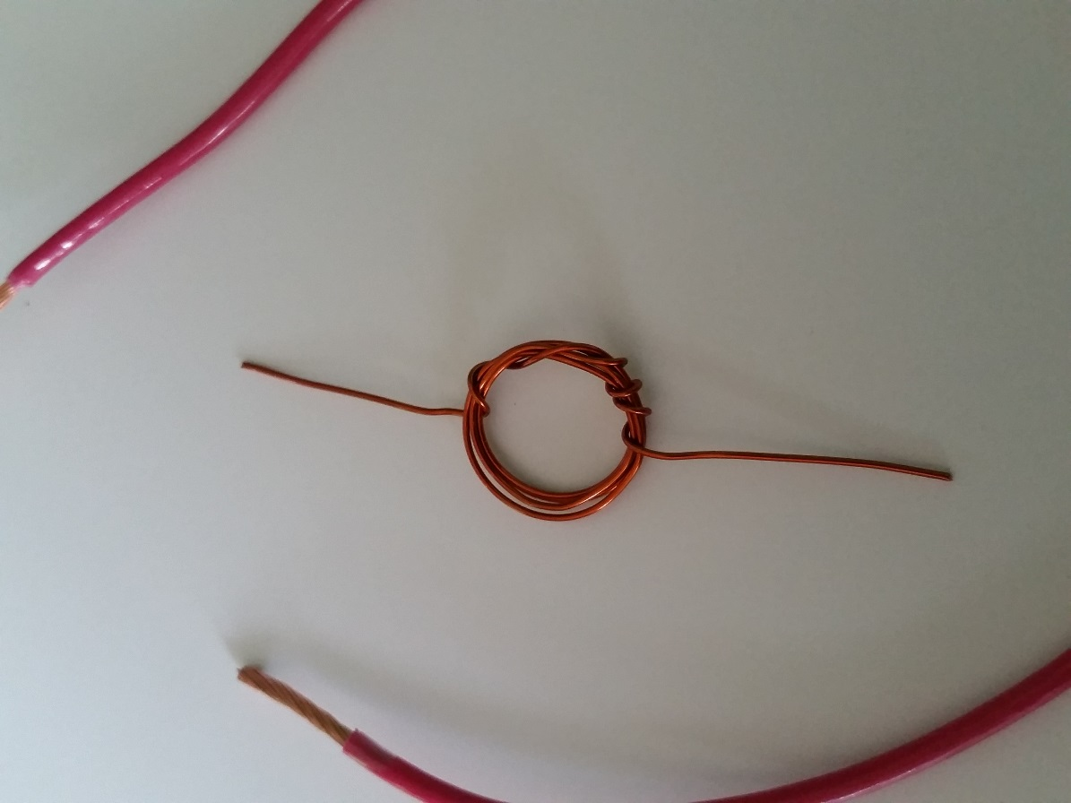
After you have created the loop, use sand paper and remove all of the coating from one end, and only half of the coating from the other end. To strip only half of the coating from one of the coil, lay the coil on the edge of a table and sand the top half.
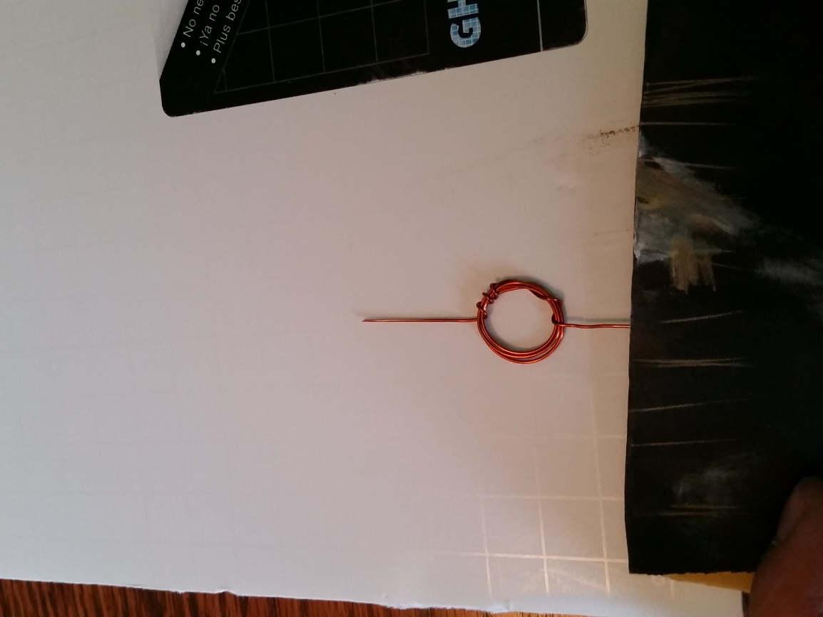
Next take 2 paper clips and slightly bend one end of each clip to create a holder for the battery. Twist one piece of heavy wire around each paper clip. Tape the clips to your board.
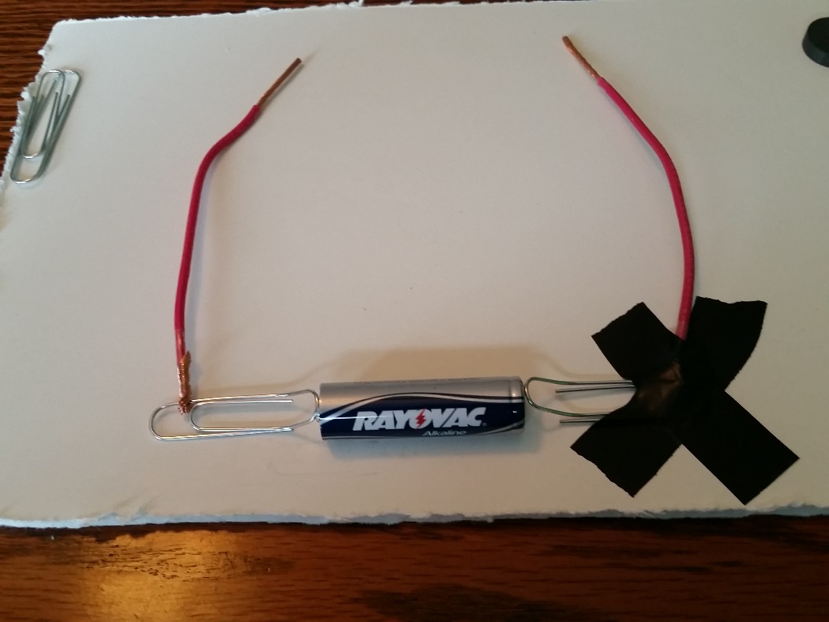
Take the other 2 paper clips and bend them into holders for the wire coil you made earlier.
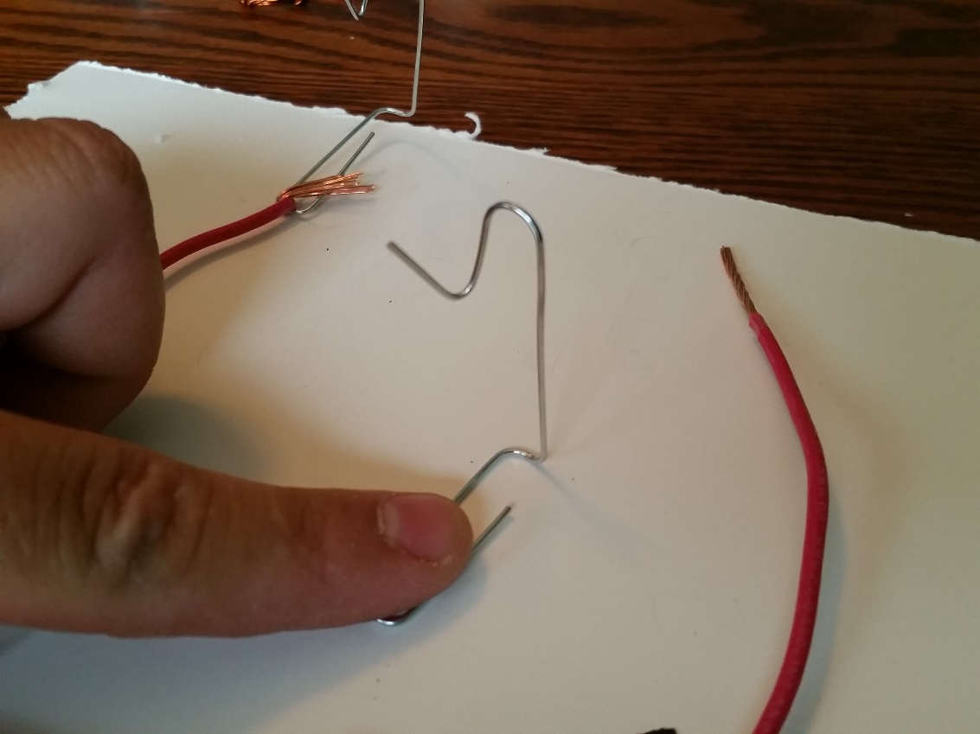
Wrap the other end of each heavy wire around the base of the paper clip coil holders. Tape the holders down to the board at a distance apart that is wide enough to hold the wire coil.
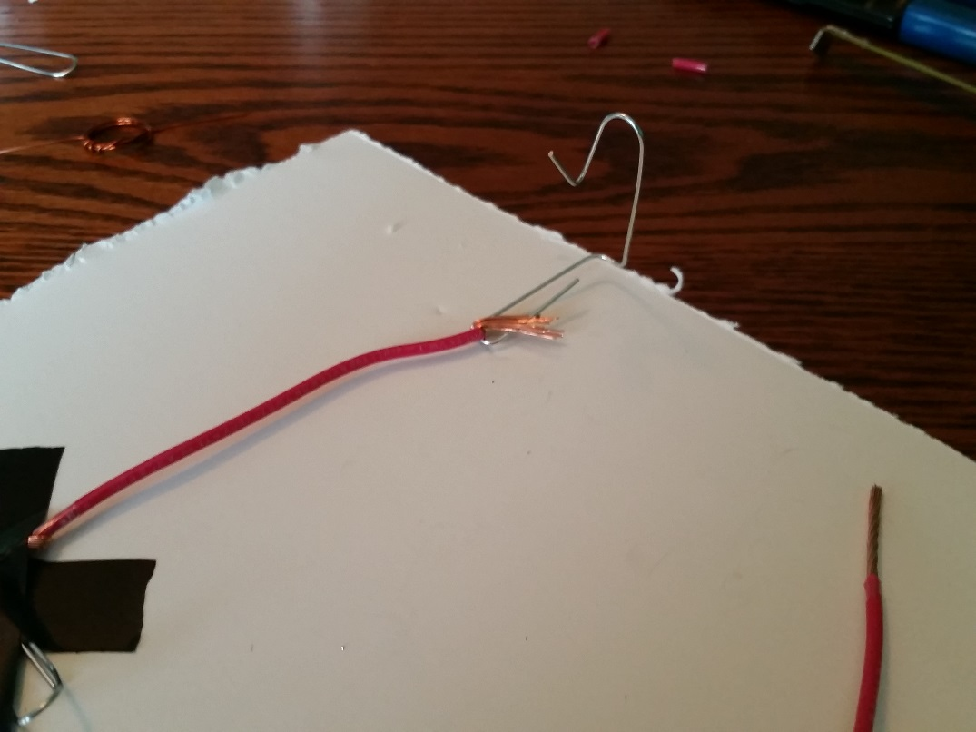
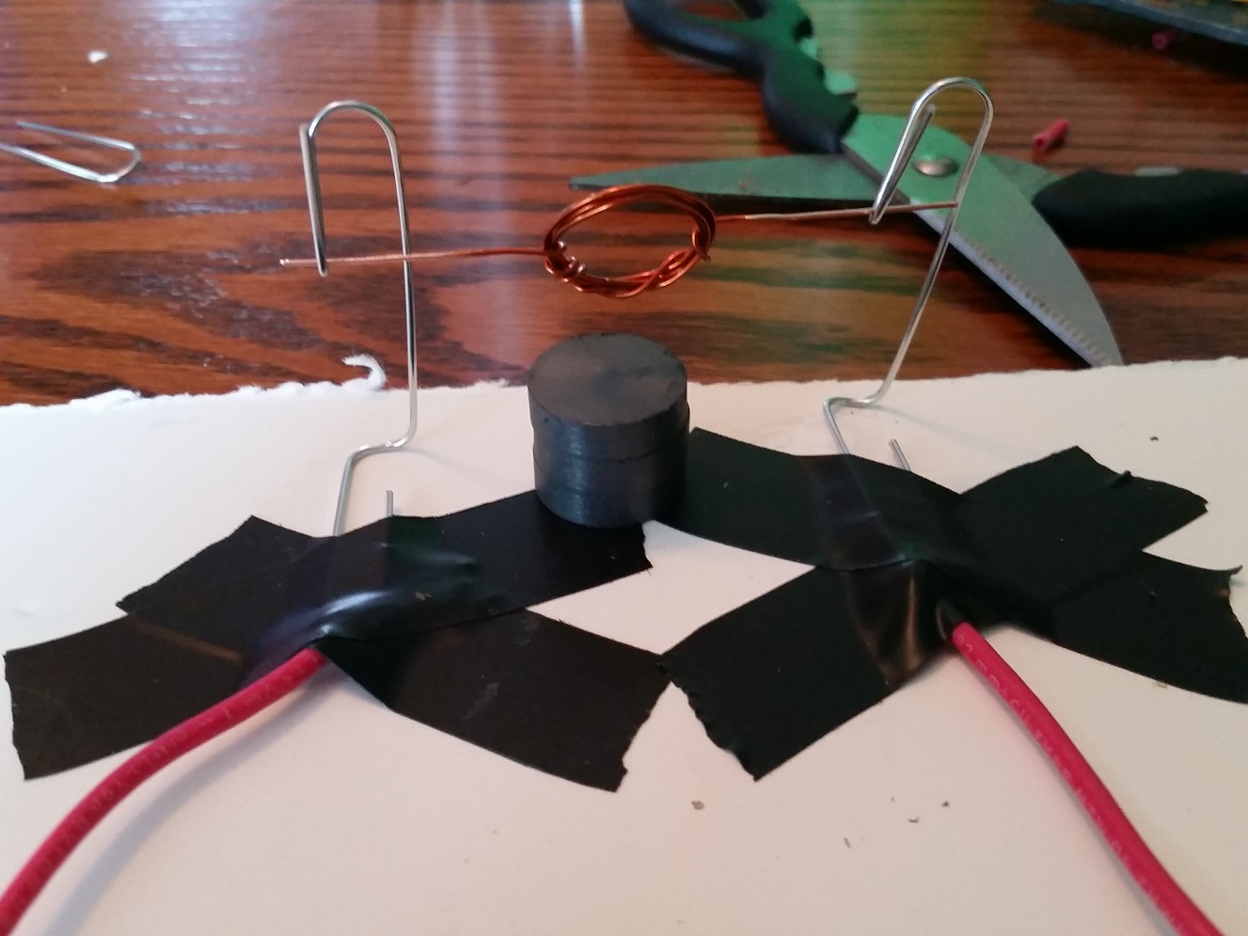
After you have assembled your stand, stack 3 round magnets between the stand and below the coil. Place your battery in its holder. Make sure all electrical connections are secure, if they are you should notice an attraction between the coil and magnets. You may need to assist the coil to start spinning. You may need to adjust the coil and stands to make the coil spin as efficiently as possible.
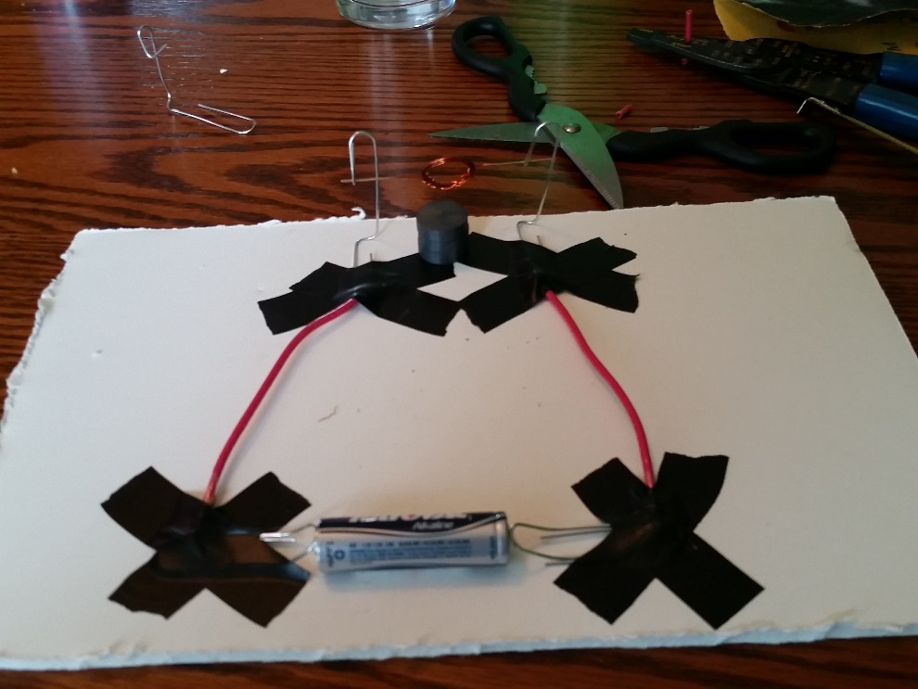
Activity #2
Mousetrap Cars
Materials: (per group)
1 wooden mousetrap 7” wooden craft sticks X 4
Stick ball point pens X 2 12” rubber balloons X 2
New or used CD’s X 4 #6 cork stoppers X 4
1/8” x 6” wooden dowel X 2
7” string Small pushpin
Construction paper Hot glue gun
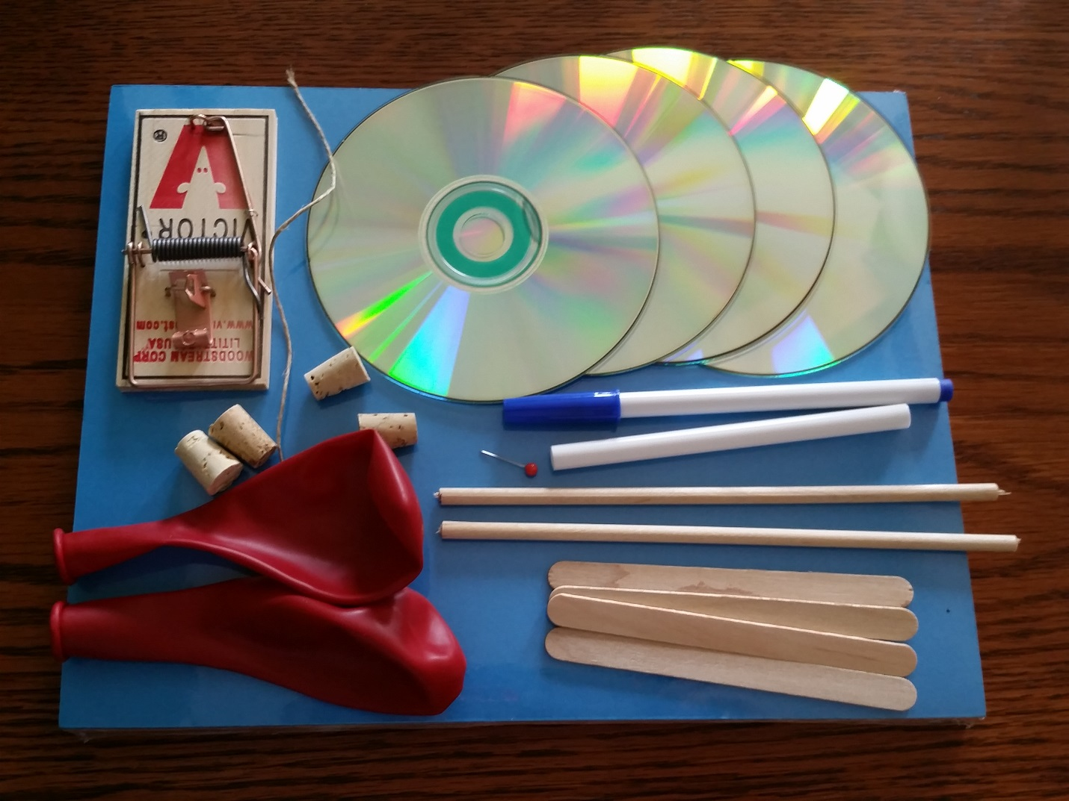
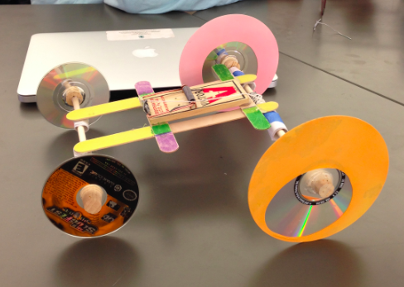

Procedure:
Start by collecting all of your materials. Using the picture above, popsicle sticks, mousetrap and hot glue, create a frame for your car and attach your engine (mousetrap).
Next, using an electric drill, drill a hole through the center of each cork large enough for the wooden dowel to fit snuggly inside of the cork.
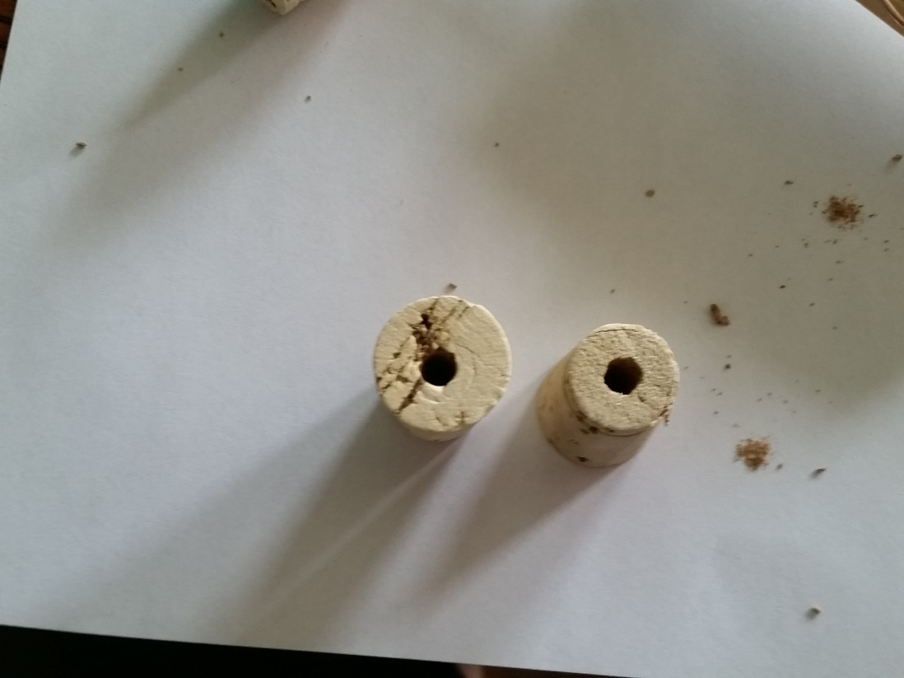
Next, remove the ink and end caps from both pens leaving a hollow tube. Glue one of the tubes to the front of the frame you created making the front axle. Take the second pen tube and cut it in half. Glue the two pen tube halves to the rear of the frame, leaving a gap between them.
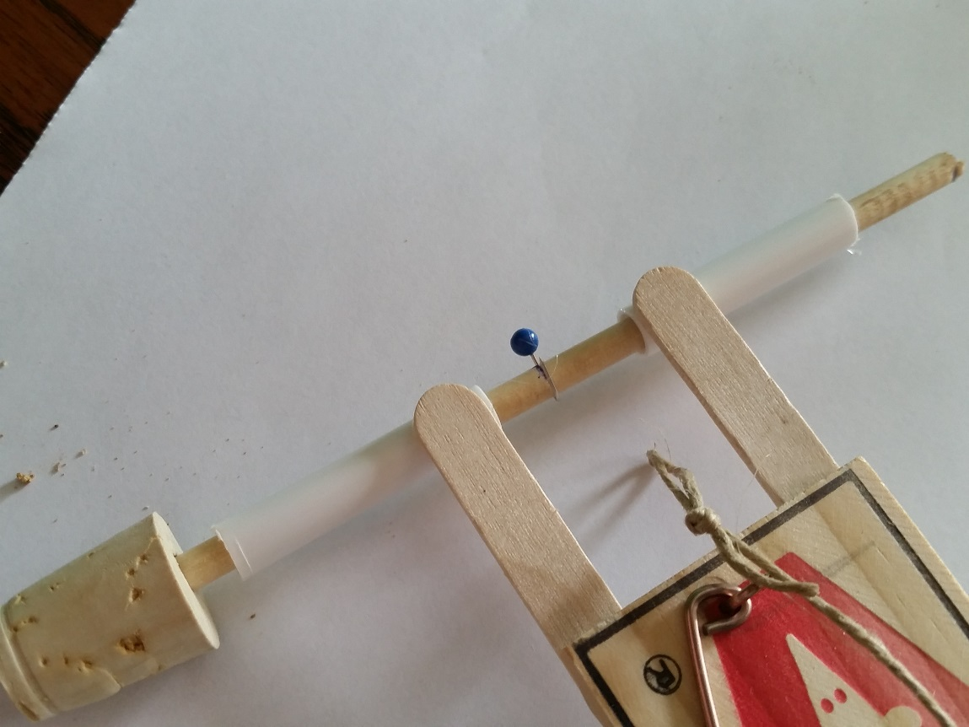

Next, take one of the wooden dowels and mark the center. Put the dowel through the rear pen tubes and push a stick pin through the center marking. Push the pin all the way through the wood until the head is against the wood (you may need some help from an instructor for this). Bend the bottom of the pin over so it doesn’t catch the string. Install corks on each end of the dowel with the narrow ends pointing outward. Now, take the second dowel and push it through the pen tube on the front of the car, install a cork on each end with the narrow end of the corks facing outward.
Take the string and tie it the center of the trapping bar of the mousetrap. Tie a loop on the other end of the string. This string is used to catch the pin in the rear axle and to wind up the trap.
Finally, cut the wide end off of all 4 of the balloons and cut the very tips off, and cut each one of those in half. Wrap 2 balloon circles around each edge of two of the CD’s, these 2 CD’s will be the rear wheels of your car. Press the 2 rear CD’s onto the corks of the rear axle. Press the last 2 CD’s without the balloons onto the corks of the front axle.
After your car is completed, use different colors of paper and markers to create a “body” for your car.

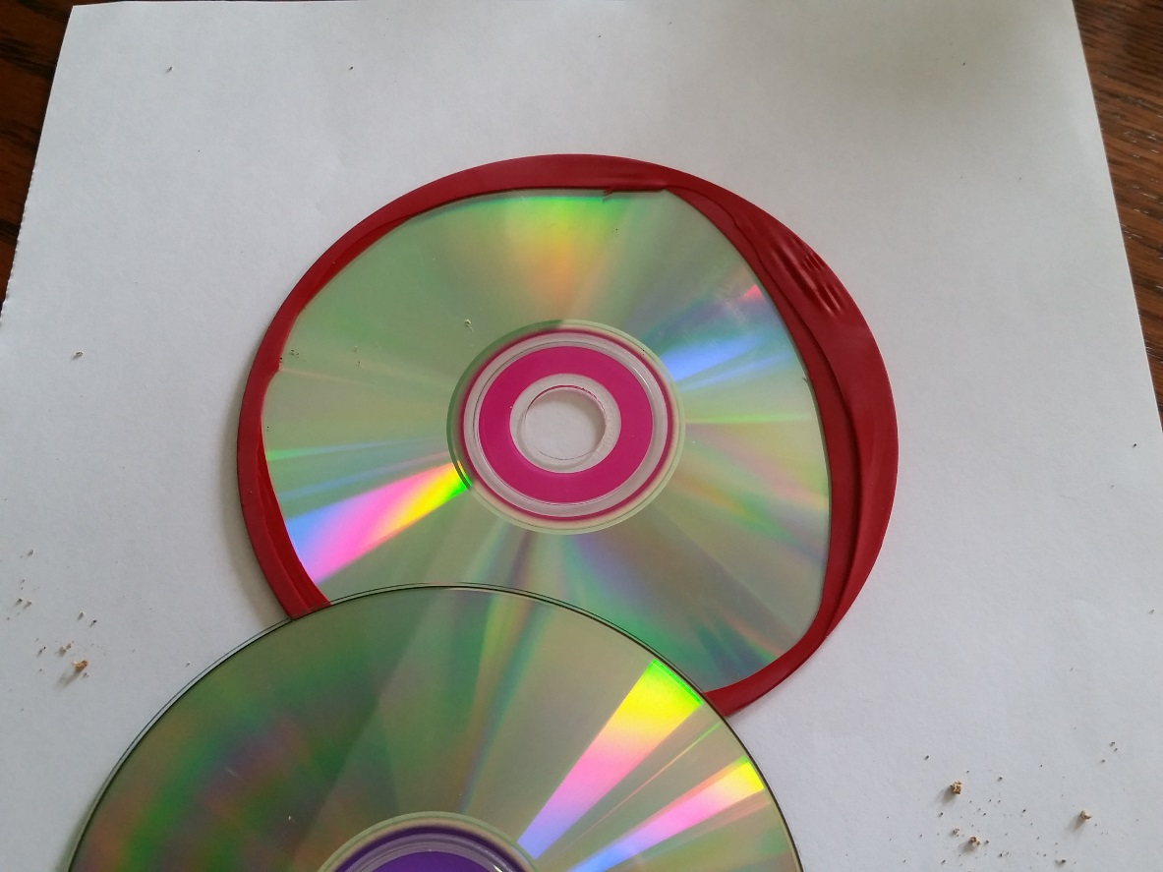
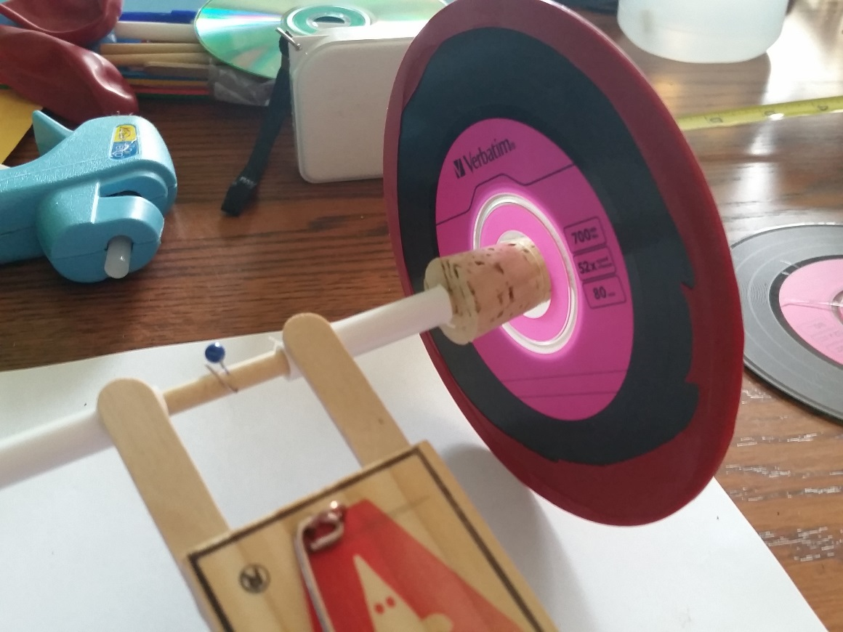
To wind your car, take the loop at the end of your string and hook it to the push pin of the rear axle. Spin the rear wheels to pull the trap bar back, when the trap bar is pulled all the way back latch the trap bar down. When you are ready to drive your car, use another pen to set off the trap.
Activity #3
Hovercraft
Materials (per group):
1 empty plastic bottle
1 new or used CD
1 12” balloon
Hot glue gun

Procedure:
Cut the very top of your plastic bottle off, trying to make the bottom edge as flat and smooth as possible. Next glue the bottle top to the CD so that it is centered over the center hole of the CD. After the glue has cooled and hardened, stretch the mouth of the balloon over to mouth of the bottle. When you are ready to test your hovercraft, blow into the bottom of the CD to inflate the balloon. Quickly set your new “hovercraft” onto a flat, smooth surface and watch as it hovers on a cushion of air.
