Summer Academy 2016
Stem Cells
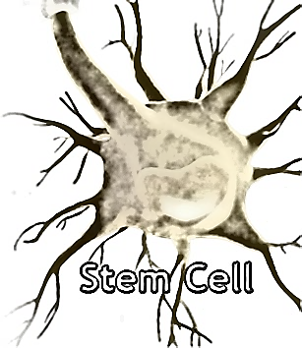

Activity 2: Culturing stem cells

Discussion:
Plant cell/tissue culture is the in-vitro culture of sterilized plant cells, tissues and/or organs on a nutrient medium. Unlike animal cells, many plant cells are totipotent, meaning that each cell has the capacity to regenerate the entire plant. This fact lies at the foundation of all tissue culture work. As the plant regenerates, many stem cells are formed and the student is able to watch these cells form into all necessary cells to make the plant.
Micropropagation is the regeneration of whole plants from small pieces of plant material. These small pieces (known as ‘explants’) are grown on sterile media and the plants produced can be potted up in soil and transferred to the glasshouse/field. Various parts of a plant can be cultured; plants have been regenerated from leaves, stems, roots, meristems, flowers and even pollen or ovules. In this case, students use a tiny piece of a cauliflower. Since all the explants come from the same cauliflower, the new plants will be clones of each other.

Objectives:
Students will:
- Apply knowledge to an experiment in which they have to isolate a plant stem cell
- Use critical thinking to make decisions about setting up the culture
- Examine results from home

Materials needed:
- 1 plate of MS media
- 1 pair of sterile scissors or scalpel
- 1 pair of sterile forceps
- Disinfectant to sterilize working surface and tools
- 1 sterilized piece of cauliflower
- Sterile sheet of paper towel
- Parafilm strip
- Gloves

Instructions:
- It is absolutely crucial that the area and all of the tools used are free of contaminants; sterile technique is mandatory
- Completely sanitize work station and tools
- Wear gloves to prevent any contamination from your hands
- On a sterile piece of paper towel, use a sterile forceps and scissors, or scalpel to cut the sterile cauliflower into tiny pieces, the size of a pea – be certain to include part of the floret as well as a piece of stem
- Place the tiny cauliflower on the petri plate with MS media
- Seal with parafilm
- Take home
- Leave by a sunny window for about 3 weeks
- Watch as the stem cells in the plant give rise to many new stem cells and structures

1. Sample on petri plate 2. Stem cell callus (2-3 weeks) 3. New cauliflower plant!

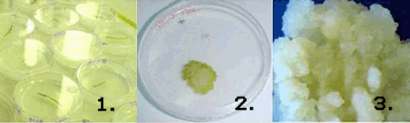

Life Sciences Learning Center Copyright © 2008, University of Rochester May be copied for classroom use

