Summer Academy 2016
Stem Cells
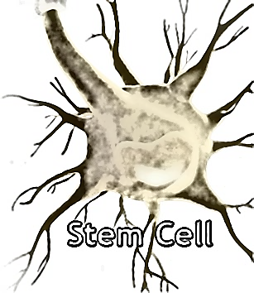

Activity 1: Use the internet to A. define the following terms, and B. answer questions.

A. Define:
1. Embryonic stem cell:

2. Adult (somatic) stem cell:

3. Induced pluripotent stem cells (IPS):

4. Blastocyst:

5. Totipotent:

6. Pluripotent:

7. Unipotent:

8. Multipotent:

B. Answer these questions:

1. What is a stem cell?

2. Why are stem cells special? Name 2 things they can do.

3. Why do our bodies need stem cells?

4. Name 2 kinds of stem cell.

5. Where do embryonic stem cells come from?

6. Name the three leading causes of death in Native Americans, and give an example of how stem cells are used to treat them.

7. Explain an iPS cell.

8. What kind of stem cell is an iPS cell like?

9. Do we still need embryos for research? Explain your answer.

10. In your own words, explain what is meant by differentiation.

