Summer Academy 2016
Stem Cells
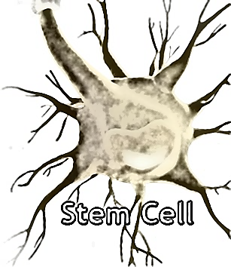

Activity 1: Use the internet to A. define the following terms, and B. answer questions. (Teacher notes)

A. Define:
1. Embryonic stem cell: answer: taken from a blastocyst can differentiate into all of the different types of cells in your body

2. Adult (somatic) stem cell: answer: make only a few specific types of cells from the bone marrow, muscle, skin, and brain; are more specific and can only make the type of cell that they are – they do not differentiate

3. Induced pluripotent stem cells (IPS): answer: modified somatic adult cells (most commonly skin or blood) to make it behave like an embryonic stem cell (pluripotent).

4. Blastocyst: answer: Fertilized egg becomes a blastocyst at ~5 days
Stem cells develop within the inner cell mass

5. Totipotent: answer: immature stem cell that differentiates into all other cell types, umbilical cord, and placenta

6. Pluripotent: answer: stem cell that differentiates into all cell types, but not an umbilical cord or placenta

7. Unipotent: answer: Only give rise to that specific cell; ex. Skin only gives rise to skin (one type)

8. Multipotent: answer: stem cell that gives rise to limited types of cells; blood – all types of blood related cells (more than one type); nerves – all types of nerve cells (more than one type)

B. Answer these questions:

1. What is a stem cell? Answer: They are the first cells produced to form the human body
Can differentiate (change into) to all of the various types of cells in the body; such as nerves, muscles, bones, blood, skin, et al

2. Why are stem cells special? Name 2 things they can do. Answer: differentiate, self-replicating, test for medications, repair birth defects, disease, and impairments, replace normal cells, et al.

3. Why do our bodies need stem cells? Answer: Constantly need to replace lost, dead, or constantly sloughed cells.

4. Name 2 kinds of stem cell. Answer: Embryonic, adult (somatic)

5. Where do embryonic stem cells come from? Answer: blastocysts
6. Name three leading causes of death in Native Americans, and give an example of how stem cells are used to treat them. Answer: Heart disease (adult stem cells), stroke (adult stem cells), diabetes (embryonic or IPS stem cells)

7. Explain an iPS cell. Answer: answer: modified somatic adult cells (most commonly skin or blood) to make it behave like an embryonic stem cell (pluripotent).

8. What kind of stem cell is an iPS cell like?
Answer: embryonic (pluripotent)

9. Do we still need embryos for research? Explain your answer.
Answer: No, IPS cells can be altered to behave like embryonic stem cells. More research is needed to be as effective.

10. In your own words, explain what is meant by differentiation. Answer: the ability for a stem cell to change into a specific cell type

