Summer Academy 2016
Stem Cells
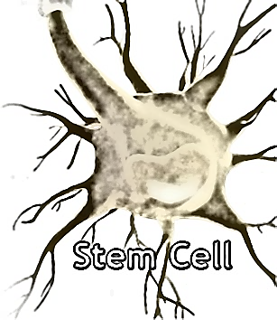

Activity 3: Use the internet to access stem cell virtual lab at: http://virtualstemlab.com/stemcell.html (Teacher notes)
Place the students in groups of 3. Have them enter the virtual lab and follow these instructions. Encourage them to pay close attention as their next activity will be to use that information to create a teaching video on YouTube.
Instructions:
Go to the link provided. Enter the lab and review all three sessions (embryonic, adult, and induced pluripotent). Pay close attention because this will become the information you will need to complete the final activity. Take notes and draw pictures! You will only have 15 minutes to collect as much information as possible.

