Summer Academy 2016
Stem Cells
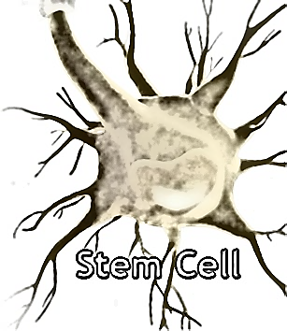

Activity 4: Create 3 minute YouTube video to present to the class.

Equipment needed:
- Computer access
- Poster board
- Markers
- Scissors
- Tape

Instructions:
There will be one hour and 15 minutes to work with your group to create an instructional video for YouTube. It must be 3 minutes long. You will be supplied poster board, markers, scissors and tape to create visual-aides. Come up with a way to explain stem cells and embryonic, adult, and induced pluripotent cells to your audience. Rehearse it a few times, then using your phone, record it and upload to YouTube. When you are finished, you will play the video for the class.

How to upload videos from phone to YouTube
  - Sign in to YouTube.
  - Open the Guide in the upper left corner of the screen and navigate to Uploads.
  - Touch the Upload icon at the top of the screen.
  - Select the video you want to upload.
  - Adjust the title, description, tags and privacy settings of your video.
  - Touch the Upload icon.
  - HAVE FUN!!!

