Cultural Connection
Medicine Garden
Medicine Gardens were originally intended to bring awareness to links between nutrition and health among Indian people related to health disparities. The Medicine Gardens provide a natural, organic, welcoming, and experiential setting for Native students, staff, faculty and community members to learn about the importance of integrating Native culture into all aspects of life, including food, health, and food sovereignty.
Medicine Wheel Garden:
In 2005, Francis Bettelyoun, Native Master Gardener and Landscape Designer, was hired to oversee the coordination and education in the Medicine Gardens. Three quarters of the first plot, now known as the Medicine Wheel Garden, was formed in the shape of a medicine wheel, which is a traditional, Indigenous tool often used for educational purposes. The medicine wheel is anchored by four plants, native to the area, which sustained Indigenous people. These include a Wild Plum tree and Chokecherry, Buffalo Berry, and Black Currant bushes. Surrounding the defined medicine wheel, are sage and sweet grass, used in traditional ceremonies. In the four quadrants of the medicine wheel itself, grow yucca, tobacco and milkweed. Other traditional plants are continually added. Strawberries, rhubarb, and other berries are grown in the other quarter of the plot, adjacent to the Medicine Garden.
https://diversity.umn.edu/multicultural/uofmnativegardens
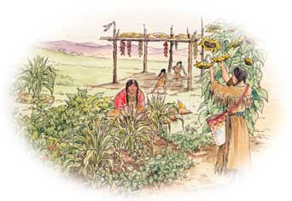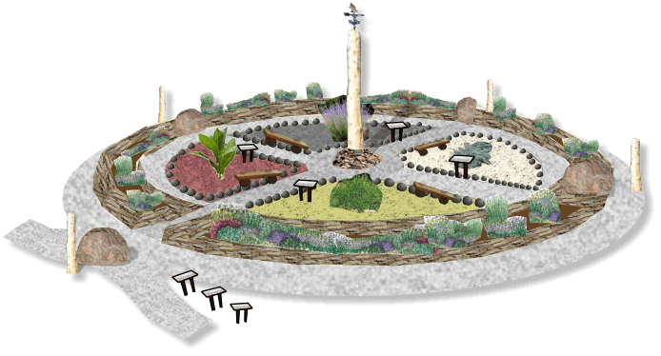
3 Sister Garden

The Real Three Sisters Garden
The concept of companion planting, in which one plant helps the other, is the basic idea behind the Three Sisters, but focusing on this alone glosses over many of the nuances in native garden traditions. Growing plants to work together symbiotically — using hills of corn to serve as poles for beans, and interplanting this with squash to keep down invasive weeds — is as much about compatibility and harnessing nature to do part of the work as it is a study in what we take from nature and what we give back. Like strip mining, modern agribusiness is based on yields extracted from the land regardless of the environmental cost. The Native American garden, which was actually a form of small-scale farming, made the land richer — one reason why early settlers were eager to seize Native American fields.
http://www.motherearthnews.com/organic-gardening/vegetables/native-american-gardening-zm0z13fmzsto

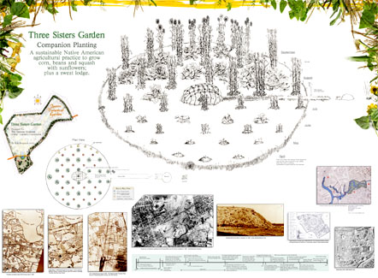
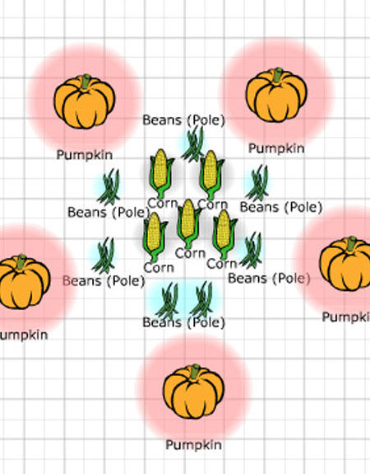
Other Links:
http://digital.library.upenn.edu/women/buffalo/garden/garden.html
https://www.ncbi.nlm.nih.gov/pmc/articles/PMC2765410/
http://www.sciencedirect.com/science/article/pii/S2352618116300750
http://www.nativevillage.org/Messages%20from%20the%20People/Squanto%27sGarden1.pdf

