Heart Dissection Activity

Student Lesson Plan

Objective:

Students will gain an understanding of the parts of the heart through dissection.
Materials per Group:
- One heart (pig, cow, or sheep from the butcher as in tact as possible)
- Scalpel
- 4 x Dowels (or pencils)
- Tweezers
- Tray
- Pair of Gloves
Video of heart dissection:

https://www.youtube.com/watch?v=mGPZ7WOyj0c

Directions:

Step 1: Identify these external structures of the heart:

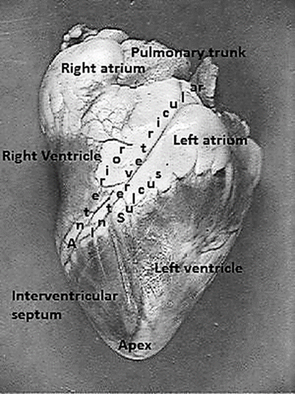
- Right auricle and atrium
- Left auricle and atrium
- Anterior (front) Interventricular sulcus
- Apex
- Right and left ventricles
- Interventricular septum
- Pulmonary trunk

There are a few clues to help you figure out the left and the right side, the front (ventral) side of the heart has a couple of key features:
- a large pulmonary trunk (sinus) that extends off the top of it
- the flaps of the auricles covering the top of the atria.
- the curve of the entire front side, whereas the backside is much flatter.
- left ventricle is larger

Step 2: Locate the vessels that enter and leave the heart:
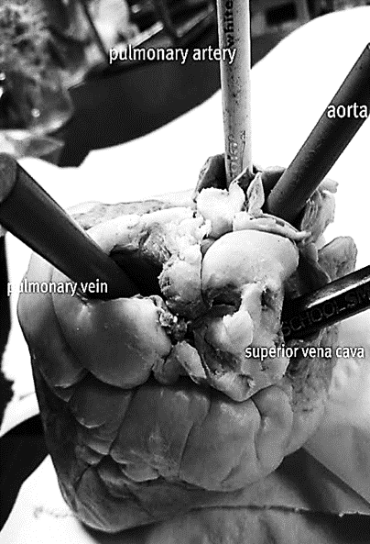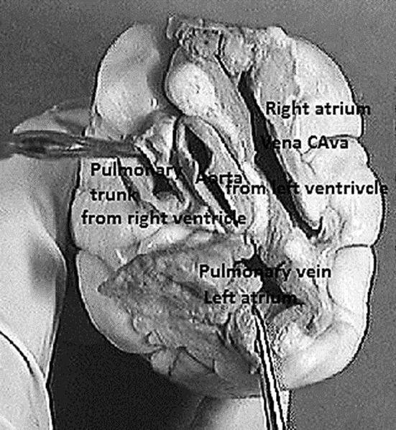
- Use your fingers to probe around the top of the heart. The four major vessels can be found entering the heart:
- the pulmonary artery
- aorta
- superior/inferior vena cava
- the pulmonary vein
- Once you find the pulmonary vein, the aorta should be situated a little bit behind it. It may be covered by fat, so use your fingers to poke around until you find the opening.
- Push your finger all the way in and you will feel inside of the left ventricle. The left ventricle has a very thick wall, unlike the right ventricle.
- Insert your finger through the pulmonary vessel to feel the left ventricle and you will notice and feel that it is much thinner than the left side of the heart.
- At this point, you may want to use your colored pencils/dowels to mark these vessels so that you don't get them confused when you are searching for the other two openings that top of the heart.
- With your fingers or probes in the aorta and the pulmonary trunk you should notice that they crisscross each other, with the pulmonary trunk in the front.
- The two major veins that enter the heart can be found on the backside, as both enter the atria.
- On the left side, you should be able to find the opening of the pulmonary vein as it enters the left atrium.
- The superior vena cava enters the right atrium. In many preserved hearts, the heart was cut at these points, so you won't see the vessels themselves, you will just find the openings.
- Again, use your fingers to feel around the heart to find the openings. If you've marked the aorta and pulmonary then you won't mistake them for the veins you are looking for.

Step 3: Make the Incisions
- Use the superior vena cava and pulmonary vein as guides for where to cut. You are basically going to be cutting each side of the heart so that you can look inside.

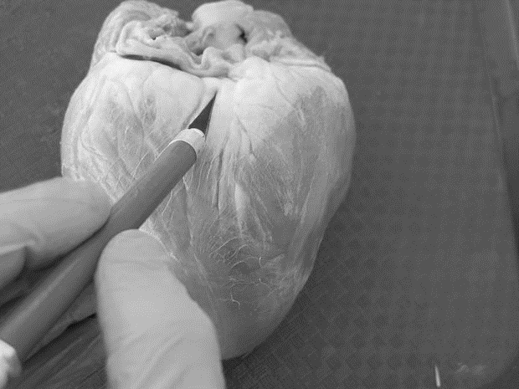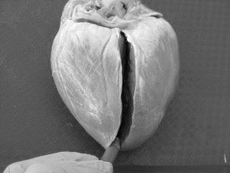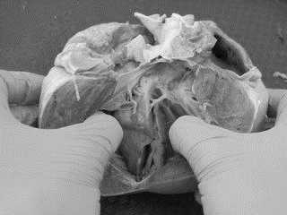

Step 6: Viewing the Chambers
- At this point it is helpful to have two hands, one to hold the heart apart so you can take a peek inside of it and another to use a probe to locate the specific parts.
- Your colored pencils you used to mark the heart in step 2 can also now be used to see where those vessels connect within the heart.
- The aorta pencil can now be seen ending in the left ventricle.
- You can also now see how much thicker the walls of the left ventricle are compared to the right ventricle.
