Heart Dissection Activity

Instructor Lesson Plan

Not all of us will have the hearts or want to do dissection. If that is the case, the students could (at minimum) watch the dissection video and answer questions about heart structures using a model.

For dissection:

Objective:

Students will gain an understanding of heart structures and function through dissection.
Materials per Group:
- One heart (pig, cow, or sheep from the butcher or order through Carolina or Nebraska biologicals)
- Scalpel
- 4 x Dowels (or pencils)
- Tweezers
- Tray
- Pair of Gloves
- Handout
Video of heart dissection:

https://www.youtube.com/watch?v=mGPZ7WOyj0c

Step 1: Orientation
There are a few clues to help you figure out the left and the right side, the front (ventral) side of the heart has a couple of key features: 1) a large pulmonary trunk (sinus) that extends off the top of it 2) the flaps of the auricles covering the top of the atria. 3) the curve of the entire front side, whereas the backside is much flatter. 4) left ventricle is larger
The auricle is the flap that covers the atrium, it looks like an ear. The pulmonary trunk is located at the front (anterior) of the heart and enters at an angle. See the following labeled pictures:
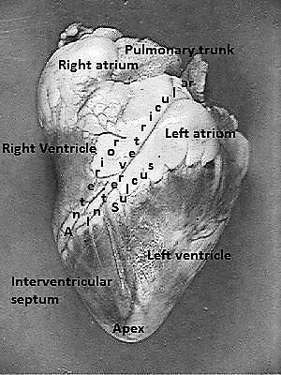

Step 2: Locate the Aorta
Use your fingers to probe around the top of the heart. Four major vessels can be found entering the heart: the pulmonary artery, aorta, superior/inferior vena cava, and the pulmonary vein. Remember that if you are looking at the back of the heart, then the right and left sides are the same as your right and left hand.
If you find the pulmonary vein, the aorta should be situated a little bit behind it. It may be covered by fat, so use your fingers to poke around until you find the opening. Push your finger all the way in and you will feel inside of the left ventricle. The left ventricle has a very thick wall, unlike the right ventricle. Insert your finger through the pulmonary vessel to feel the left ventricle and you will notice and feel that it is much thinner than the left side of the heart.
At this point, you may want to use your colored pencils/dowels to mark these vessels so that you don't get them confused when you are searching for the other two openings that top of the heart.
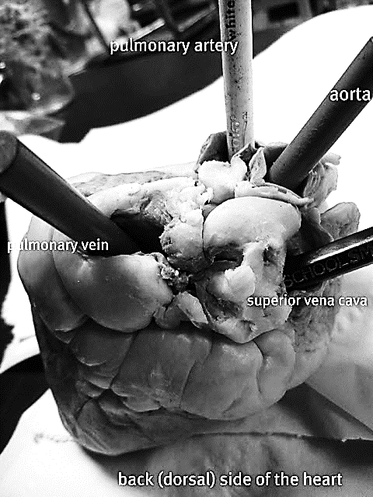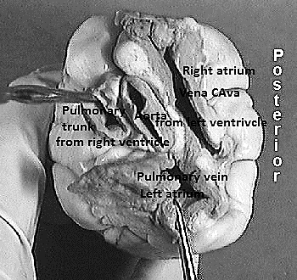

Step 3: Locate the Veins
With your fingers or probes in the aorta and the pulmonary trunk you should notice that they criss-cross each other, with the pulmonary trunk in the front.
The two major veins that enter the heart can be found on the backside, as both enter the atria. On the left side, you should be able to find the opening of the pulmonary vein as it enters the left atrium. The superior vena cava enters the right atrium. In many preserved hearts, the heart was cut at these points, so you won't see the vessels themselves, you will just find the openings. Again, use your fingers to feel around the heart to find the openings. If you've marked the aorta and pulmonary then you won't mistake them for the veins you are looking for.
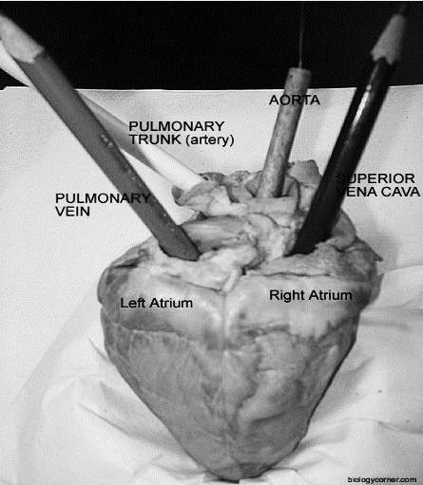

Step 4: Make the Incisions
Use the superior vena cava and pulmonary vein as guides for where to cut. You are basically going to be cutting each side of the heart so that you can look inside.

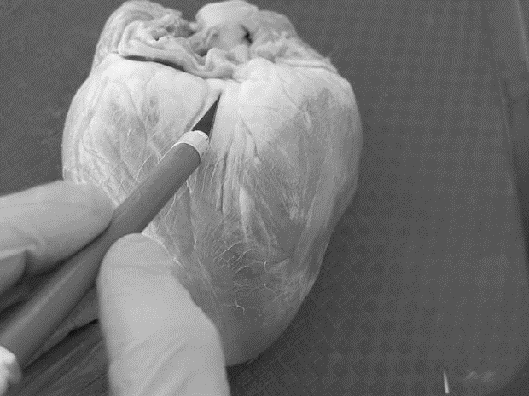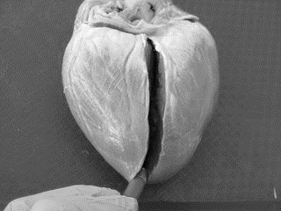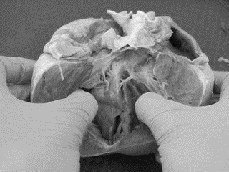

Step 5: Viewing the Chambers
At this point it is helpful to have two hands, one to hold the heart apart so you can take a peek inside of it and another to use a probe to locate the specific parts. Your colored pencils you used to mark the heart in step 2 can also now be used to see where those vessels connect within the heart. For instance, the aorta pencil can now be seen ending in the left ventricle. You can also now see how much thicker the walls of the left ventricle are compared to the right ventricle.
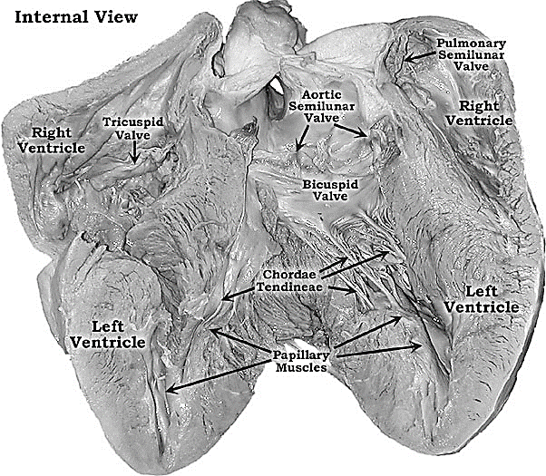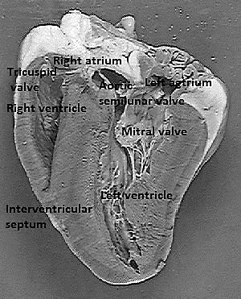

Source:
https://www.biologycorner.com/anatomy/circulatory/heart/heart_dissection.html
http://www.instructables.com/id/Heart-Dissection/

