Creating a Model Heart
Instructor Lesson Plan
Objective: Students will make a working model of a four-chambered heart.
Materials per Groups of 2-3:
- Four small soda or water bottles with lids
- Two large bulldog clips or valves
- Two pourable measuring cups (or small pitchers)
- Two pieces of clear plastic tubing about 12 inches long
- Two pieces of clear plastic tubing about 4 inches long
- Red and blue food coloring
- Electrical tape
- Modeling clay
- Water
Procedure:
- Make a small hole in the lid of each bottle to fit the plastic tubing through.
- In the bottom of two of the bottles, make a hole about 1/2 inch in diameter.
- On the sides of the other two bottles, make a small hole (to fit the plastic tubing through) about two inches from the top. [Note: Photo shows holes lower than they should be due]
- Thread the two pieces of 12-inch tubing into the small holes in the side of the two bottles. Push the tubing to the bottom of the bottles and seal the holes around the tubes with modeling clay.
- Connect two lids together (with their tops facing each other) with the small 4-inch piece of tubing, leaving about two inches of tubing between the lids. Repeat with other two lids and 4-inch tubing.
- Seal holes around tubing with modeling clay.
- To reinforce the seal in #6, tape over the clay with electrical tape.
- Screw all four lids onto the bottles.
- Tape the bottles next to each other in pairs using electrical tape, ensuring that the two bottles with holes in the bottom are next to each other. (You may also want to tape the ends of the longer plastic tubing to the upper bottles to keep them out of the way.) Attach the clips onto the tubing between the lids. These will acts as heart valves, allowing the fluid to flow only in one direction.
- Mix enough red water and blue water to fill up one of the bottles.
- Pour red water into the top of one bottle and pour blue water into the top of the other bottle.
- Open the clips to let the fluid (“blood”) flow through the tubes to the lower bottles and then close them again.
- Squeeze the lower bottles, which will cause the “blood” to squirt out of the tubes.

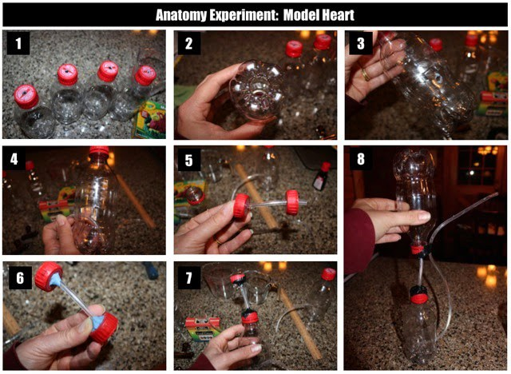
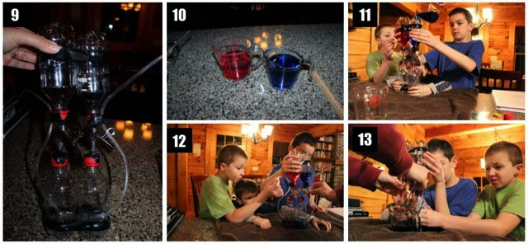

Source: http://www.halfahundredacrewood.com/2014/11/make-pumping-model-heart/
Follow up questions:
Are students able to identify/label the parts of the model?
The four bottles represent the four chambers – right atrium, right ventricle, left atrium, and left ventricle
Tubes – The pulmonary artery carries blood from the right side of the heart to the lungs to pick up a fresh supply of oxygen. The aorta is the main artery that carries oxygen-rich blood from the left side of the heart to the body.
Can students explain how this simulates a real heart?
The left ventricle pumps oxygen-rich blood into the main artery (aorta). The blood travels from the main artery to larger and smaller arteries into the capillary network. There the blood releases oxygen, nutrients and other important substances and takes on carbon dioxide and waste substances. The blood, which is now low in oxygen, is now collected in veins and travels to the right atrium and into the right ventricle.

