How to Make a Stethoscope

Objective:

Students will make a stethoscope to listen to a heartbeat.

Materials per Groups of 2-3 Students:

- Funnel
- Duct Tape
- Cardboard tube
(If you choose to do the extension activity you will need more funnels and plastic tubing. The dollar store has all kinds of plastic funnels very cheap.)

Procedure:

- Attach the funnel to the cardboard tube using duct tape.
- Place on a friend’s chest and listen to their heart beat.
- Can you count how many times the heart beats in one minute?

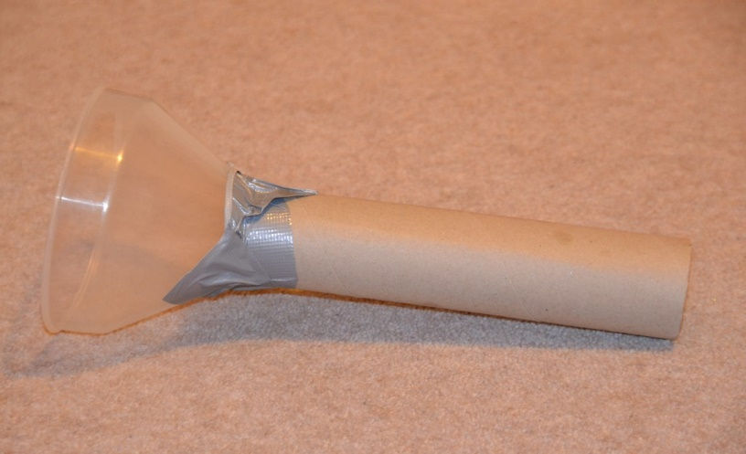

Extension:

How could you make the stethoscope better? What if you used a hose with a funnel at each end? Or different sized funnels?

Which do you think would work the best? What happens to your heart rate if you jump up and down for a few minutes?

Use the following charts to listen to team members heart sounds:

