NATURE Summer Camp 2017
Conduction: get pumped!
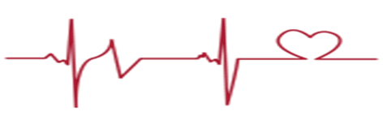

Description:
This class introduces the learner to the biological processes of the cardiovascular system, structures and functions of the heart, blood flow and conduction; structures and functions of blood.

Objectives:
Students will:
- Develop understanding of the heart and blood
- Recall important functions of blood cells and how they work within the immune system
- Use technology to create a heart simulation
- Demonstrate knowledge of topic by investigating a series of questions through jeopardy
- Apply information to hands-on lab exercise by dissecting the heart

North Dakota state standards covered:
11-12.2.1. Understandings About Scientific Inquiry: Explain how new knowledge and methods emerge from different types of investigations and public communication among scientists
11-12.4.1. Structure and Function: Explain the importance of heart and blood
11-12.2.7. Abilities Necessary To Do Scientific Inquiry: Design and conduct an independent investigation
9-10.2.3. Abilities Necessary To Do Scientific Inquiry: Identify questions and concepts that guide scientific investigations
MS-LS1-1. Conduct an investigation to provide evidence to explain how the heart transports gases.
MS-LS1-2. Develop and use a model to describe the function of a heart and how this contributes to a healthy living system.
MS-LS1-3. Use argument supported by evidence for how blood is a system of interacting subsystems composed of different cells.

Schedule:
09:00-09:30 Introduction and cultural connection
09:30-09:50 PowerPoint: Circulation
09:50-10:50 PowerPoint: heart structures, function, blood flow, and video
10:50-11:30 Activity 1: Heart Dissection
11:30-12:15 Activity 2: Construct a Heart Simulation
12:15-12:45 Lunch
12:45-01:15 PowerPoint: conduction, heart sounds, and two short videos
01:15-01:45 Activity 2: How to create a stethoscope and listen to heart sounds
01:45-02:15 PowerPoint: blood and video
02:15-03:00 Activity 3: Jeopardy and wrap-up

