Summer Academy 2018
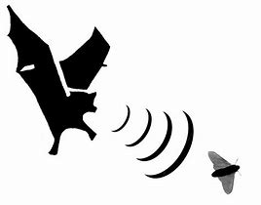 Echolocation

Description:
We need to know where things are, and many times we need to be able to "see" something even when it's dark outside, if something is far away, or obstructed by mountains, the ocean, or clouds. Many animals, or blind people, can’t rely on their vision to move around and hunt. In this lesson, students will investigate how sound can be used to navigate, communicate, locate objects, and find food in these types of surroundings.

Learning Objectives:
After this lesson, students should be able to:
- Discuss soundwaves, amplitude and frequency, absorption and reflection, and echolocation.
- Explain how soundwaves waves require a media, such as water or air, in order to move.
- Discover how echolocation is used by some animals to survive in nature.
- Perform activities to stimulate thought and answer critical thinking questions.
- Understand that engineers developed SONAR based on natural echolocation.
- Compare sonar to echolocation.

Standards:
- HS-PS4-1 Use mathematical representations to support a claim regarding relationships among the frequency, wavelength, and speed of waves traveling in various media.
- HS-PS3-2 Develop and use models to illustrate that energy is associated with motion and relative position of particles (objects).
- HS-PS3-3 Design, build, and refine a device that works within given constraints to convert one form of energy into another form of energy.
- HS-PS3-2 Develop and use models to illustrate that energy is associated with motion and relative position of particles (objects).
- MS-PS4-2 Develop and use a model to describe that waves are reflected, absorbed, or transmitted through various materials.
- MS-ETS1-2 Evaluate competing design solutions using systematic process to determine how well they meet the criteria and constraints of the problem.

Session Organization:
10:00 – 10:30 Cultural Connection
10:30 – 11:00 Background Information: sound, amplitude, and frequency
11:00 – 12:30 Activity 1a: Make Sound, 1b: Move Sound, and 1c: See Sound
12:00 – 01:00 Lunch
01:00 - 01:10 Background information: reflection and absorption
01:10 - 02:00 Activity 2a: Feel Sound, and 2b: Reflect and Absorb Sound
02:00 – 02:30 Background information: echolocation
02:30 – 03:00 Activity 3: Echolocation
03:00 – 03:30 Background information: sonar and wrap up
Activity 1a
Make Sound with Drums

Materials needed:
- Use pencils (one per student) for drumsticks and hands to show different sounds
- Cylinder (wide, short) shaped canister or bowl (one per student)
- Balloon large enough to cover cylinder top (2 per student)
- Rubber bands – large enough to wrap around balloon (two per student)
- Items to use on drums (marbles, beans, rice)
- Scissors (one per student)
Procedure:
1. To make a drum, cut the end from the balloon (the part you would blow into). Now stretch the balloon tightly over the container, secure with a rubber band.
2. Set up your experiment. Add one of your items to the center of the drum. Use pencils to beat the drum. Watch how the item responds to the vibration. Document findings on accompanying worksheet. Include what happens when you bang lightly or with more force, how high the items bounce, and how long they continue to bounce. Repeat using two more items (need to experiment with three different items).
3. Loosen the balloon and repeat experiment. Document changes from the previous attempts using a tight membrane.
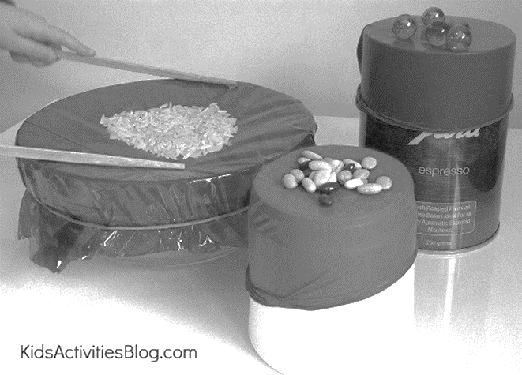
Activity 1a worksheet
Make Sound with Drums

 | Item 1 | Item 2 | Item 3
What is the item?
Tight drum
Loose drum

Answer the following questions:
1. Which drum surface causes the objects on top to bounce the highest? Why?

2. Which drum surface causes the objects on top to bounce for the longest time? Why?

3. Which objects have the most bounce? Why?

4. How are the results affected if you bang your drumstick softly or more heavily? Why?

Activity 1b
Move Sound Through a Hose

Materials needed:
- 20-foot garden hose, or other tubing
- Plumber’s tape
- 4 funnels that fit into the tube
- Scissors
Procedure:
1. Cut hose into 2-10 foot pieces
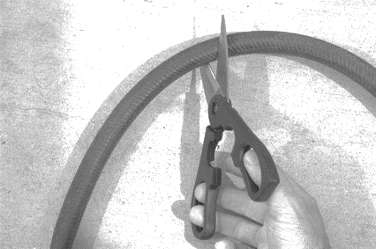
2. Put funnels on each end of the hose and apply tape to adhere firmly.
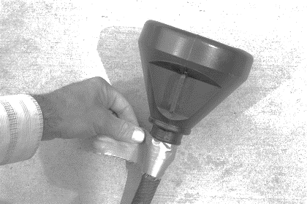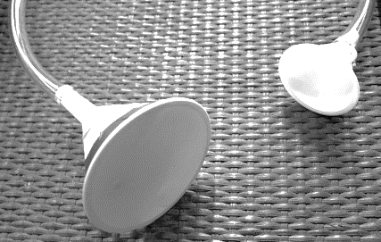
3. Have one students hold an end in the classroom, while another takes it out to the hallway or another adjacent room.
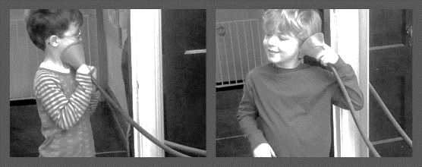
4. One student speak normally into the funnel, the other listen. This demonstrates how soundwaves travel.

Activity 1c
Watch Sound Using a Tonoscope

Materials needed:
- Reuse containers for drums (from experiment 1a)
- Keep balloon tightly secured to drum (from experiment 1a)
- 6” x 12” piece of heavy poster board (one per student)
- Sturdy tape to adhere to poster board and hold it securely in the shape of a cylinder that is 2” wide X 12” long; also use it to adhere the cylinder to side of drum
- Scissors
- 2” circle stencil (one per student)

- Salt or sand (one tablespoon or so per student)

Tonoscopes are fun tools that allow you to see the beautiful patterns that sound waves make.
Procedure:
1. Use the drum with tightly fitting balloon from activity 1a.
2. Roll the poster board into a tube, 12” long and 2” wide; tape securely.
3. Use the 2” stencil and draw circle onto side of the drum, cut the hole into the drum.
4. Insert the 12” X 2” tube into the hole and secure with tape. Not too tightly as you will remove the tube later.
5. Apply about a tablespoon or less to the center of your tonoscope membrane.
Make sounds (tones) like do-ra-me. First do a low tone slowly and watch the pattern that forms from the sand. No try it quickly and watch as the design changes. Try a high tone slowly; then quickly. Try medium tones. This demonstrates how different amplitudes and frequency can cause a variety of soundwaves to form. You are witnessing sound.

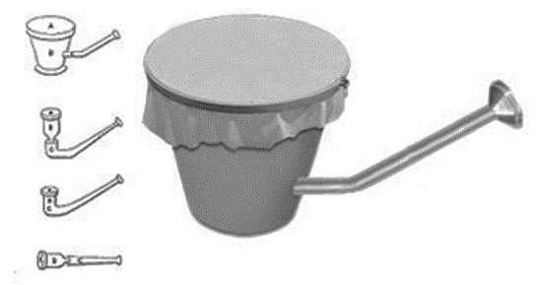

Activity 2a
Feel Sound Waves

Materials needed:
- Balloons (any size, one per student)
- Source of music (cell phone or computer)

Procedure:
1. In this experiment the student will have an opportunity to feel sound waves.
2. Blow up balloon, tie it shut.
3. Place the balloon against a music source. The speaker from a computer or cell phone. Select music with low tones and press hand on the balloon. Now try it with high tone music.
4. Air molecules in the balloon are squeezed together, making the balloon vibrate.
5. Think about this – could you repeat this experiment using water to get similar results? If not, why? If so, why?

Activity 2b
Reflect and Absorb Sound Waves

Materials needed:
- Use drum from experiment 1c (one per student)
- Sturdy tape
- Large rubber bands (6 per student)
- Rags (one per student)

Procedure:
1. Remove balloon and 12” tube from tonoscope.
2. Tape up hole on side of drum.
3. Wrap rubber bands around drum as pictured:
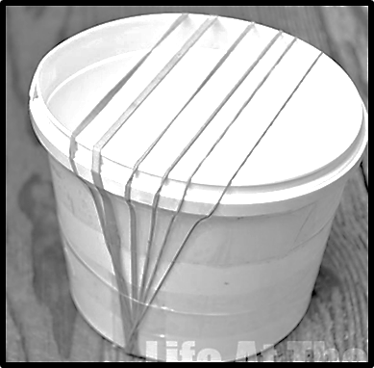
4. Keep rubber bands in place by adhering with tape as shown in picture (wrap tape around the outer drum.
5. Play the rubber bands like strings on a guitar. Each one makes different sounds. The sound should be loud and clear with a slight reverberation.
6. Now stuff a rag into the container. Play the bands like guitar strings. How does it sound? Explain why it is different than it sounded without the rag.

Activity 3
Echolocation

Materials needed:
- Blindfold (one per student)
- Earplugs (one set per student)
The swimming pool game, Marco Polo, demonstrates our ability to localize sound. With eyes closed we hear “Marco” then swim towards its direction. This ability is only possible with two ears. Although we can hear with just one ear we can’t distinguish the location of its source as well as or at all. A single ear can process the amplitude (loudness) and frequency (pitch) of a sound wave. But, together, both ears detect sound location through minute differences in timing. Bats, although blind, can fly without running into trees, caves, other bats, etc. by listening to the echoes produced by their own calls, known as echolocation.
To some extent humans use echolocation. The blind use canes to walk around, alerting the user of any objects in his or her path. Tapping the cane allows the user to listen to its echoes and sense objects around them, just as bats. In this experiment students will demonstrate how two ears help us locate sounds.
Procedure:
1. One student stand in the center of an empty or cleared room, wearing the blindfold, like a bat or dolphin, can’t see well but needs to move around and hunt.
2. Three other students will be placed randomly around the room, as objects, insects, or fish.
3. The three students will be asked to clap their hands twice. No other movement or sounds. The room must remain quiet.
4. The blindfolded student should turn and face the direction they think the sound is coming from. Continue this sequence until the student successfully locates a clapper.
5. Now have the blindfolded student repeat the experiment, only this time with one ear plugged.
6. Have the student try again with both ears plugged.
7. Let students take turns being the bat and the prey.
8. This demonstrates how echolocation localizes sound to help navigate and hunt.

