Materials list for echolocation lesson
Most of these items can be found at a dollar store

A TUNING FORK – any sound
20’ garden hose
4 funnels

1. Produce sound:

Make drum:
– use pencils (one per student) for drumsticks and hands to show different sounds
- cylinder (wide, short) shaped canister or bowl (one per student)
- balloon large enough to cover cylinder top (2 per student)
- rubber bands – large enough to wrap around balloon (two per student)
- items to use on drums (marbles, beans, rice)
- scissors (one per student)
2. Making sound waves visible:
Tonoscope:
- Reuse containers for drums (from experiment 1)
- Keep balloon tightly secured to drum (from experiment 1)
- 6” x 12” piece of heavy poster board (one per student)
- Sturdy tape to adhere to poster bard and hold it securely in the chape of a cylinder 2: wide by 12” long; also stirdy enough to tape poster board cylinder to side of drum
- Scissors
- 2” circle stencil
- Scissors (cut 2” diameter circle in side of drum)
- Salt or sand ( one tablespoon or so per student)
- Do not ruin the poster board tubes as will reuse them
3. Reflection and absorption:
Reflection:
- reuse tubes from experiment 2 (2 per two students)
- aluminum pie pans (one per two students)
- sturdy tape

Reflection and absorption:

- use drum from experiment 2 (one per student)
- remove drum membrane (balloon)
- tape up hole
- large rubber bands (big enough to wrap around the container), like this:

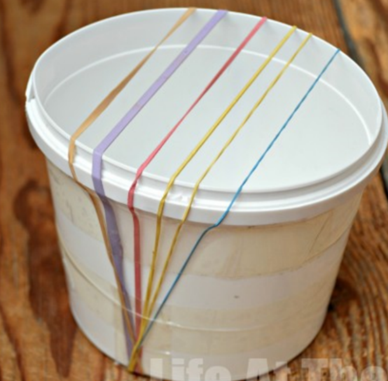 (6 per student)
- sturdy tape to hold rubber bands in place
- rags to put inside container (any rags) (one per student)

4. Feel sound:
- Balloons (any size) (one per student)
- music (cell phone or computer)

5. Echolocation:
- earplugs (one pair per student)
- blindfold (strip of fabric, et al) (one per student)

