Summer Nature Academy 2018
Plate Tectonics
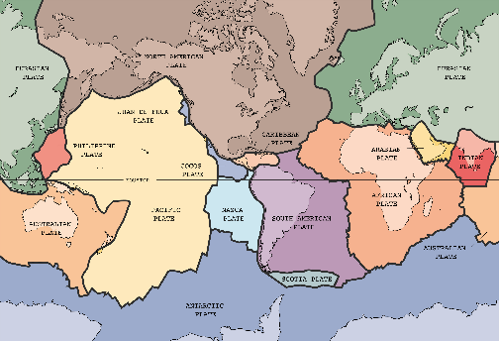

Description:
Plate tectonics is a scientific theory that describes the large-scale motion of Earth's lithosphere. The lithosphere is the outer rigid layer of the earth and it is divided into “plates” that move around on the earth’s surface relative to each other. The movement of these plates occur do to convection currents and other forces. The movement of these plates has formed the many different landscapes that we see across the globe today such as mountains. This theoretical model builds on the concept of continental drift which was developed during the first few decades of the 20th century by a scientist named Alfred Wegener. Alfred Wegener was a German geophysicist and meteorologist.

Objectives:
- Understand how Earth is dynamic and how moving plates form ocean basins, mountain ranges, islands, volcanoes, and earthquakes
- Identify the three general categories of plate boundaries recognized by scientists: convergent, divergent, and transform
- Use acquired knowledge to identify several types of modern volcanic eruptions around the world and to understand why we have different types of landscapes around the world.
  - Why Hawaii is at the end of a thousand mile long chain of seamounts.
  - Why Yellowstone is just the latest super volcano scar in a chain of them in the US interior.
  - Why are the movement of these plates and the geological processes that take place in earth’s crust important to life on Earth?
    - Several billion years ago, the surface of our Earth began forming into puzzle pieces called plates. This process trapped our atmospheric carbon dioxide into rocks and stabilized our climate, making Earth habitable.

North Dakota State Science Standards:
9-10.5.3. Explain how energy in the Earth system is governed by convection, conduction, and radiation (e.g., heat moves in the Earth’s mantle by convection, conduction occurs along the mid-oceanic ridges, energy from the Sun reaches the Earth through radiation)
9-10.5.4. Identify the short-term and long-term effects of physical processes (e.g., plate tectonics, extreme weather phenomenon) on the environment and society
9-10.5.5. Analyze how evidence of past natural hazards and geologic events has predicted subsequent hazards and events (e.g. Gap time method to predict earthquakes and tsunamis)

Session Organization:
9:00-9:30 Cultural connection and general introduction
9:30-11:00 Background information: (Internet activity and discussion on plate tectonics)
11:00-12:00 Activity I: Earthquakes- How to build a seismograph
12:00-12:30 Lunch
12:30-1:30 Activity II: Tsunami’s- How to make a simulation of a tsunami & Lesson: Understanding Waves
1:30-2:30 Activity III: Volcanoes- How to make a lava volcano
2:30-3:00 Wrap it up: Jeopardy Challenge

Cultural Connection:
The Pacific Northwest traditions speak of shaking and flooding from the sea by referring to a struggle between the Thunderbird and the Whale. The Thunderbird and Whale in the Native American stories are creatures of supernatural size and power. Although native myths vary between tribes, the acts and personalities of these supernatural beings in the stories generally describe the effects of earthquake and/or tsunami. Thunderbirds are usually said to bring storms and rain in the native stories. They create thunder by flapping their wings and shoot lightning bolts out of their eyes. To the Pacific Northwest Indian, the Thunderbird is the most powerful of all spirits. The thunderbird is a regular fixture on top of totem poles of native tribes in the Northwest.

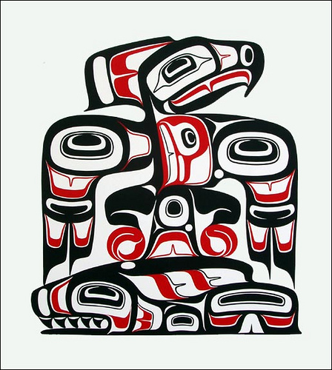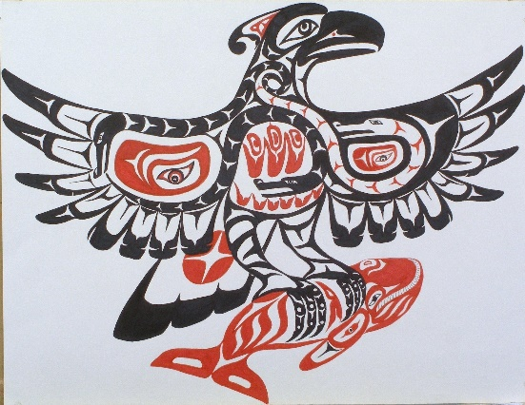

The Thunderbird is a widespread figure in Native American mythology, particularly among Midwestern, Plains, and Northwest Coast tribes. Thunderbird is described as an enormous bird (according to many Northwestern tribes, large enough to carry a killer whale in its talons as an eagle carries a fish) who is responsible for the sound of thunder (and in some cases lightning as well.) Different Native American communities had different traditions regarding the Thunderbird. In some tribes, Thunderbirds are considered extremely sacred forces of nature, while in others, they are treated like powerful but otherwise ordinary members of the animal kingdom. In Gros Ventre tradition, it was Thunderbird (Bha'a) who gave the sacred pipe to the people. Some Plains tribes associated thunderbirds with the summer season (in Arapaho mythology, Thunderbird was the opposing force to White Owl, who represented winter.) Thunderbirds are also used as clan animals in some Native American cultures. Tribes with Thunderbird Clans include the Kwakiutl and Ho-Chunk tribes of Wisconsin. (nativelanguages.org)
https://www.youtube.com/watch?v=QM2KTWcxNII (4.24 minutes about the thunderbird)
These 9 Fascinating Stories Of Hawaiian Mythology Will Leave You Shaking Your Head In Awe http://www.onlyinyourstate.com/hawaii/hi-mythology/

PLATE TECTONICS, SPACE, GEOLOGIC TIME, AND THE GREAT PLAINS (R.F. Diffendal, Jr.)
“There is a relationship between climate change and the geological development of the Great Plains as it has been influenced by major geological events both outside and within the region. These events include movements of the earth's rigid lithosphere plates with attendant mountain formation and volcanism, cyclic changes in sea level and glaciation, broad uplifts and down warps of the continents, the evolution of new environment changing organisms, and meteorite impacts”. So as you can see, plate tectonics has played a major role in the development of the plains region of the United States and has had an impact in how the Native American of the Plains lived. (Nomadic/Agriculture)

Background Information:
Click on this link: Interactives. Dynamic Earth. Earth's Structure: Plate Tectonics
Procedure: Go to “Introduction” and go through the entire simulation with the students. This will take some time which may vary between sites.

Activity I: Earthquakes

How do scientists measure the size of earthquakes?
The size of an earthquake depends on the size of the fault and the amount of slip on the fault, but that’s not something scientists can simply measure with a measuring tape since faults are many kilometers deep beneath the earth’s surface. So how do they measure an earthquake? They use the seismogram recordings made on the seismographs at the surface of the earth to determine how large the earthquake was (figure 5). A short wiggly line that doesn’t wiggle very much means a small earthquake, and a long wiggly line that wiggles a lot means a large earthquake. The length of the wiggle depends on the size of the fault, and the size of the wiggle depends on the amount of slip.
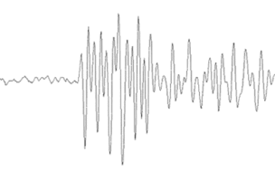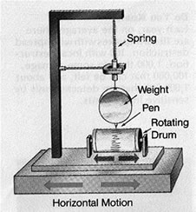
The size of the earthquake is called its magnitude. There is one magnitude for each earthquake. Scientists also talk about the intensity of shaking from an earthquake, and this varies depending on where you are during the earthquake.

Make Your Own Seismograph

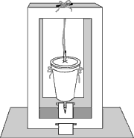
A seismograph is an instrument used by scientists to measure the motions of the Earth's surface.
A seismograph is a simple pendulum. When the ground shakes, the base and frame of the instrument move with it, but the pendulum bob in place. It will then appear to move, relative to the shaking ground. As it moves it records the pendulum displacements as they change with time, tracing out a record called a seismogram.
Materials:
- Cereal box (work in groups of 5, you will need 5 boxes)
- Cardboard sheet (size of cereal box)
- Plastic cup with cover
- Pencil
- Scissors
- Strip of paper (2" wide, by 2' long)
- Piece of string
- Rubber bands
- Sand
Instructions:
- Cut a rectangle out of both sides of a cereal box, leaving 1 inch wide edges.
- Cut in the middle of the bottom edge, two narrow horizontal slots about 2 inches wide through which you can slide the 2 foot long strip of paper.
- Pierce a hole at the center of the top cup cover and another at the bottom of the cup.
- Push a pencil, point down, through the two holes.
- Fill the cup with sand around the pencil.
- Thread string through the holes near the top of opposite sides of the cup. Hang the cup from the center of the cereal box by tying the string around a small stick at the center at the box top.
- Adjust the length of the string so the tip of the pencil touches the strip of paper threaded through the bottom cuts of the box.
- Glue the bottom of the cereal box to one of the sheets of cardboard.
- Shake the cardboard base back and forth. The weighted pencil should stay put and will make a mark on the paper strip you have moved through the cardboard base. You will need a friend to guide the strip of paper through the slits.

Questions:
- How well did your seismograph work?

- Name (3) ways you could change or improve on your model?

- Why is it important to know the size, intensity or magnitude of an earthquake?

Activity II: Tsunami’s
- Lesson: Understanding Waves- you will need calculators.
- Tsunami’s- Simulation Tsunami

What is a Tsunami (3 minute video) https://www.youtube.com/watch?v=oWzdgBNfhQU

Lesson Outline: Understanding Waves

Introduction
Introduce the lesson by showing the video named “Animation of September 29, 2009 tsunami” at the link below: Click on link below then click on the picture!
https://nctr.pmel.noaa.gov/samoa20090929/
Lecture Notes:
A wave is transmission of energy through matter
  - As energy travels through matter, the energy is transmitted to adjacent matter.

  - As energy moves through matter, the matter moves and then returns to its original position.

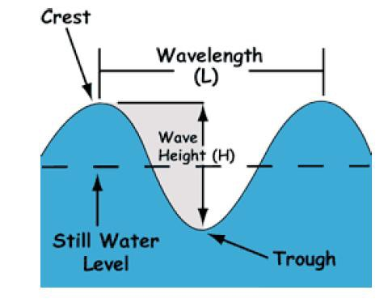
Some important features of a wave
- The major parts of a wave are the crest (the highest point), the trough (the lowest point), the height (distance from trough to crest), the wavelength (distance between identical points on two waves, typically crest to crest) and period (the time it takes for the same spot on two
consecutive waves to pass the same point).

- The ratio of a wave’s height to wavelength (H:L ratio) can tell us some information about the wave, for example if it is about to break.

There is more than one type of wave
Two major wave types to know are shallow-water waves and deepwater waves.

These waves are defined by their wavelength compared to the depth of the water in which they occur.
A deepwater wave occurs when water depth is greater than or equal to 1/2 of its wavelength.
A shallow-water wave occurs when water depth is less than or equal to 1/20 of its wavelength.

How does a wave break?
- As waves move from deep water to shallow water, they come into contact with the ocean floor. This causes the wavelength to decrease and wave height to increase.

- Once the H:L ration surpasses 1:7, the wave breaks.

Why is it important to know so many details about waves?
- Waves, especially tsunamis, can be very destructive.

- A tsunami is a shallow-water wave triggered by displacement of a large amount of water

- Understanding wave physics has helped scientists learn how to identify disturbances that can trigger tsunamis and predict when associated waves will reach affected locations.

Can You Outrun the Tsunami?
Student Edition

Introduction
Knowing information about wave physics can save lives. You may have seen videos of the terrible destructive power of tsunamis. These shallow-water waves happen when large amounts of water are displaced, for example by earthquakes, icebergs falling into the ocean or even a volcanic eruption. When scientists detect these disturbances, they can figure out how fast the tsunami is traveling, where it will hit and when. In this way, they can do their best to evacuate people before the tsunami hits and save lives. Today, that is your job!

You and your team members are scientists working for NOAA and you have received information about a disturbance in the ocean. Unfortunately, all your high-tech computing systems have shut down. How are you going to figure out where and when the tsunami will strike?

Procedure
For this activity, you will be given a scenario of the location of disturbance (i.e., the origin or epicenter of the tsunami) you detected and the depth at which it occurred. You will use this information to calculate the speed of the tsunami and when it will affect given locations.
- Read the Tsunami Scenario and identify the location on a map.

- Use the wave speed formula below to calculate the speed at which the tsunami is traveling.

- Fill out the information sheet that will be passed on to emergency services personnel to help warn and aid people in the affected areas.

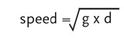
Wave Speed Formula

Speed of the tsunami (meters/second) is equal to the square root of g (the acceleration due to gravity, which a constant 9.81 meters/second) times the water depth (d) at which the disturbance occurred (meters).

NOTE: You may also see reference to tsunami “velocity” (V) at the bowl. Velocity refers to the rate and direction of water displacement but, for our purposes, can be thought of as similar to speed.

Convert your final answer to km/h: 1km = 1,000m
1hr = 60 min
1 min = 60 sec

Calculating Time to Affected Locations
To figure out how long it will take for the tsunami to reach the affected locations, first calculate the distance in meters between the epicenter and the affected location. Use Google to find the coordinates (latitude and longitude) of the epicenter and each location. Enter the information for the epicenter and location at the website below to find the distance between them in km and multiply by 1,000 convert to meters.

http://www.chemical-ecology.net/java/lat-long.htm

Once you know the distance, multiply by the speed of the tsunami to find out how long you have before the tsunami strikes.

Distance (meters)/Speed (m/second) = time until tsunami
(seconds) State your final answer in hours, minutes and seconds.

Tsunami Scenario
You received information that there was an earthquake in Seward, Alaska large enough to produce a tsunami at an ocean depth of 4,000m. Calculate the speed of the tsunami at this depth. Then, calculate the time it will take the tsunami to reach the two following affected locations:
- Kodiak, Alaska
- Kauai Island, Hawaii

Tsunami Information Sheet

Epicenter: Seward, Alaska

- Speed of the tsunami:

- Time that it will take to reach each location: Kodiak, Alaska:

Kauai Island, Hawaii:

- List the locations in the order in which the tsunami will strike in the table below. Indicate some actions at each location that should be taken to help local citizens.

Record your data and answer the questions on the information sheet.

Order of tsunami  strike | Affected location (include  coordinates) | Time until tsunami  hits | Emergency actions
1st
2nd

Questions: Waves

    - Short answer: This term refers to the time it takes identical points on two waves to pass through the same point?________________________

    - The lowest point on a wave is the:
      - Crest
      - Wavelength

c. Trough
d. Benthic

    - Wavelength is best described as the:
a. Vertical distance between a wave’s crest and the next trough

b. Horizontal distance, either between the crests or troughs of two consecutive waves.

c. The number of waves that pass a given point in a designated amount of time
d. The distance a wave travels in one second

    - If you followed a single drop of water during a passing wave, it would:
      - Move horizontally
      - Remain stationary
      - Move away from shore

Move in a circle

    - Deep water waves are defined as waves found in water deeper than:

1/2 their wavelength
      - 1/3 their wavelength
      - 2 times their wavelength
      - 4 times their wavelength

    - Shallow water waves are defined as waves in water shallower than:
a. 1/2 their wavelength

b. 1/20 their wavelength
- 2 times their wavelength
- 2/3 their wavelength

    - A wave has a speed of 10m/s and a period of 5s. What is the wavelength of this wave?
      - 2m
      - 5m
      - 10m

50m (speed= wavelength/period)

    - Which of the following is true of a tsunami?
      - A tsunami is a deep water wave
      - A tsunami may be caused by the tides, and thus is sometimes accurately called a tidal wave
      - The speed of a tsunami can be calculated by dividing its depth(d) by the acceleration due to gravity (g)

A tsunami is caused by displacement of large volumes of water, for example Short answer: This term refers to the highest point on a wave.

B. Build a Tsunami: Live video on youtube showing procedure.

https://www.youtube.com/watch?v=DZZFPCY6RlE
Materials:
- Large container (rectangular aluminum pans)
- Newspapers (crumple into balls to fill half the container)
- Sand (place on top of newspaper)
- Rocks (place on top of sand)
- Water (enough to fill half of the container)
- Piece of cardboard (fit the width of the container)
- Optional: trees, houses, roads (made out of various materials or toys to place on top of rocks & sand)
Procedure:
Line half of the large container with balls made out of crumpled newspaper. Pour sand on top of the newspaper balls (representing a coastal community). Place houses, trees, and other items in the community. Then pour water in the other end of the container (representing the ocean).
Place a piece of cardboard in the 'ocean' section, and move it back and forth to create a wave. Observe what happens to the model community.
Create another model community, using rocks instead of sand, and repeat the experiment. Observe the effects of the tsunami on the new community.

Discussion questions:
- Do you think anything could be done to prevent damage to the community? If so, what?

- How did the tsunami affect the coastal community model? How did it affect the model with rocks? Compare and contrast the effects.

- What caused the wave in this experiment? How are waves created in nature?

- Are all coastal communities at risk? What makes a community more or less at risk?

Activity III: Volcanoes

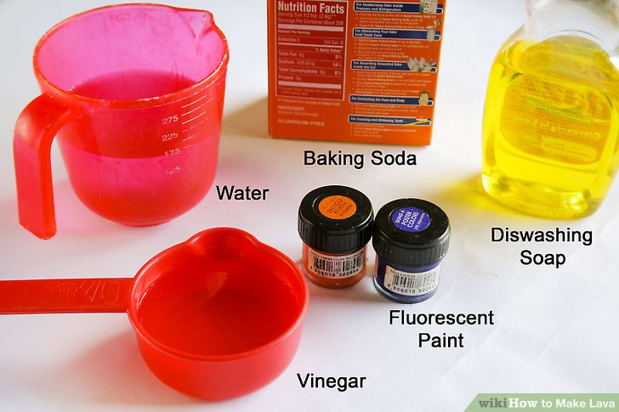

How to Make Lava & Volcano
Gather your supplies. In this project, you will be combining baking soda and vinegar to create a foaming, frothy lava. This lava does not last very long, but it is fun and exciting to watch as it foams out of your volcano.

Materials:
  - A homemade volcano, plastic bottle, bowl, cup, or jar
  - ½ cup (64 grams) baking soda
  - ½ cup (112.50 milliliters) of vinegar
  - Food coloring (few drops per volcano) or, glow-in-the-dark paint, or fluorescent paint (1 tsp. per volcano)
  - Dish soap (few drops per volcano)
  - Water (few drops per volcano)
  - Funnel (1) that fits into the top of your bottle or whatever you are using.

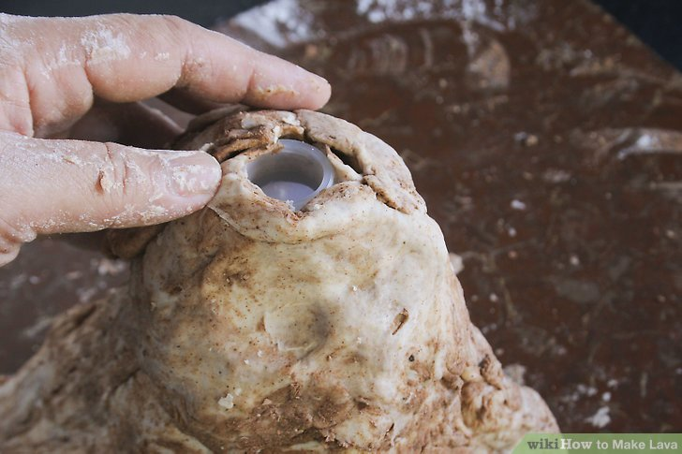
Procedure:
Build your volcano. Find a plastic bottle and take the cap off. Set the bottle down on a flat surface and wrap clay around it until you get a cone shape. You can do this by putting more clay on the base of the bottle and less clay at the top. Do not cover the top of the bottle; leave it open so that you can pour the ingredients inside. You can then decorate your volcano with fake plants, rocks, paint, and plastic animals. Let the clay dry before making the lava.
  - You can use any type of clay you want. You can also use plasticine or paper mache.
  - You can also make a simple "volcano" by using a tall glass or an empty bottle.

Set up your area. This volcano can get messy. Find a large, shallow bin or tray, and place your bottle or volcano inside it. The bin or tray will catch any lava that flows out of your "volcano."

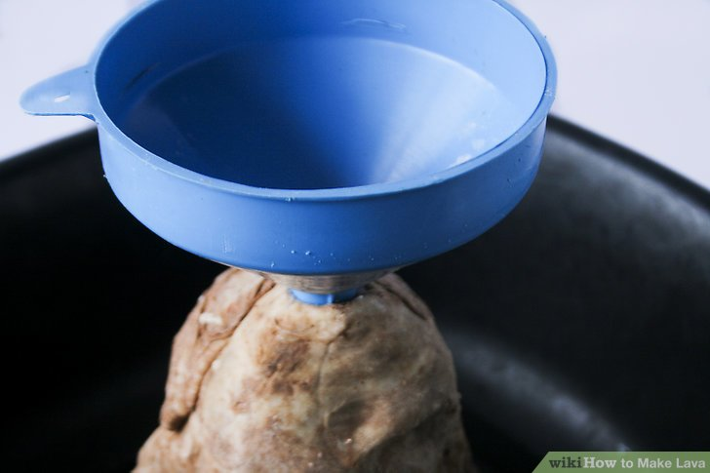

Place a funnel over the bottle or volcano. This will make it easier to pour in all of your ingredients. If you are using something with a wide mouth, such as a bowl, cup, or jar, then you probably will not need the funnel.
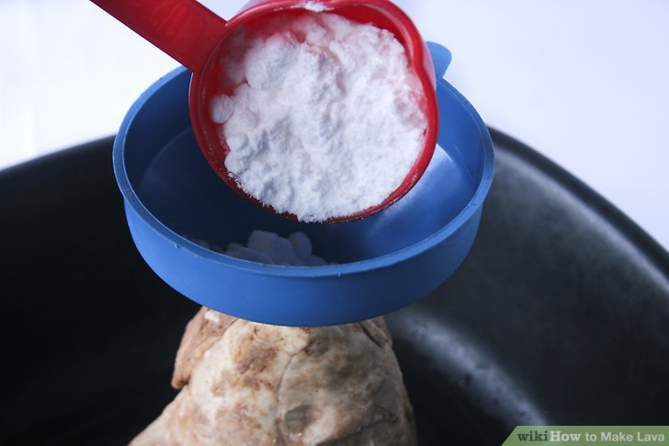
Pour some baking soda into your container. If the baking soda has clumped up, then place a sieve over the funnel first. The tight netting of the sieve will help break up any clumps of baking soda.

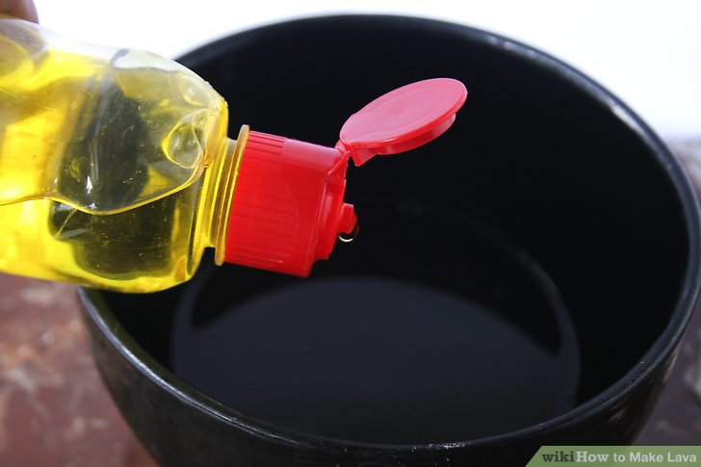

Mix your liquid ingredients. You will need at least ½ cup (112.50 milliliters) of vinegar, a few drops of liquid dish soap, and a few drops of water. The more vinegar you use, the more dish soap you will need. The dish soap will not only make the lava fuller, but also make it last longer.^{[1]}

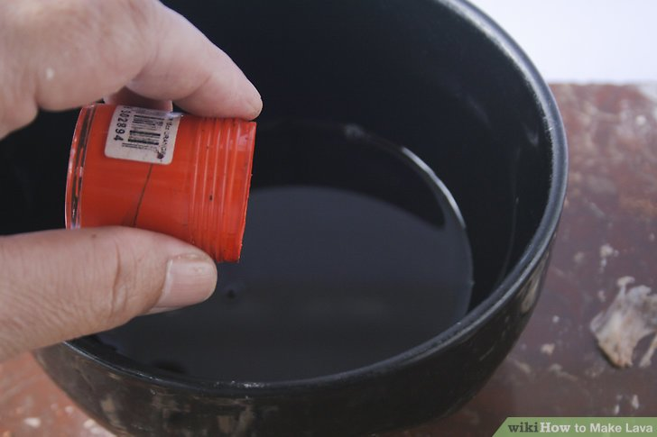

Consider making colored or glowing lava. You can make your lava look like real lava by adding a few drops of food coloring to the vinegar. You can also make glowing lava by adding 1 teaspoon of glow-in-the-dark paint or fluorescent paint to the vinegar. Be sure to stir the vinegar well to make sure that the food coloring or paint is completely mixed.^{[2]}
  - If you are using glow-in-the-dark paint, you will need to "charge" it by setting it in the sun or under a bright lamp for a few minutes. Once the paint is charged, you will need to turn off the lights in order to make it glow.
  - If you are using fluorescent paint, you will need a black light. Once you have the paint and vinegar all mixed, you will need to turn off the regular lights and turn on the black light. You can purchase a black light online or in an arts and crafts store, and switch out one of the light bulbs at home with the black light. If you are a child, please ask an adult to help you with this step.
  - You can make your lava any color you want, but red, orange, and yellow will give you the most realistic-looking lava.
  - You can make the lava even more exciting by adding in some sparkly glitter!

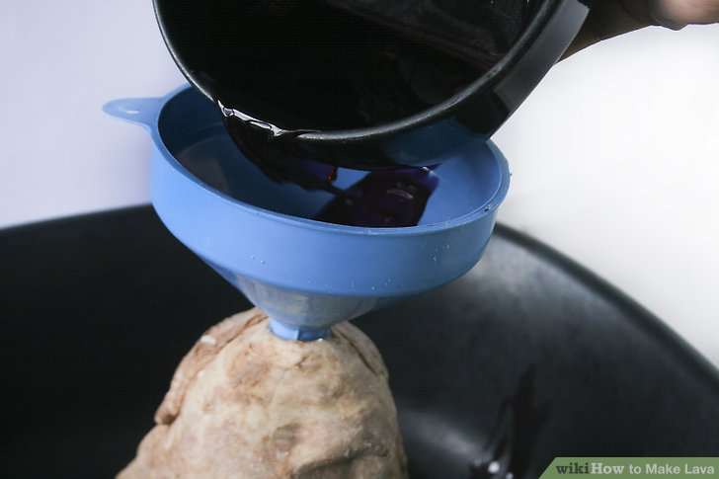
Pour the vinegar into the jar and quickly remove the funnel. You do not need to pour it all in all at once. Even a little bit of vinegar is enough to make the baking soda fizz. Take the funnel off the volcano quickly, or it will stop the lava from coming out!
  - If you are using glow-in-the-dark lava, turn off the lights first
  - If you are using fluorescent lava, turn off the lights and switch on the black light.

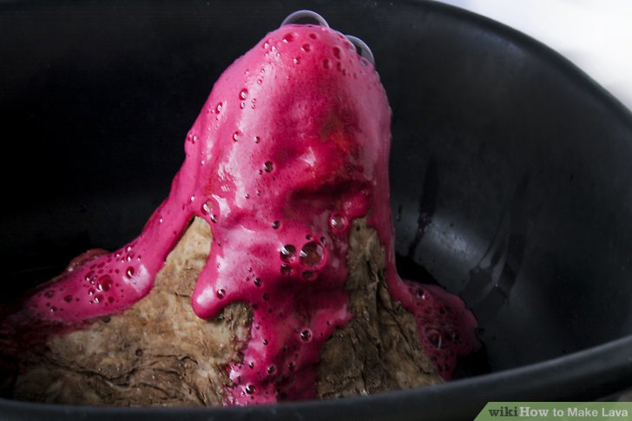

Questions:
- Can you predict when a volcano will erupt and how?

- What is erupted from a volcano?

- In what country did the latest volcano erupt? HINT: just in the news and it was in the US.
Wrap It Up: Fun Facts & Jeopardy Challenge:
**Please go through each of the Fun Facts & Plate Tectonics Worksheet with the students before you play jeopardy!
A. Fun Facts: Tsunami’s, Volcanoes & Earthquakes

Tsunami

Japanese word
pronounced: soo - nah – me
means “wave in the harbor”
misnamed as “tidal waves”

Tsunami traveling in deep water and open Ocean cause no damage and are hardly noticeable.

Tsunami traveling in shallow water can batter coastlines with waves as high as 100 feet, causing considerable damage.
A tsunami is a series of ocean waves caused by an underwater earthquake, landslide, or volcanic eruption. More rarely, a tsunami can be generated by a giant meteor impact with the ocean. These waves can reach heights of over 100 ft.
About 80% of tsunamis happen within the Pacific Ocean’s “Ring of Fire.”
The first wave of a tsunami is usually not the strongest, successive waves get bigger and stronger.
Tsunamis can travel at speeds of about 600 miles or 805 kilometers an hour, almost as fast as a jet plane.

Earthquakes
Natural events such as volcanic eruptions and meteor impacts can cause earthquakes, but the majority of naturally-occurring earthquakes are triggered by movement of the earth's plates.
The earth's surface consists of 20 constantly moving plates. The pressure increase from shifting plates can cause the crust to break. This break allows stress to be released as energy, which moves through the earth in the form of waves (aka earthquakes).
Normally, it's not the shaking ground itself that claims lives during an earthquake. It's the associated destruction of man-made structures and the instigation of other natural disasters such as tsunamis, avalanches and landslides. Not only is it important to have a plan for yourself in the case of an earthquake, but your pets need a disaster plan as well. Create an earthquake plan for the animals around so if disaster strikes, you’ll be prepared.
The National Earthquake Information Center (NEIC) records an average of 20,000 earthquakes every year (about 50 a day) around the world. There are, however, millions of earthquakes estimated to occur every year that are too weak to be recorded.

Volcanoes
There are about 1,900 active volcanoes on the earth. ...

Most of the earth's volcanoes are in the Pacific Ocean, in an area called the Ring of Fire.

The word “volcano” comes from Vulcan, the Roman god of fire.
Volcanoes are openings in the Earth’s surface. When they are active they can let ash, gas and hot magma escape in sometimes violent and spectacular eruptions.
While most volcanoes form near tectonic boundaries, they can also form in areas that contain abnormally hot rock inside the Earth. Known as mantle plumes, these hotspots are found at a number of locations around the globe with the most notable being in Hawaii.
Hot liquid rock under the Earth’s surface is known as magma, it is called lava after it comes out of a volcano.
Some famous volcanic eruptions of modern times include Mount Krakatoa in 1883, Novarupta in 1912, Mount St Helens in 1980 and Mt Pinatubo in 1991.
Most people think of volcanoes as large cone shaped mountains but that is just one type, others feature wide plateaus, fissure vents (cracks were lava emerges) and bulging dome shapes.
There are also volcanoes found on the ocean floor and even under icecaps, such as those found in Iceland.
Common volcanic gases include water vapor, carbon dioxide, sulfur dioxide, hydrogen chloride, hydrogen fluoride and hydrogen sulfide.
Volcanic eruptions can send ash high into the air, over 30km (17 miles) above the Earth’s surface.

B. Plate Tectonics Terminology & Questions Worksheet

Define the following terminology- you may use the computer for help.

Density-

Which is more dense the continental plate or the oceanic plate?

Plate tectonics theory-

Alfred Wegener-

Convection currents-

Focus-

Epicenter-

Slip-strike faults-

Shearing force-

Tension-

Compression-

Seismogram-

Seismograph-

Tsunami-

Vent-

Lava-

Magma-

Mantel-

Core-

Crust-

Hotspot-
Jeopardy Challenge: Now let’s play Jeopardy.
Rules:
NO notes, put everything away, let’s see how much you have learned
Divide the class into (2) groups
Decide which team goes first
Each team will choose a topic and they will have only (15 seconds) to give an answer
Click on the slide to show the answer: if the team gets it right they get to choose another category and they keep on going until they get a wrong answer or if they do not answer in the allotted time
The next team will do the same
After all of the categories have been completed, add up the scores
Final Jeopardy Question:
Each team will decide how much they are willing to bet and place it on a sheet of paper
You will have 20 seconds to write down your answer on the sheet that you placed you bet on
Collect the sheets immediately after the 20 seconds
Click on the slide to reveal the answer and add up the scores
The team with the highest score wins!!

Materials List
Activity I
How to Build a Seismograph
  - Cereal box
  - Cardboard sheet (size of cereal box)
  - Plastic cup with cover
  - Pencil
  - Scissors
  - Strip of paper (2" wide, by 2' long)
  - Piece of string
  - Rubber bands
  - Sand

Activity II
How to Build a Tsunami
- Large container (rectangular aluminum pans)
- Newspapers (crumple into balls to fill half the container)
- Sand (place on top of newspaper)
- Rocks (place on top of sand)
- Water (enough to fill half of the container)
- Piece of cardboard (fit the width of the container)
- Optional: trees, houses, roads (made out of various materials or toys to place on top of rocks & sand)
Activity III
How to Build a Lava Volcano
  - A homemade volcano, plastic bottle, bowl, cup, or jar
  - ½ cup (64 grams) baking soda
  - ½ cup (112.50 milliliters) of vinegar
  - Food coloring (few drops per volcano) or, glow-in-the-dark paint, or fluorescent paint (1 tsp. per volcano)
  - Dish soap (few drops per volcano)
  - Water (few drops per volcano)
  - Funnel (1) that fits into the top of your bottle or whatever you are using.

