Sustainable Energy Cities

Introduction:
With our changing planet, we need to adapt, grow, and produce different types of energy sources that not only benefit ourselves but our planet itself. In this lesson, you will do the following

-go on a webquest to do research on the different types of sustainable energy resources
-create and design a creative city with different energy resources available to the current population’s needs
-make a 3D city using recyclable materials to model different types of sustainable energy and where they can be implemented within cities

Learning Goals:
- Understand how renewable energy resources are used
- Identify the advantages and disadvantages of different energy sources
- To determine how to build and design a renewable city
- Identify different types of renewable energy resources
- Determine what energy source is most beneficial to a region
Schedule:
11:00-11:30 Cultural Connection
11:30-12:00 Introduction to Renewable Energy in Cities: Power Point
*Power Point has speaker notes for teacher’s use to supplement the slides
12:00-1:00 Lunch
1:00-1:30 Activity 1: Researching Renewable Energy Resources
1:30-2:30 Activity 2: Building Renewable Cities
2:35-2:45 Activity 3: Present Cities
2:45-3:00 Wrap Up
*Extra Time Activity 3: Which has more Heat Energy: Vegetable Oil or Petroleum Oil?

Standards Addressed:

9-12.2.2 Select and use appropriate instruments, measuring tools, and units of measure to improve scientific investigation.

9-12.2.3 Use data from scientific investigations to accept or reject a hypothesis

9-12.2.4 Formulate and revise explanations based unpon scientific knowledge and experimental data

9-12.2.5 Use technology and mathematics to improve investigations and communications

9-12.2.8 Communicate and defend a scientific argument

9-12.5.3 Explain the short-term and long-term effects of chemical processes on the environment and society

9-12.6.2 Identify examples of how new technologies advance science

9-12.6.3 Explain how designing and implementing technology requires weighing trade-offs between positive and negative impacts on humans and the environment

9-12.7.1 Explain the impact of environmental laws and policies on the environment and society

9-12.7.2 Explain ways renewable and nonrenewable resources are managed

9-12.7.3 Explain the economic and social impact of using alternative energy resources

9-12.7.4 Explain how science and technology can influence personal, industrial, and cultural decision-making

Vocabulary: Nonrenewable Energy, Renewable Energy, Fossil Fuel, Nuclear Fission, Nuclear Fusion, Placer Deposit, Biomass, Geothermal Energy, Hydroelectric Energy, Wind Energy, Conservation, Reclamation

Activity 1
Researching Renewable Energy:
Advantages and Disadvantages

Directions: Using the internet, research the various advantages and disadvantages of using renewable energy resources. Complete the information on the following activity and discuss your findings after completion.

Materials:
Computers
Internet Access
Pencil/Pen
Webquest Questions
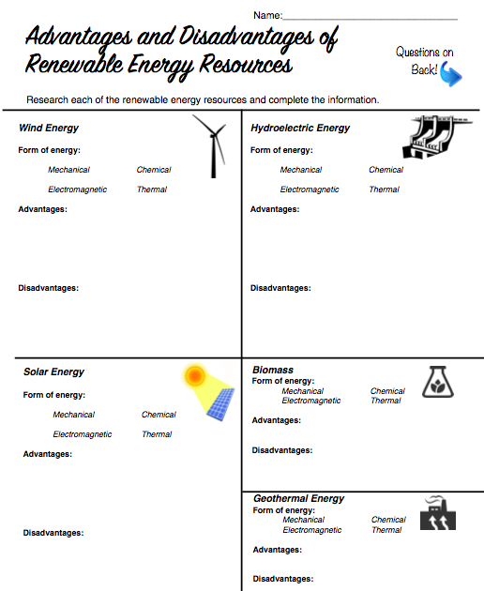

Answers may vary-
Unreliable
Threat to Wildlife
Noise Disturbance
Answers may vary-
Efficient
Long Lasting
No Fuel Source Needed

Can release harmful gases
Loud
High start up costs
Answers may vary:
Inexhaustible Fuel Source
Min environmental impact
Available Around the World

Can contribute to global warming
Expensive
Small net loss of energy
Answers may vary-
Expensive to build
People in region can lose houses to flooding
Wildlife can be impacted negatively
Answers may vary:
Clean and renewable
Cheap
Easily Stored
Works on large scale

Answers may vary-
Renewable
No fuel cost
No harmful gases produced
Little Installation Space Used
Answers may vary-
Expensive
Cannot be harnessed 24/7
Answers may vary-
No harmful emissions
No Noise
No Fuel Use

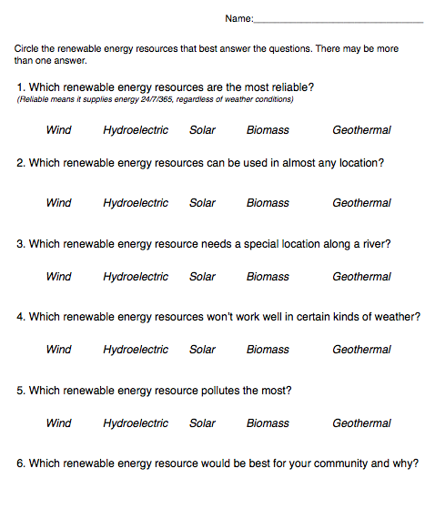
Answers may vary for each question.
Answers may vary.

Activity 2: Building Your Own Renewable City

Directions: Create/build a city with housing, jobs, people, etc. on graph paper. Follow the rules provided on the activity. After completion of the city, use various left over recyclable materials and create renewable energy on another sheet of paper or tag board. This can be 3D.Ex: use egg carton to create a windmill, plastic tub to create a hydroelectric dam, etc. Consider all of the various types of renewable energy resources and implement them into your designed city. Creativity and imagination need to be applied to create a visual representation of your town.
Picture examples of previous cities are provided to give you an example to get your brainstorming started.

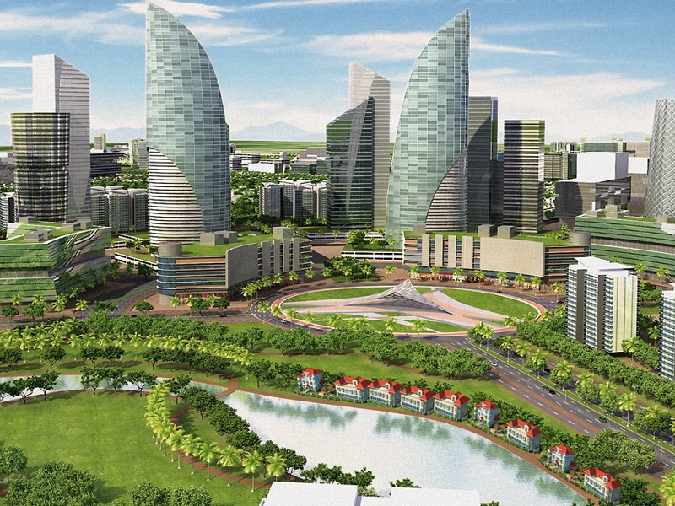
Materials:
graph paper
colored pencils
recyclable materials-
egg/milk cartons
plastic containers
old maps
tin foil
pipe cleaners
etc.
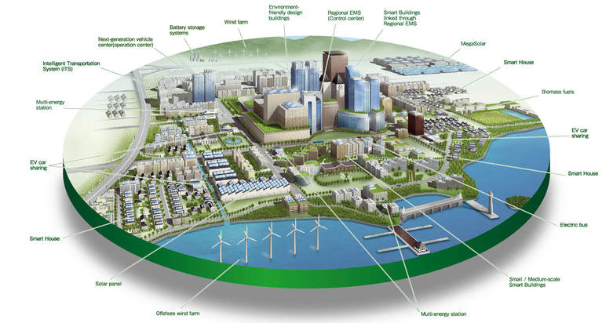

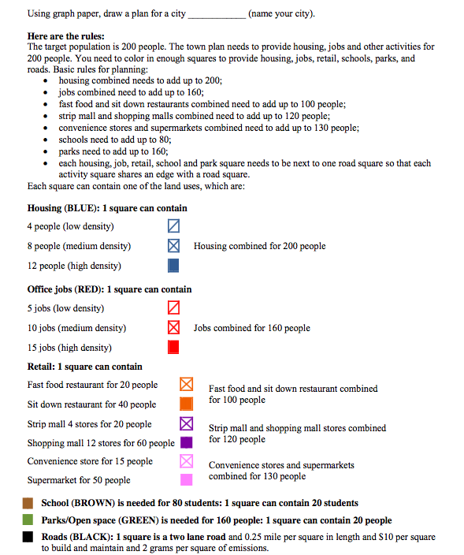

Picture Examples of Previous Projects
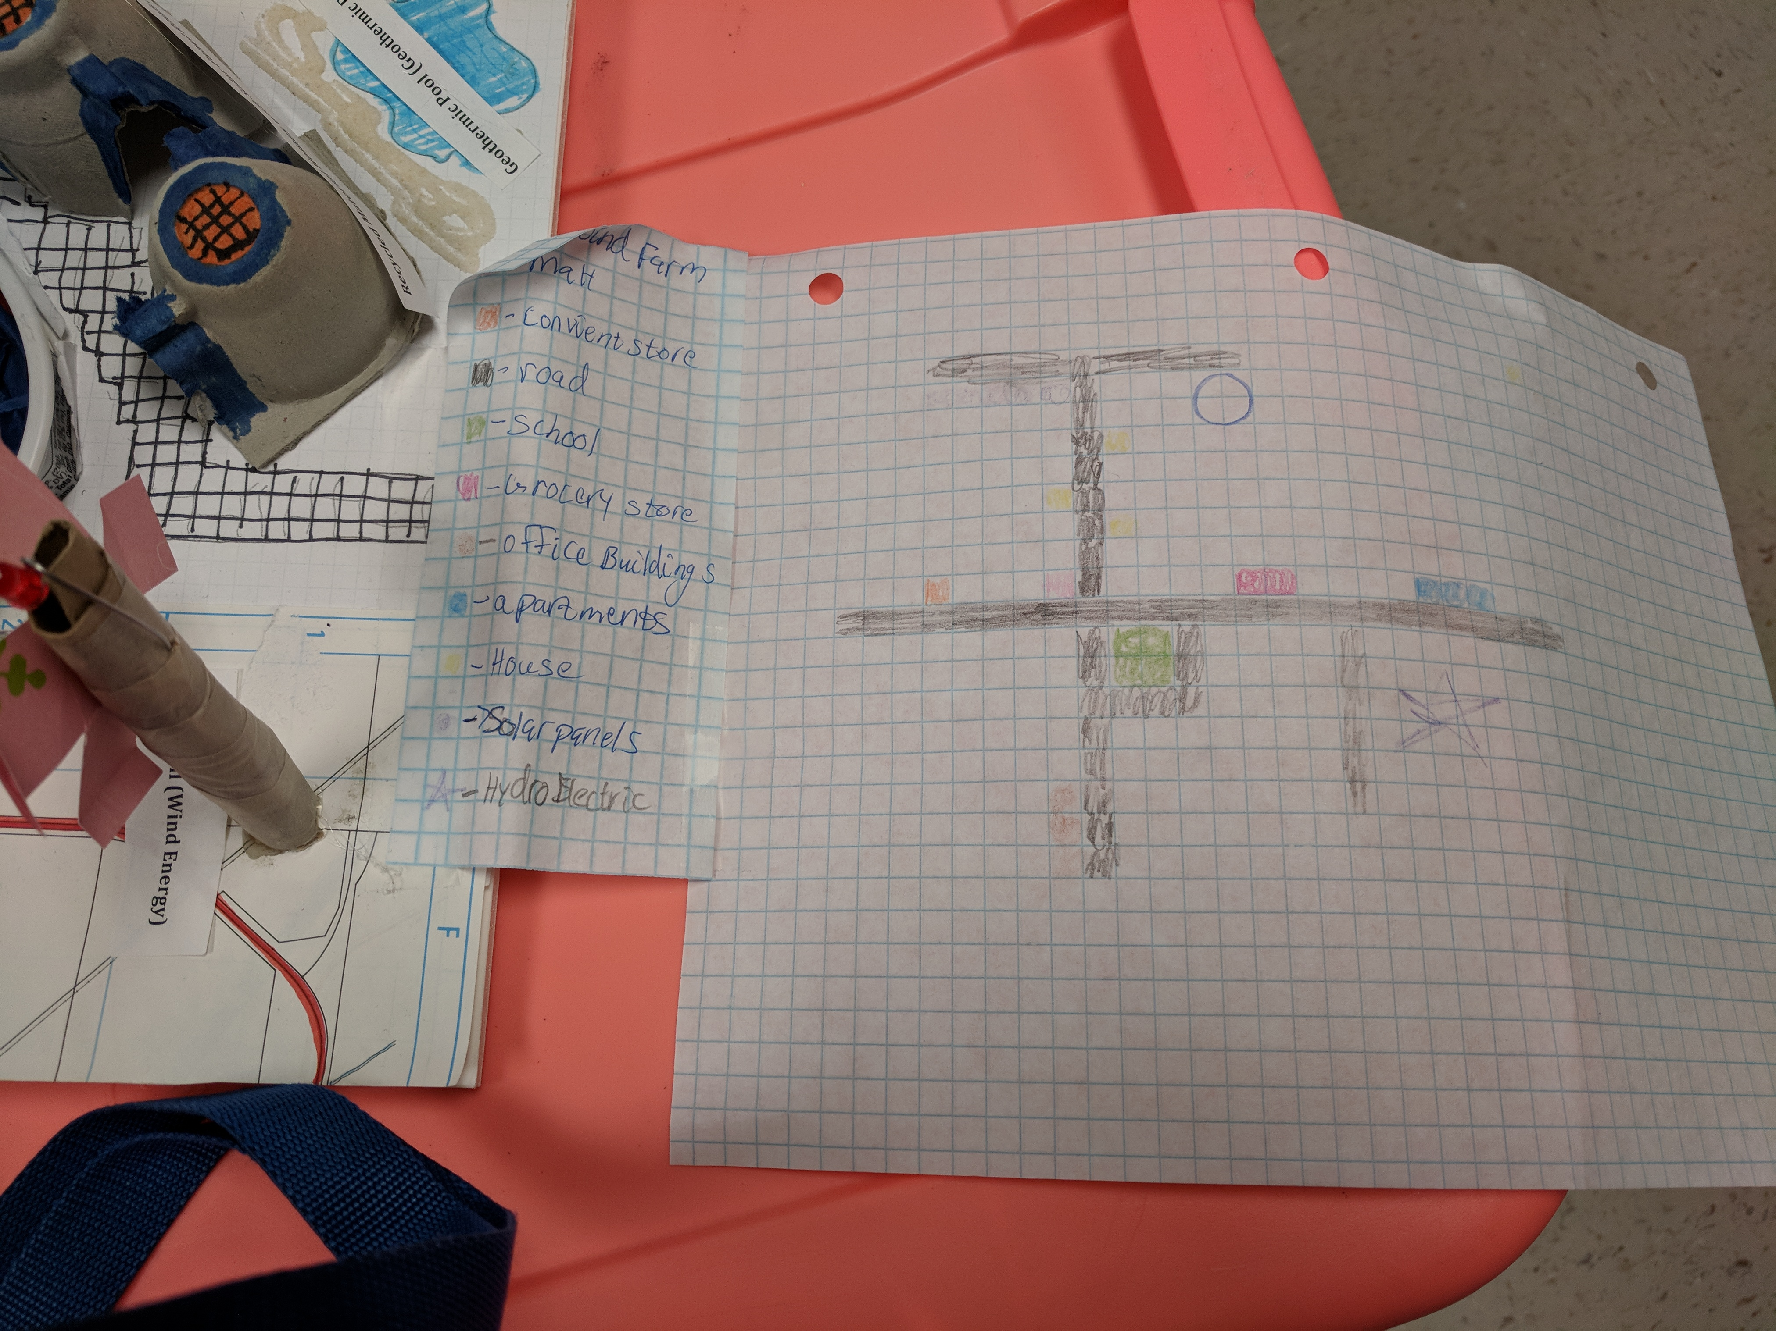

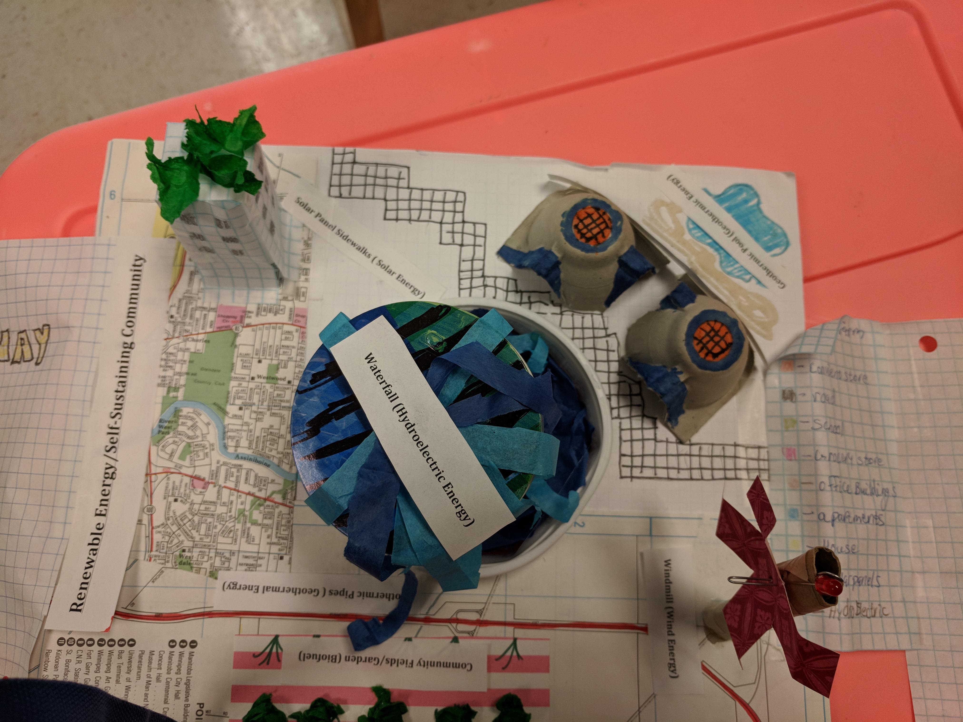

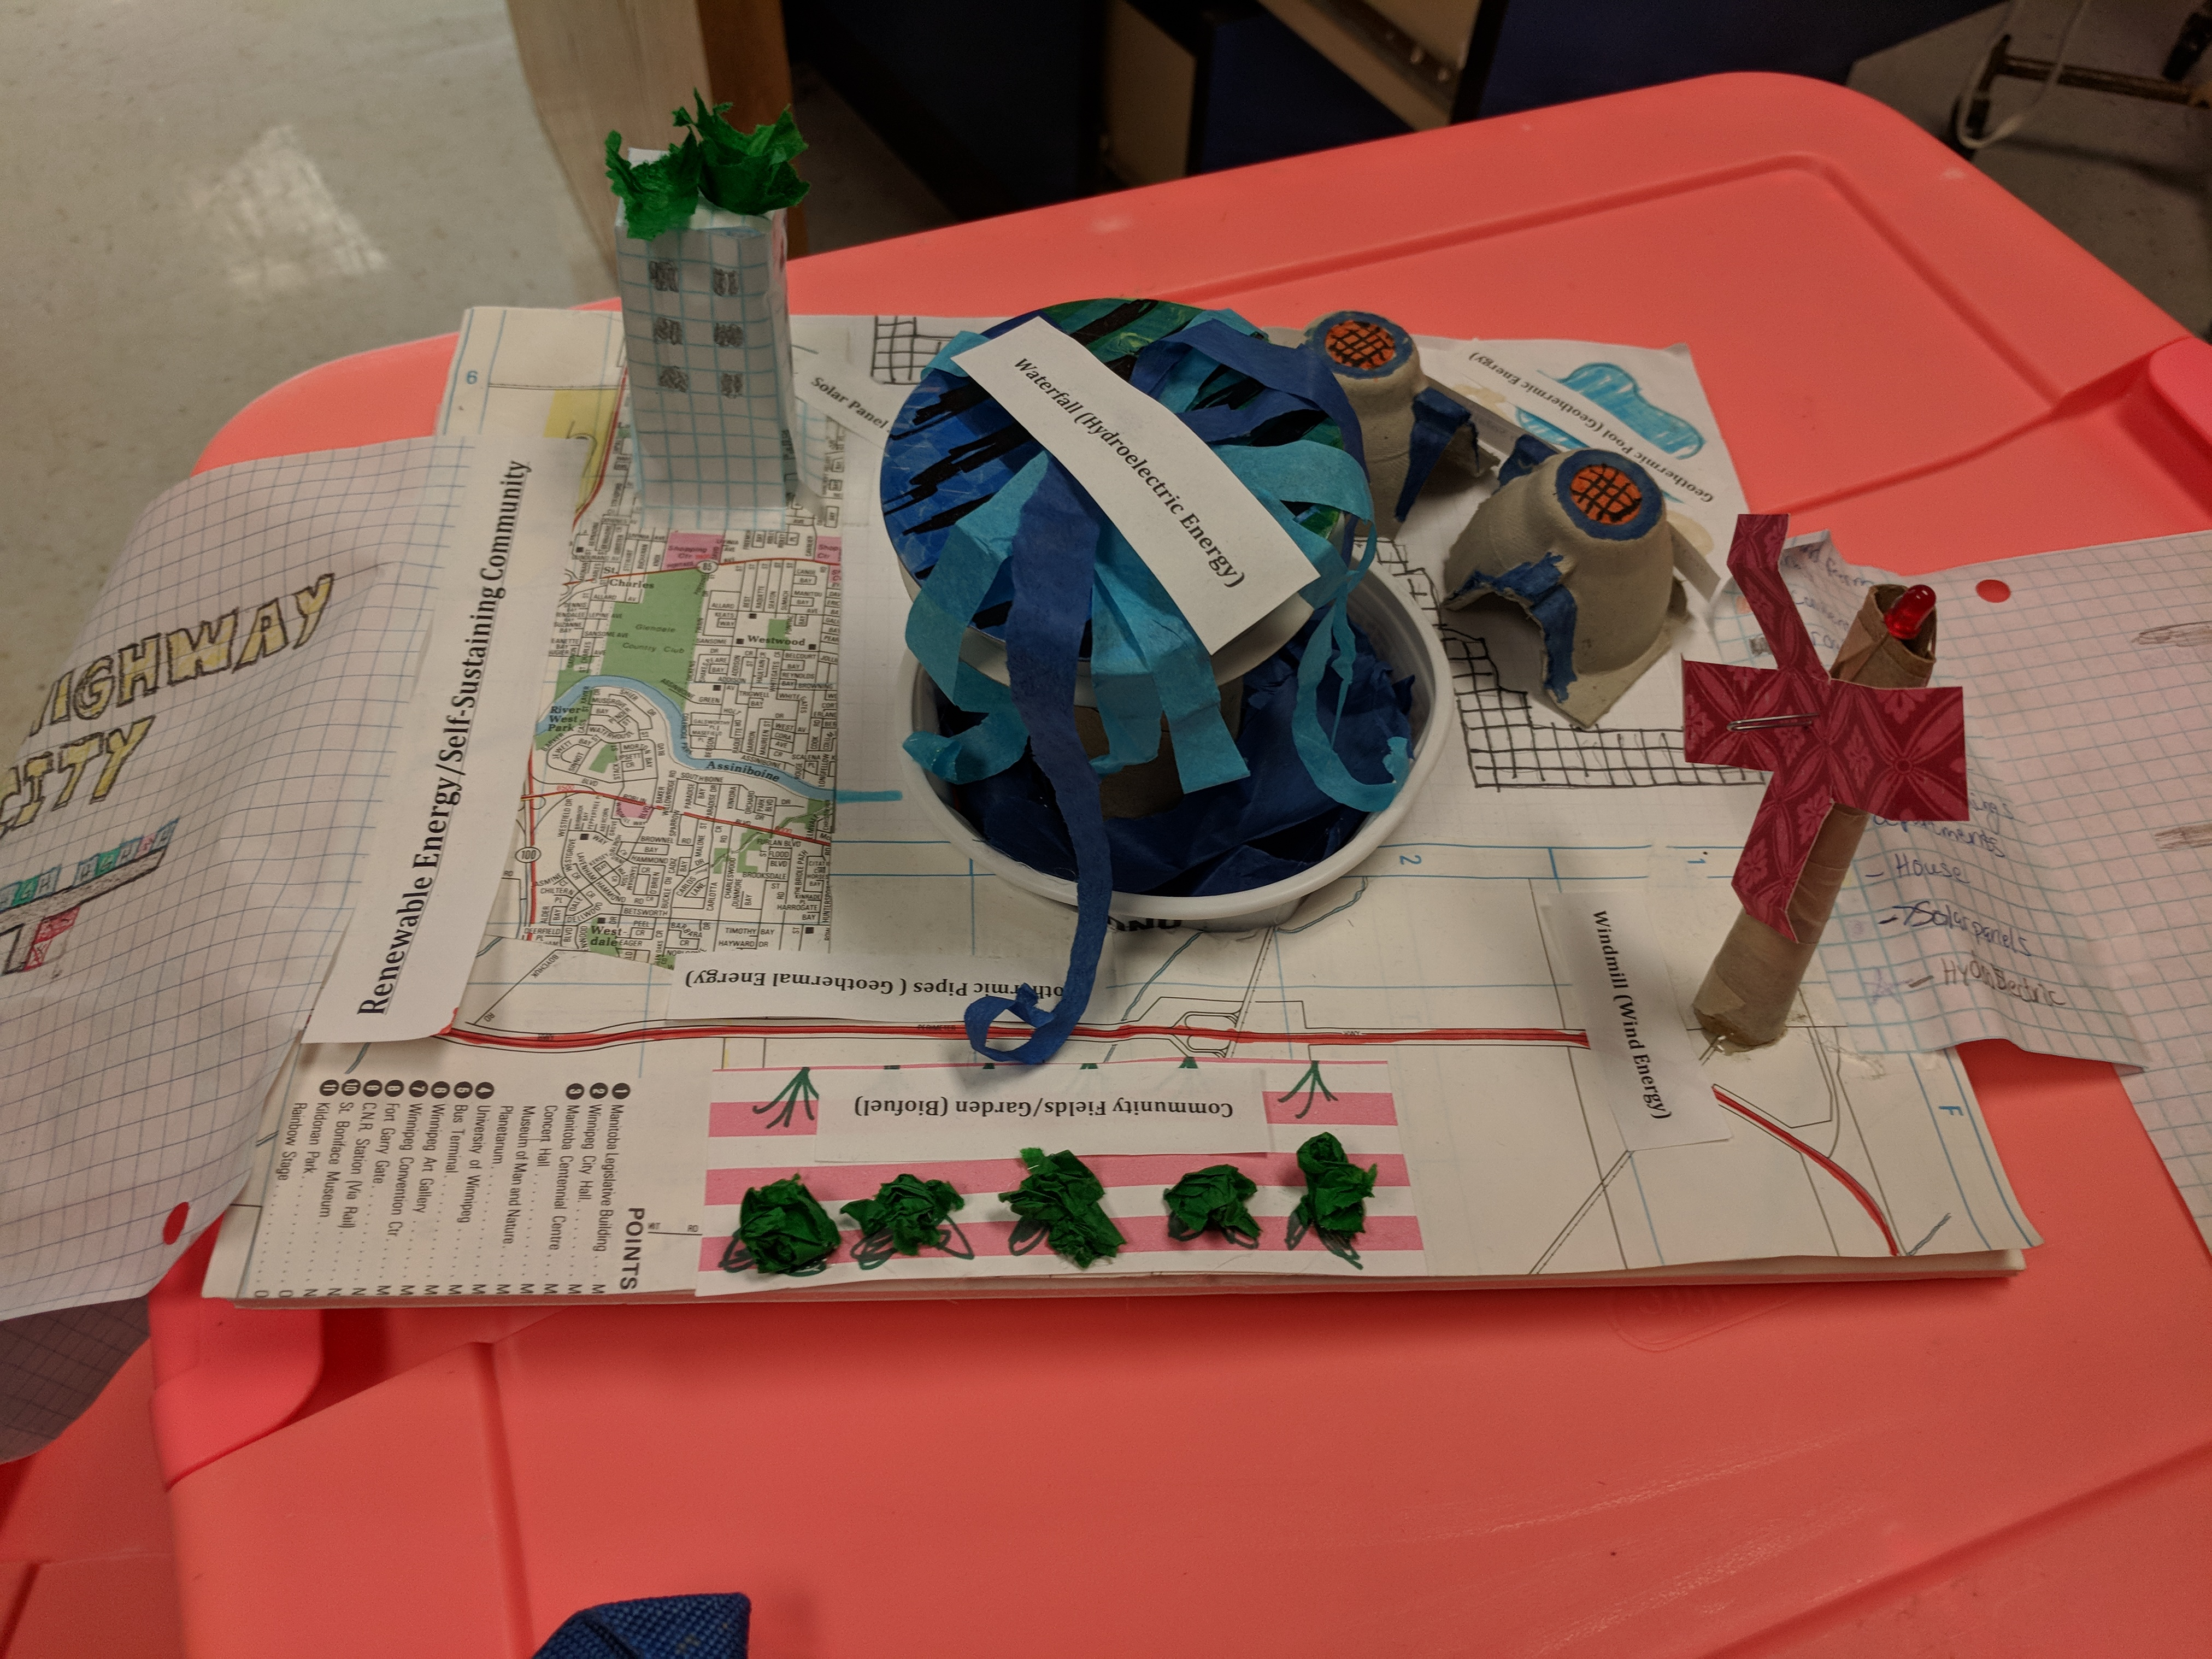

Activity 3
Which has more heat energy: Vegetable Oil or Petroleum Oil?
(*Optional- if time allows)

Materials:
vegetable oil
#20/#30 automobile Oil
2 Pieces cotton clothesline, 3 cm each or similar substitute
glass eyedropper
thermometer
matches (teacher’s discretion)
tin can
paper clips
metric measuring cup
styrofoam cup
wire coat hanger or ring stand

Directions:

1.) Prepare your experiment like the following:
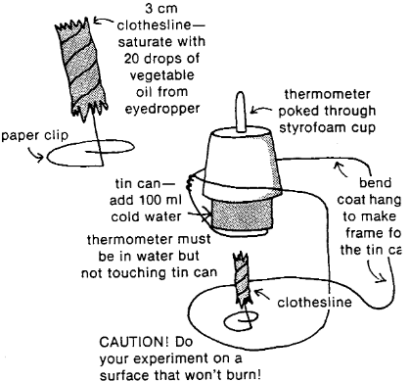

2.) Which do you guess has more heat energy?

______Anwers may vary.________

3.) Measure the temperature of the cold water and record. Light the oil on the clothesline and let the oil burn completely. Record the water temperature.

4.) Run the experiment again using automobile oil. Record the water temperature and compare results.

Types of Oils Tested | Temperature of Cold Water | Temperature After Burning | Difference in Temperatures
Vegetable Oil | Answers Vary | Answers Vary | Answers Vary
Automobile Oil | Answers Vary | Answers Vary | Answers Vary

Would vegetable oil be a good substitute for petroleum oil as fuel? Explain your reasoning. Discuss among your peers.

Answers may vary.

Taking Further Steps:

*Try different kinds of oils (peanut, olive, safflower, etc.) to see if they have different heat contents.

Types of Oils Tested | Temperature of Cold Water | Temperature After Burning | Difference in Temperatures
Peanut Oil | Answers Vary | Answers Vary | Answers Vary
Olive Oil | Answers Vary | Answers Vary | Answers Vary
Safflower Oil | Answers Vary | Answers Vary | Answers Vary

Is there a difference in the heat content of solid animal fats (such as lard) and vegetable oil?
Answers may vary.

Where does the energy stored in the oils originally come from?

It comes from the sun---thermal energy.

