All About Winter Weather
NATURE Sunday Academy 2019-2020

Project Description:
Students will investigate the properties and characteristics of winter hazards such as blowing snow and blizzards that impact the region.

Project Objectives:
Students will learn:
- Basics about interpreting weather maps
- The types and properties of winter storms that impact the region
- Why the region is the blizzard capital of the United States
- Characteristics of snowflakes and what conditions determine their properties.
- How optical phenomena like halos and sundogs form
- Impacts of blizzards and snow on the region

Session Organization:
11:00-11:30 Cultural connection/brief introduction (PowerPoint)
11:30-12:00 Blowing Snow Tank / Snowfall Measurements
12:00-12:45 Lunch
1:00-1:45 Weather Patterns that cause blizzards
1:45-2:30 Snowflakes and optical effects
2:30-3:00 Wrap up

ND State Science Standards:
K-ESS2-1: Use and share observations of local weather conditions to describe patterns over time.
K-ESS3-2: Ask questions to obtain information about the purpose of weather forecasting to prepare for and respond to weather.
3-ESS2-1: Represent data in tables and graphical displays to describe and predict typical weather conditions expected during a particular season.
MS-ESS2-5: Use data to provide evidence for how the motions and complex interactions of air masses results in changes in weather conditions.
HS-ESS2-2: Analyze geoscience data to make the claim that one change to Earth's surface can create feedbacks that cause changes to other Earth systems.
HS-ESS3-1: Construct an explanation based on evidence for how the availability of natural resources, occurrence of natural hazards, and changes in climate have influenced human activity.

Materials and Equipment:
- Worksheet including example weather patterns from historical blizzard events.
- Activity 1: aquarium, bucket, fake snow, ruler, hand-held fan, obstacles for tank.
- Activity 2: None needed.
- Activity 3: Prisms, 3d-printed snowflakes, flashlight.

Activity I: Blowing Snow Tank
PowerPoint slides 5-8

Step 1. Feel the two types of fake snow.
How are they dissimilar?

Which type do you think is more likely to blow?

What type would make a better snowball?

Step 2: Use the fan and attempt to blow the snow in the buckets.
Was your intuition correct? Why or why not?

Step 3: Level the snow in the tank and place objects. Making sure the lid is in place, use the fan to blow the snow around. Once it has drifted, stop.

Step 4: Use a ruler and take a measurement of snowfall.
What range in snowfall was observed? What is truth? (Observations will be written on the board)

Activity II: Blizzards and Weather Patterns
PowerPoint slides 10-20
Activity 2 - Part 1 - Weather Basics:
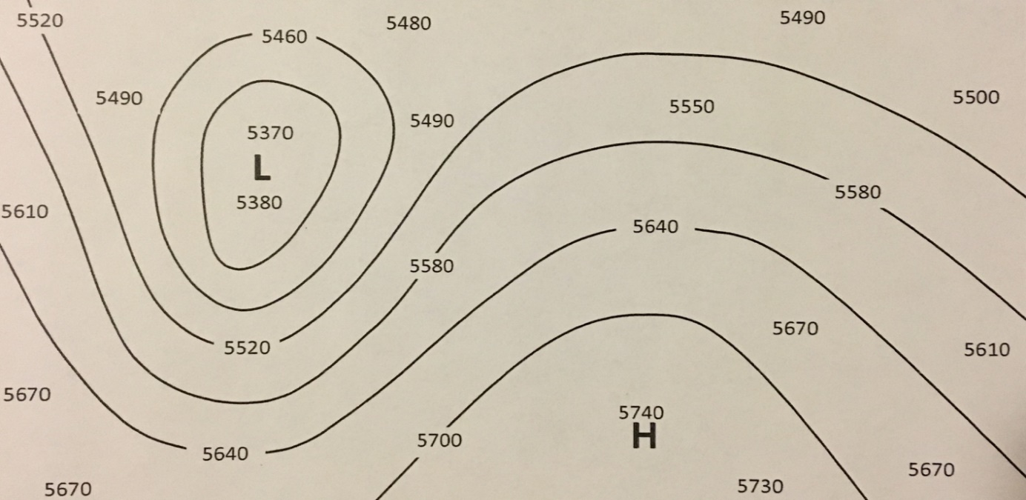
A
E
D
C
B
F
- Locate these features on the chart above. Larger numbers indicate higher pressure.
High Pressure System _______ Area of fastest Winds ______
Low Pressure System _______ Area of slowest Winds ______
Trough _______ Ridge ______

- In the image above, what type of flow pattern is the jet stream: Meridional or zonal? ________
L

- Locate the cold and warm front in the above low pressure system. Shade where you would expect snowfall.

Cultural Activity (PowerPoint Slide 21)
Discuss weather stories or legends that you have heard while growing up. How do these relate to the discussed weather patterns?

Activity 2 - Part 2 – Blizzard Identification
PowerPoint Slides 22-31
Using the weather maps attached at the end of the worksheet, circle the type of blizzard for each case.
Case 1: Colorado Low, Arctic Front, Alberta Clipper

Case 2: Colorado Low, Arctic Front, Alberta Clipper

Case 3: Colorado Low, Arctic Front, Alberta Clipper

Which case most likely had the most snowfall associated with it? ________________

Which case may have occurred with blue skies overhead? ________________

Which type of event was the Children’s Blizzard? ________________

Winter Weather Safety (PowerPoint and discussion)
PowerPoint Slides 32-36

Activity III: Snowflakes and Optics
PowerPoint Slides 38-45

Activity 3 - Part 1 – Crystal Matching
Step 1: Investigate the shapes of the 3-D printed ice crystals
Step 2: Match them to the appropriate type to the table below:
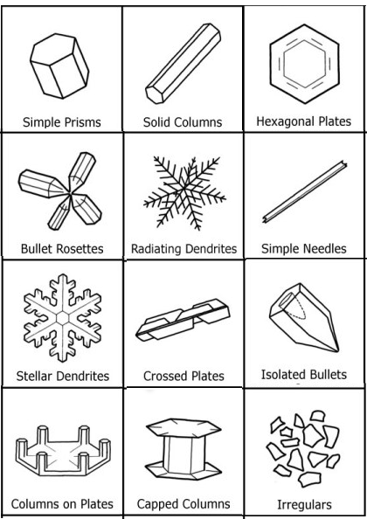

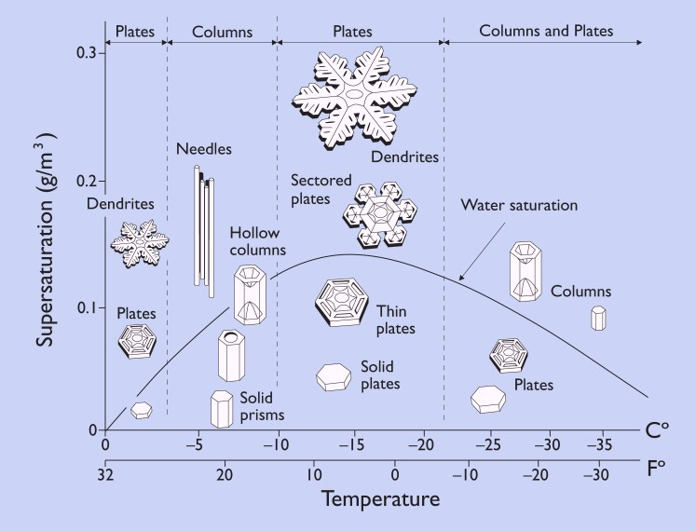
More humid
Less humid
Warmer
Colder
- What snowflakes occur when it is less humid and around 20 F?

  - Are these snowflakes good for snowballs?

  - What type of blizzard may these snowflakes occur with?

- What snowflakes occur when it is less humid and around -10 F?

  - Are these snowflakes good for snowballs?

  - What type of blizzard are these snowflakes in?

- What snowflakes occur when it is more humid and around 0 F?

  - Are these snowflakes good for snowballs?

  - What type of blizzard are these snowflakes in?

- What snowflakes are the most common?

- What are the snowflakes called that stick together?

Activity 3 - Part 2 – Winter Optics
Use prisms and lights to create optics.

1. How does the angle of light impact the optical phenomenon?

2. How is color separated?

Wrap-Up & Discussion:
1. How were the concepts of STEM used in today’s activity?
2. What was the most successful idea you used in the activity?
3. What did you try in the activity that did not work?
4. Why do think it did not work?

