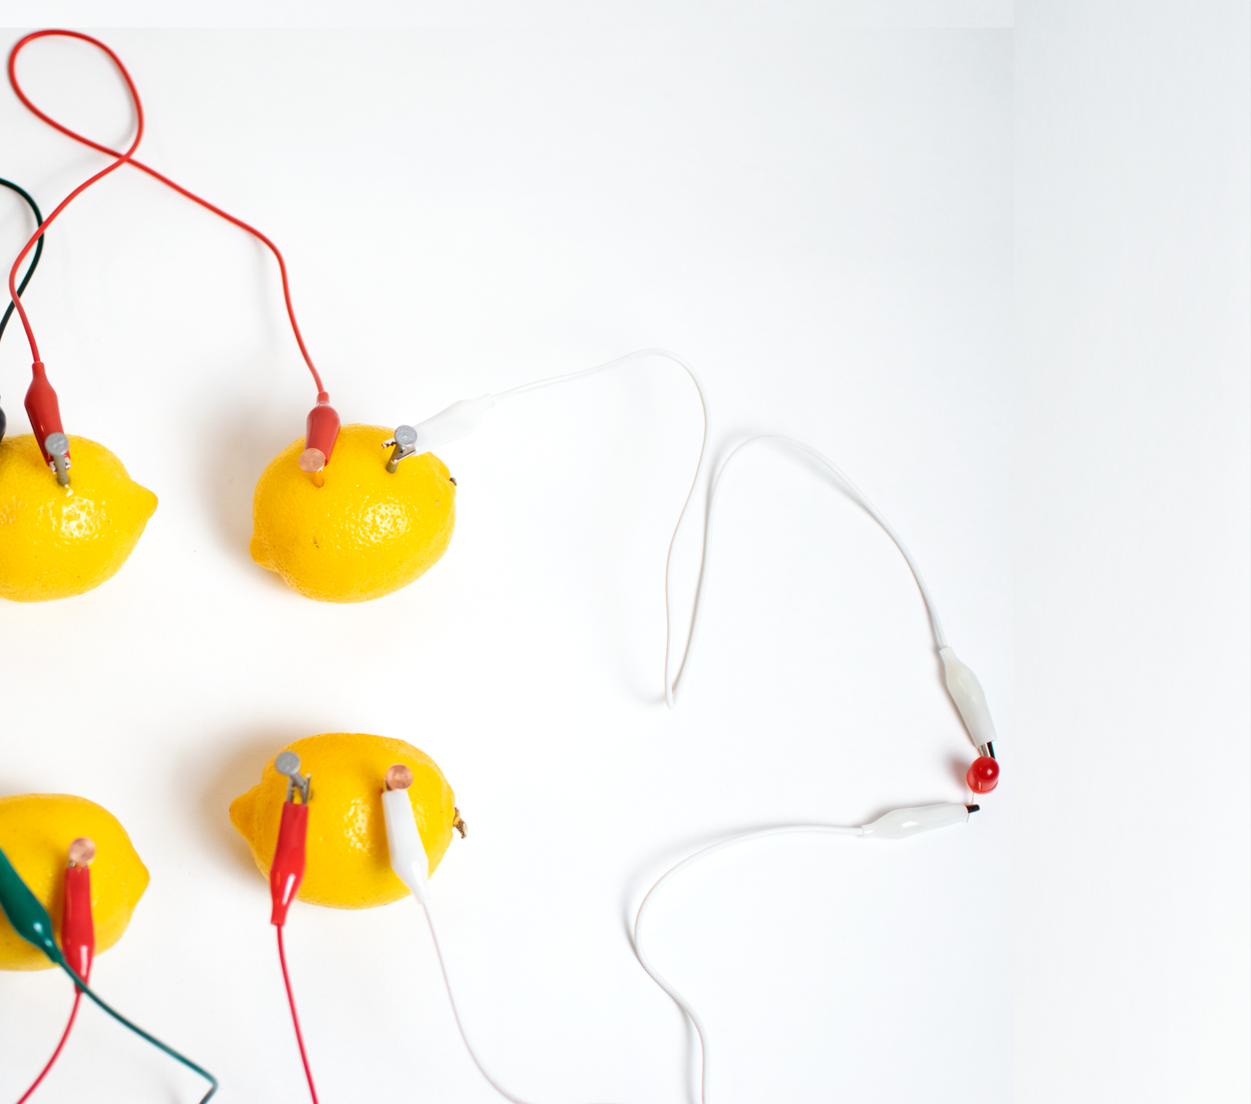



­­

Lesson plan and more resources

are available at: aka.ms/hackingstem

Lemon battery & switch

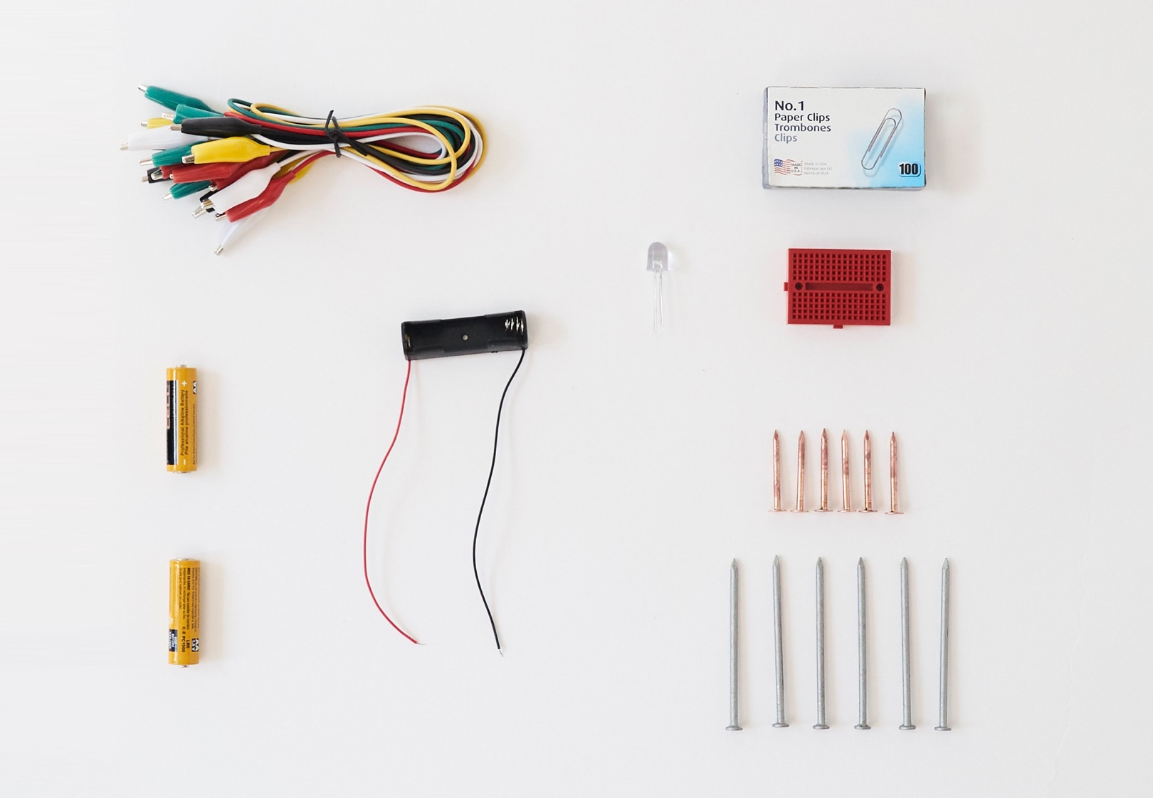

|  |
| --- |
|  |
| Things You’ll Need |

**Materials**

6 jumbo yellow lemons

6 zinc nails

6 copper rod/nail

7 alligator clips

1 5W LED

100 paperclips

1 breadboard

2 AA batteries

1 AA battery holder

**Substituting materials**

Similar items can be substituted/hacked for most materials, according to availability and the student design process.

Please note that this activity will require adult supervision.

Assemble the battery

|  |  |  |
| --- | --- | --- |
|  |  |  |
| **1** | Puncture six lemons with a zinc nail and a copper rod as shown. |  | **2** | Orient your six lemons into 2 rows. |
|  |  |  |
|  |  |  |
| **3** | Connect one alligator clip to a nail and a LED at the other end of the alligator clip. |  | **4** | Connect another alligator clip to a copper rod of the next lemon in the row below. Then connect the other end of the alligator clip to the LED. |
|  |  |  |
|  |  |  |
| **5** | Connect the nail of this lemon to the copper rod of the next lemon over. |  | **6** | Continue connecting nails to copper rods, bridging all the lemons until you return to the first lemon you started with. Your battery is now complete and your LED will light up. |

Design Challenge!

**Design statement**

Your goal is to design a switch for a lemon battery powered LED to conserve energy.

**Constraints**

These constraints set the parameters for your mitigation prototype design:

* Use only materials provided by your teacher. This includes:

**Provided for you**

* Paper clip
* Mini breadboard
* Battery pack with 2 AA Batteries (backup power supply substitute for lemon battery)
* Additional resources provided by your teacher.

**Provided by you**

* Any other available resources at your table allowed by your teacher

* Your switch should interact with your lemon battery system to enable users to turn an LED off and on
* Your switch should remain sturdy after prolonged use

**Off**

**On**

Light

Light

Power source

Switch

Power source

Switch

