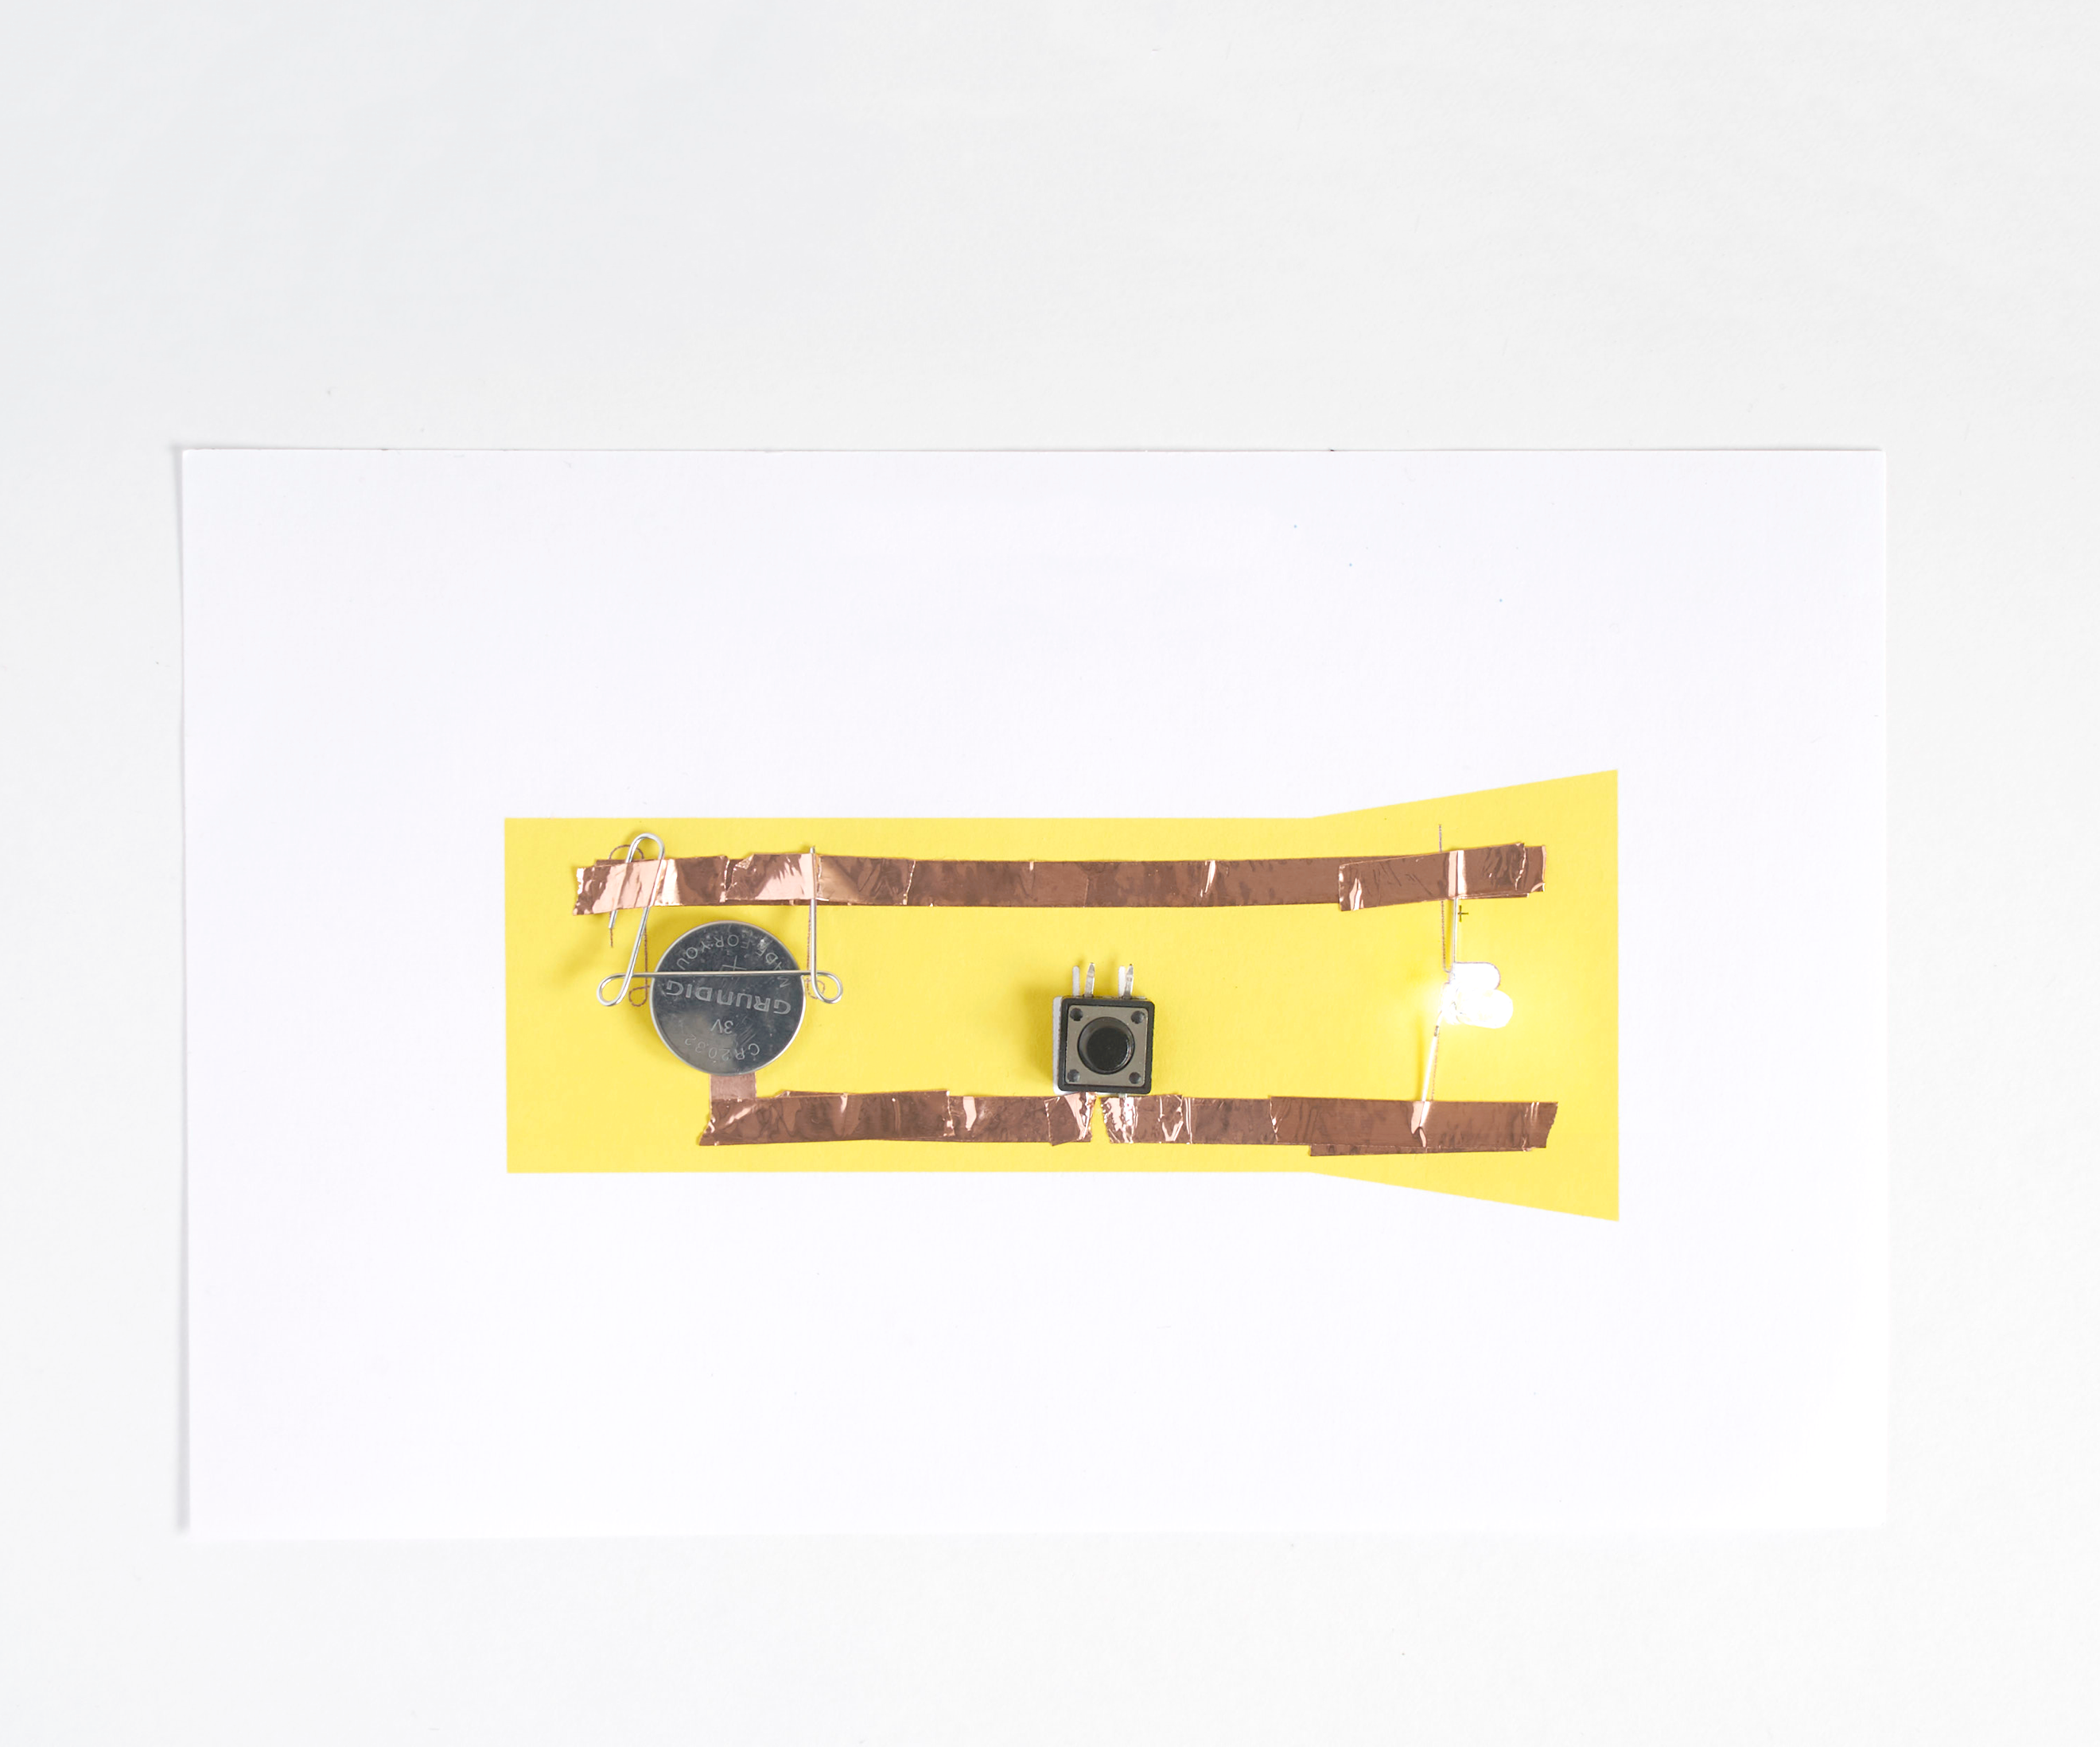



Lesson plan and more resources

are available at: aka.ms/hackingstem

Flashlight

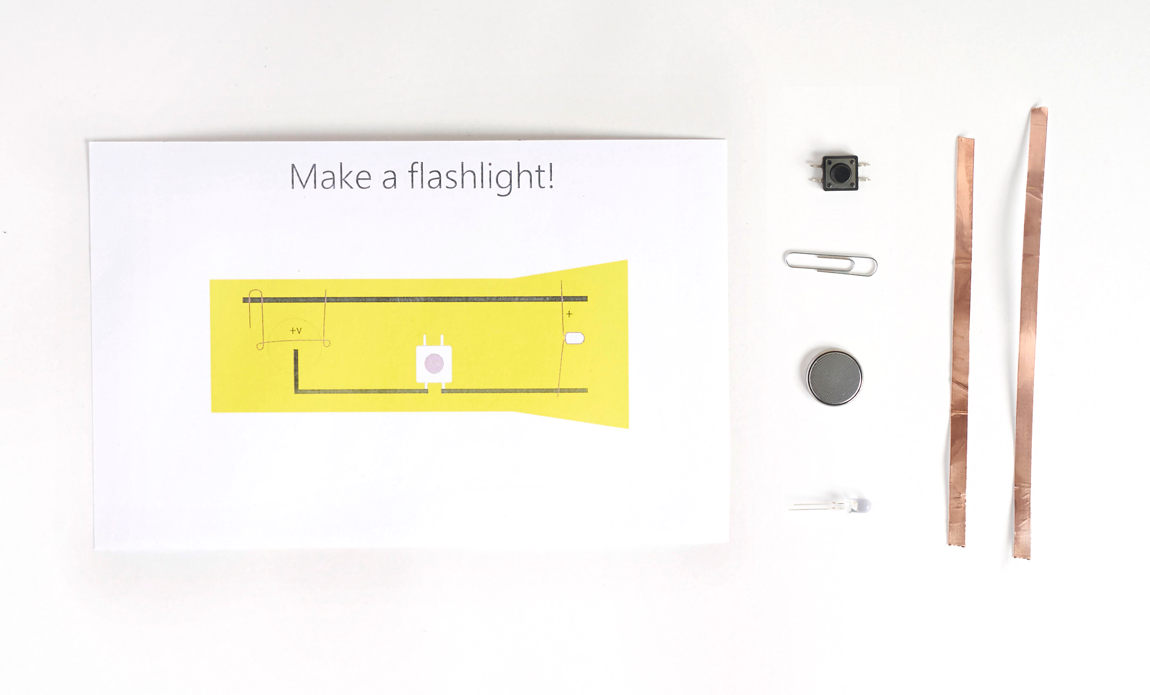

|  |
| --- |
|  |
| Things You’ll Need |

**Materials**

1 flashlight diagram (pg. 7)

1 button switch

1 coin cell battery

1 LED light

1 paper clip

2 strips of copper tape (must make a cut at the switch)

**Substituting Materials?**

Similar items can be substituted/hacked for most materials, according to availability and the student design process.

Please note that this activity will require adult supervision.

Fold copper tape to make corners

The key to making successful circuits with copper tape has a lot to with how good the connections are between LEDs, paperclips and switch contacts with the tape. Folding the tape is the best way to do this rather than laying on multiple strands of tape to make the turn.

|  |  |  |
| --- | --- | --- |
|  |  | /Users/brycehenthorn/Microsoft/Cassie Klingler - Hacking STEM design/Lesson Plans/Bite-sized/HackingSTEM_flashlight_2017_06_08 Folder/Links/Fold-2.png |
| Before you remove the tape backing, hold your tape with both hands and create a right angle in the tape by folding it back onto itself. | | |

|  |  |  |  |  |  |  |  |  |  |  |  |  |
| --- | --- | --- | --- | --- | --- | --- | --- | --- | --- | --- | --- | --- |
| |  |  |  |  |  | | --- | --- | --- | --- | --- | |  |  |  |  |  | | Bend the paperclip upwards as shown in the photos above. This will give your battery a secure connection. | | | | | |  |  |

Make the flashlight circuit

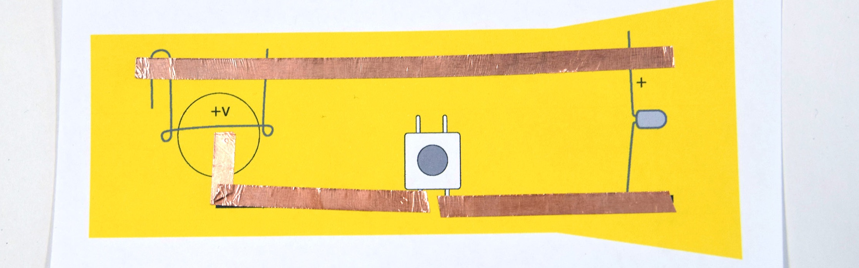

**1 |** Lay down the copper tape on the flashlight diagram along the dark lines. Be careful not wrinkle the copper tape too much or it may obstruct the connection.

|  |  |  |
| --- | --- | --- |
|  |  |  |
| **2** | Place the paper clip on your circuit diagram. |  | **3** | Tape down the ends with copper tape. |
|  |  |  |
|  |  |  |
| **4** | Flatten the switch tabs by pushing down then place it on the diagram with the legs touching the copper tape. |  | **5** | Tape down the switch legs with copper tape. |

|  |  |  |
| --- | --- | --- |
|  |  |  |
| **6** | Bend the legs of the LED apart and place on circuit diagram. Connect the longer leg of the LED to the positive (+) side of the circuit. |  | **7** | Tape down the LED with copper tape. |
|  |  |  |
|  |  |  |
| **8** | Place the battery under the paper clip. |  | **9** | Press the button to turn on your flashlight! |

🔍 **Troubleshooting**

If the LED is not lighting check the following:

* Make sure the LED is properly oriented. Try flipping it around.
* Make sure the battery is secure and that the paper clip is held securely.
* Sometimes the overlaps of copper tape need a little more pressure to make contact. Try running over them with a pen or your finger.

Start with the flashlight diagram

