The Math and Science of
Advertising Claims
2015-16 NATURE Sunday Academy
(Instructor Version)

Advertising is a form of marketing communication used to persuade an audience (you) to take or continue some action, usually with respect to a commercial offering. Most people believe that they are not influenced by advertising claims and that they make their buying decisions based on their needs, not the advertisement. That is what the advertisers what you to believe. It is shown that well designed advertisements can have dramatic effects on what products are purchased.

A well designed advertisement gives you the impression that their product is superior to the others when in reality, most products are identical. If a product is truly better, it will say so and prove it. There is a narrow line between truth and falsehood in the careful choice of words used by advertisers. Since most products are identical, advertisers spend the majority of their budget trying to convince you to buy their brand. These identical products are called parity products.

Better vs. Best – Most products claim they are the best and they are probably true. Since most products are parity products and are essentially identical that means that they are all the best and no one is better that the other. If a product is truly better that means that is actually superior to the other products and it will offer some evidence that this is true.

There are a variety of techniques that advertisers use to try to convince you to spend your hard earned money on their product and not another brand. These will be covered in the Introductory Powerpoint and Activity 1.

TimeLine:
11:00 – 11:30 Cultural Connection
11:30 – 12:00 Intro PowerPoint
12:00 – 12:30 Lunch
12:30 – 1:00 Activity 1 – What Advertising Claim is Used?
1:00 – 1:15 Activity 2 – The More Cheese Sauce Claim
1:15 – 2:00 Activity 3 – The 50% Stronger Claim
2:00 – 2:30 Activity 4 – The Oreo Test Claim
2:30 – 3:00 Activity 5 – The Paper Towel Claim

ND State Standards Addressed:
9-10.1.1 Explain how models can be used to illustrate scientific principles
9-10.1.2 Describe the interaction of components within a system
9-10.1.4 Describe the relationship between form and function
11-12.1.1 Explain how scientists create and use models to address scientific knowledge
9-10.2.1 Explain how scientific investigations can result in new ideas
9-10.6.1 Use appropriate technologies and techniques to solve a problem

Materials List (Groups of 3 except Activity 1 individually)

Activity 1
None

Activity 2 (for each group)
1 box Kraft Spiral Macaroni and Cheese
1 box Kraft Cheddar Explosion Spiral Macaroni and Cheese
Scale

Activity 3 (for each group)
10 Puffs Basic Tissues (50% stronger)
10 Kleenex Regular Tissues
Water Dropper
Water
75 Pennies

Activity 4 (for each group)
3 Oreo Regular Stuff Cookies
3 Oreo Double Stuff Cookies
3 Oreo Mega Stuff Cookies
Pieces of tagboard to use as scrapers
Scale

Activity 5 (for each group)
1 Roll of Sparkle full sheet paper towel
1 Roll of Sparkle Big Roll paper towels
Meter stick

Activity 1
What Advertising Claim is Used?

As covered in the Powerpoint, there are 10 different advertising techniques that companies use to try to convince you to purchase their products. They are as follows:

- The Weasel Claim – using words that appear substantial but are really hollow and meaningless
- The Unfinished Claim – claims their product is better but does not finish the claim
- The We Are Different Claim – claims there is nothing like their product
- The Water is Wet Claim – claims there is something true about their product that is true for everyone
- The So What Claim – claims something that is true but gives no advantage
- The Vague Claim – claims that are unclear but use colorful meaningless words
- The Endorsement Claim – claims that a celebrity or authority endorses a product
- The Scientific Claim – claims some scientific proof to sound impressive
- The Complement the Consumer Claim – claims that butter up the consumer
- The Rhetorical Question Claim – claims that require a response from the consumer

Following are a 10 sample advertisements. Match the ad to the claim used. Write the claim name in chart.

1.
8. Fortified with 150% of RDA of Vitamin C.

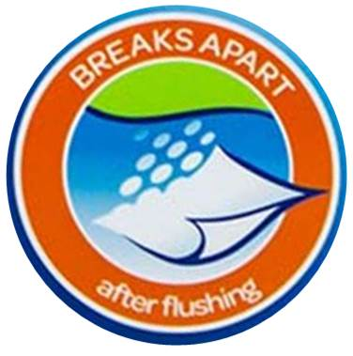
2. Dodge Ram – This isn’t your Grandpa’s Pickup 9.

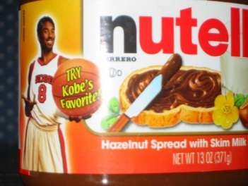
3.

10. You deserve the very best!!

4. Why wouldn’t you give your family Tyson Chicken?
Ad # | Which Claim Is It?
1. | Unfinished Claim
2. | We Are Different Claim
3. | Endorsement Claim
4. | Rhetorical Claim
5. | Weasel Claim
6. | So What Claim
7. | Vague Claim
8. | Scientific Claim
9. | Water is Wet Claim
10. | Complement Claim

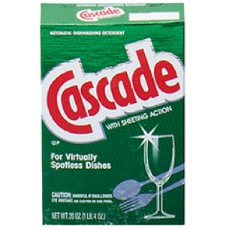
5.

6. Centrum Silver has twice the calcium of regular vitamins.
7.

Activity 2
The More Cheese Sauce Claim?

Some products claim to have more of something than the other products have. This may be true, but how much more is more? Let’s find out.

Kraft Cheddar Explosion Spiral Macaroni and Cheese claims to have more cheese sauce than Kraft Regular Spiral Macaroni and Cheese. In this activity we will measure the amount of cheese sauce powder to verify this claim and then calculate exactly how much more is more.

Procedure (Groups of 3)
- Weigh the amount of cheese sauce powder in Kraft Cheddar Explosion Spiral Mac and Cheese.
Record amount in chart below.

- Weigh the amount of cheese sauce powder in Kraft Regular Spiral Mac and Cheese.
Record amount in chart below.

- Calculate how much cheese sauce powder Kraft Cheddar Explosion has vs. Kraft Regular.
Percent = (weight of Cheddar Explosion/weight of Regular) x 100

Weight of Cheddar Explosion | Weight of Regular | % Cheddar vs. Regular
42.09 grams | 28.60 grams | 147%

Questions

- Does the Cheddar Explosion actually have more cheese sauce powder? yes

- How much more or less cheese sauce powder does the Cheddar Explosion contain? 13.49 grams
Or 47% more

- Do you think there should be some standard Percentage as to how much more should be considered more? Explain. Student’s answers may vary depending on their ideas and views.

Activity 3
The 50% Stronger Claim

When a product claims to be 50% than another product, what does that mean and is it actually 50% stronger?
In this activity we will test one of these claims.

Puffs Basic tissues claim to be 50% stronger when wet than the regular leading brand (which is Kleenex).
Is it really?

Procedure: (Groups of 3)

1. Lay 1 Puffs Basic on a flat surface and place drops of water onto the center of the tissue until you have a damp circle about 3-4 inches around, what a few seconds for the water to absorb.
2. Place 1 penny onto the center of the tissue and try to pick up the tissue by the edges.
3. Continue adding pennies, 1 at a time, and lifting the tissue until the pennies break through the tissue.
4. Record the maximum number of pennies the Puffs tissue held in the chart below.

Repeat the above procedure using the Kleenex tissue. Record the maximum number of pennies the Kleenex tissue held in the chart below.

Calculate the percentage of pennies the Puffs held compared to Kleenex to determine if it actually holds 50% more when wet.

Percent = (# pennies held by Puffs / # of pennies held by Kleenex) x 100
This should be 150% if the claim is true.

# Pennies held by Puffs | # Pennies held by Kleenex | % of Pennies held by Puffs
50-60 pennies | 10-14 pennies | About 500%

Questions
1. Is the Claim true? Yes, the Puffs held about 500% more pennies when wet

2. What do you think the claim “50% stronger when wet” means. Do you think we conducted a valid test of this claim? Explain. Student’s answers may vary depending on their ideas and views.

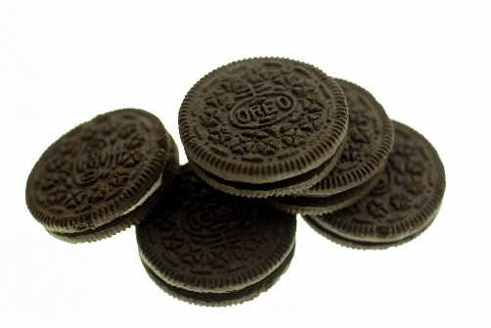
Activity 4
The Oreo Test Claim

Who doesn’t like Oreos right? What is your favorite kind? There are so many flavors of filling not to mention the amount of filling in each. Do you prefer regular Oreos or Double Stuff? How about Mega Stuff? What does Double Stuff mean? What does Mega Stuff Mean? Let’s find out.

In this activity, you are going to measure the amount of filling in regular Oreos, Double Stuff Oreos and Mega Stuff Oreos to determine if the Double Stuff brand actually have twice the filling. Then we will determine what Mega Stuff actually means.

Procedure (Groups of 3)

1. Measure the amount of filling in a regular Oreo cookie. Carefully twist the top cookie off without removing any filling. Using a piece of card stock paper as your spatula, carefully scrap off all the filling from the bottom cookie. Place the filling on a scale and weigh. Record the amount in the chart below.

2. Repeat Step 1 two more times with a regular Oreo to get a larger sample to calculate and record in the chart below.

3. Repeat Steps 1 & 2 with 3 Double Stuff Oreos and record your amounts in the chart below.

4. Repeat Steps 1 & 2 with 3 Mega Stuff Oreos and record your amounts in the chart below.

5. Calculate the average filling weight for each of the 3 Oreo varieties.

 | Cookie #1 | Cookie #2 | Cookie #3 | Average
Regular Oreos | 3.23 grams | 3.16 grams | 3.18 grams | 3.19 grams
Double Stuff Oreos | 6.52 grams | 6.51 grams | 6.64 grams | 6.56 grams
Mega Stuff Oreos | 9.20 grams | 9.02 grams | 10.33 grams | 9.52 grams

Questions

1. Calculate the amount of filling in the Double Stuff compared to the Regular. 205.6 %
Percent = (average weight of Double Stuff / average weight of Regular) X 100
Does the Double Stuff Oreo have twice the filling as a Regular Oreo? Yes

2. Calculate the amount of filling in the Mega Stuff compared to the Regular. 298.4%
Percent = (average weight of Mega Stuff / average weight of Regular) X 100
Based on this calculation, what does Mega mean? About 3 Times More Filling

Activity 5
The Paper Towel Claim

It seems in today’s stores, almost all paper products such as paper towels, toilet paper, etc. claim to come in a larger size than the regular brand or some other brand, but are these claims true.

In this activity, we will test to see if one claim is true.

Sparkle Big Roll paper towels claim to have 133% more paper towels than the regular roll. We will measure each roll to evaluate this claim.

Procedure (Groups of 3)

1. Using the meter stick, measure the total length of the paper towels in the Large roll and record the length in the chart below. (Measure in centimeters)

2. Using the meter stick, measure the total length of the paper towels in the Regular roll and record the length in the chart below. (Measure in centimeters)

 | Length of Roll (cm)
Big Roll | 1694 cm
Regular Roll | 1245 cm

3. Calculate the percentage of paper towels in the Large roll compared to the Regular roll.
Percent = (length of Large roll / length of Regular roll) x 100 136.1% compared to Regular

4. Does the claim hold true that the Big Roll has 133% paper towels compared to the Regular Roll?
YES

