Cellular Biology: The Spectacular Cell
NATURE Summer Camp/Sunday Academy 2021-2022

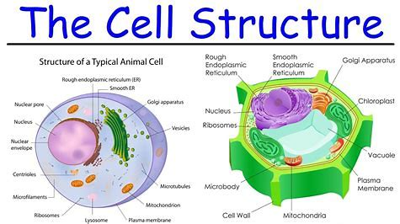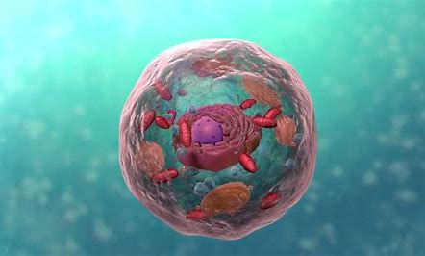

Project Description: Students will perform simple science experiments related to cellular structure and function. Students will have hands-on experience on how to use a microscope and understand the parts of a microscope. They will explore how the study of cells impacts science, technology, engineering and math today.

Project Objectives:
- You will gain a basic understanding of cellular structure and function.
- You will create a 3-D structure of a cell in order to gain knowledge of the function of cellular organelles within a cell.
- You will use the scientific process and method to understand cells and there use in medicine, cancer, stem cell research and genealogy.

Cultural Connection:
Time: (4:47) click on title. Video: What is the Medicine Wheel?
https://www.bing.com/videos/search?q=Teachings+of+the+Medicine+Wheel&&view=detail&mid=1C8EE93735B7227491291C8EE93735B722749129&&FORM=VRDGAR&ru=%2Fvideos%2Fsearch%3Fq%3DTeachings%2Bof%2Bthe%2BMedicine%2BWheel%26FORM%3DVDMHRS

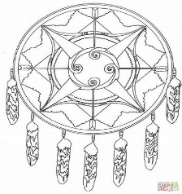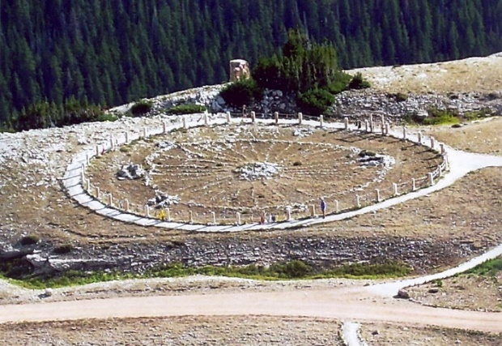

Medicine wheels, or “sacred hoops,” are symbols of harmony, balance, and peaceful interaction among all living beings on Earth. They represent the sacred cycle of life (birth, death, rebirth), its four cardinal directions (north, south, east, west), the elements (air, water, fire, earth), as well as connecting points for Mother Earth and Father Sky and a final point, the center, representing ourselves and how we connect with all of these elements. The basic idea of how we exist as living beings and described by indigenous peoples is similar to how a single cell functions within a living organism with the nucleus at the center connecting all of the working parts.

North Dakota State Standards:

HS-LS1-1 Construct an explanation based on evidence for how the structure of DNA determines the structure of proteins which carry out the essential functions of life through systems of specialized cells.

HS-LS1-2 Develop and use a model to illustrate the hierarchical organization of interacting systems that provide specific functions within multicellular organisms.

HS-LS1-6 Construct and revise an explanation based on evidence for how carbon, hydrogen, and oxygen may combine with other elements to form large carbon-based molecules.

HS-LS1-7 Use a model to illustrate that cellular respiration is a chemical process whereby the bonds of food molecules and oxygen molecules are broken and the bonds in new compounds are formed resulting in a net transfer of energy.

MS-LS1-1 Conduct an investigation to provide evidence that living things are unicellular or multicellular and may have different cell types.
MS-LS1-2 Develop and use a model to describe the function of a cell as a whole and ways cell parts (organelles) contribute to the cell functions.

Schedule:
- 11:00-11:10 Cultural connection (Video)
- 11:10-11:30 Introductory Power Point Cell Biology
- 11:30-12:00 Activity I Cell Biology Jeopardy
- 12:00-12:30 Lunch
- 12:30-12:45 Activity II Make Your Own Edible Pie Cell
- 1:45-1:00 Activity III Oil & Water Cell Membrane Function
- 1:00-1:15 Activity IV Magnetic Slime Cytoplasm
- 1:15-1:45 Activity V Quick Review:
  - The Microscope (Parts & Functions)
- 1:45-2:15 Activity VI Simple Stain:
  - Animal Cell (cheek) & Plant Cell (Onion)
- 2:15-2:45 Activity VII Central Dogma Transcription & Translation
- 2:45-3:00 Wrap up

Introduction:

Cells are the basic unit of structure and function in living things. Cell theory tells us that cells function to unite and create other living organisms and make cells come from pre-existing cells. Cells are the units that carry genetic information providing information about life itself. The study of cells is important in order to learn about processes such as reproduction, growth, and other specific functions which affect all living organisms. The study of cells branches out into many fields such as biology, biotechnology, medicine, genetics, forensic science, and engineering.

Understanding cellular function is important to the earth and life sciences. The latest news in terms of the importance of studying cells is that they just developed a new gene-therapy technique that transforms human cells into mass producers of Nano-sized particles full of genetic material that has potential to reverse disease. Scientists found a way to make bacteria behave like stem cells and in agriculture they are looking at gene control to reduce the need of herbicides in the killing of weeds in crops. There is a vast amount of technology being used to discover ways to change the world concerning living matter.

Activity I-- Cell Biology Jeopardy
- Instructors: play video Cell Structure (7.21 min.) before you play Jeopardy. https://www.youtube.com/watch?v=URUJD5NEXC8
- Instructors: go over the cell organelles & functions with your students in the handout below.
- Instructors: Jeopardy Board RULES (please practice)
  - Open power point, Slide Show from beginning.
  - When ready click on the amount under the group & it will show the question. The group gets “15 seconds” to answer.
  - If they answer or don’t answer in 15 seconds “click” anywhere on the board to reveal the answer!
  - To go back to the board (click on the house) in the lower right hand corner.
  - The amount will change color and will show that it has been used
  - Keep Score!
  - Tally up the scores once the board is complete & you are ready for Final Jeopardy.
  - Groups must place a “wager” on piece of paper and then they will go onto final jeopardy
  - Final Jeopardy: All groups have to place their answer on the paper before the “song” is finished about 30 seconds. When song is finished hand in your paper to the instructor.
  - Instructors: Show group Score/Wager/Answer and complete scores for winner.

- Student Jeopardy Rules:
  - Instructors split your students into groups however you want. Example: 3 to 5 or 12 and 12 and decide which group will go first, second, third etc.
  - Control of the board: First group gets (15 seconds) to answer
  - The instructor will then “click” on the board to see if you are correct
  - If you are correct, you win the points and you keep control of the board
  - If you are wrong, the board is turned over to the next group until the board is completed.
  - Below is a list of the answers that will be used in the game.

Answers for Jeopardy excluding the Potpourri
1 Cell membrane | 11 Vacuoles
2 Cell Wall | 12 Ribosomes
3 Centrosomes | 13 Plastids
4 Chloroplasts | 14 Peroxisome
5 Cilia | 15 Nucleolus
6 Cytoplasm | 16 Nucleus
7 Chromosomes or Chromatin | 17 Mitochondria
8 Cytoskeleton | 18 Lysosomes
9 Flagella | 19 Golgi apparatus
10 Rough Endoplasmic Reticulum | 20 Smooth Endoplasmic Reticulum

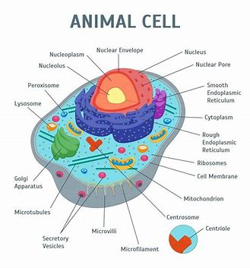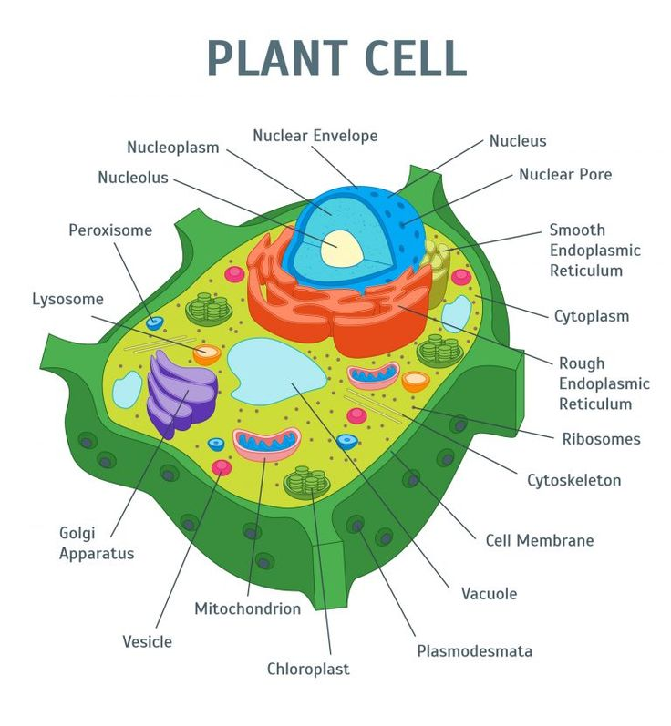

Cell membrane | A double membrane composed of lipids and proteins. Present both in plant and animal cell. Thin covering that protects cell. | Provides shape, protects the inner organelle of the cell and acts as a selectively permeable membrane. Protects the cell, performs active transport and passive transport, moves materials in and out of the cell, communication
Cell Wall | Rigid, tough, made of cellulose | Protects and supports the cell
Centrosomes | Composed of Centrioles and found only in the animal cells. | It plays a major role in organizing the microtubule and Cell division during mitosis
Chloroplasts | Present only in plant cells and contains a green-colored pigment known as chlorophyll. | Sites of photosynthesis.  Captures sunlight and uses it to produce food through photosynthesis, has both a light reaction and a dark reaction center.
Cilia | Small hair-like structures that line cells and beat in rhythmic waves | Assist in movement and locomotion
Cytoplasm | A jelly-like substance, which consists of water, dissolved nutrients and waste products of the cell. | Responsible for the cell’s metabolic activities. Pads and supports organelles inside the cell.
Chromosomes or Chromatin | In the nucleus, made of DNA and protein, contains genes, 23 pairs of chromosomes | Provides instructions for the cells activities, (growth, reproduction) and protein synthesis
Cytoskeleton | Structural support of cells; | facilitates the movement of organelles and adds shape to a cell
Flagella | Appendage that protrudes from the cell body of bacteria or protists | Primary function is locomotion but also is used as a sensory organelle sensitive to chemicals and temperature
Rough Endoplasmic Reticulum | A network of membranous tubules, present within the cytoplasm of a cell. Studded with ribosomes | Forms the skeletal framework of the cell, involved in the production of proteins.
Smooth Endoplasmic Reticulum | A network of membranous tubules, present within the cytoplasm of a cell. Does not have ribosomes | Forms the skeletal framework of the cell, involved in the Detoxification, production of Lipids
Golgi apparatus | Membrane-bound, sac-like organelles, present within the cytoplasm of the eukaryotic cells. | It is mainly involved in secretion and intracellular transport. Packages and secrets proteins for use in and out of the cell
Lysosomes | A tiny, circular-shaped, single membrane-bound organelles, filled with digestive enzymes. | Helps in the digestion and removes wastes and digests dead and damaged cells. Therefore, it is also called as the “suicidal bags”.
Mitochondria | An oval-shaped, membrane-bound organelle, also called as the “Power House of The Cell”. | The main sites of cellular respiration and also involved in storage energy in the form of ATP molecules.
Nucleus | A largest, double membrane-bound organelles, which contains all the cell’s genetic information. Contains DNA. | Controls the activity of the cell, helps in cell division and controls the hereditary characters.
Nucleolus | Small organelle in the nucleus and contains ribosomal RNA | Produces ribosomes
Peroxisome | A membrane-bound cellular organelle present in the cytoplasm, which contains the reducing enzyme. | Involved in the metabolism of lipids and catabolism of long-chain fatty acids.
Plastids | Double membrane-bound organelles. | Helps in the process of photosynthesis and pollination, Imparts color for leaves, flowers and fruits and stores starch, proteins and fats.
Ribosomes | Small non-membrane organelles made of RNA found floating freely in the cell’s cytoplasm or embedded within the endoplasmic reticulum. | Made up of two small subunits involved in the Synthesis of Proteins.
Vacuoles | A membrane-bound, fluid-filled organelle found within the cytoplasm. | Provide shape and rigidity to the plant cell and helps in digestion, excretion, and storage of substances.  Storage tank for food, water, wastes or enzymes

Activity II-- Make Your Own Edible Pie Cell
Rules and Guidelines for edible cell model:
- The model and all cell structures must contain the following structures below for either a plant or animal cell.
- The size of each organelle must be in proportion of each other as they are in the cell.
- Candy will be provided for you and you must use the correct candy & color according to the guide provided.

Materials:
- Small graham cracker pie plates (1 for each student)
- Peanut M & M’s (1 bag)
- Miniature M & M’s (1 bag)
- Pudding cups (1 individual pudding pack for each student, any flavor)
- Life savers (1 for each student)
- Cinnamon red hots (1 for each student)
- Gummy worms (1 for each student)
- String licorice (1 string for each student)
- Small icing tube (any color, 1 tube) for each student who makes a plant cell
Project Candy Guide:
Animal: cell membrane will be graham cracker crust | Plant: cell wall will be graham cracker crust & cell membrane use icing
Cytoplasm: 1 pudding pack  Nucleus: 1 life saver  Nucleolus: 1b cinnamon red hots  Mitochondria: peanut m&m’s orange  Lysosome: mini m&m’s yellow  Vacuole: mini m&m’s blue  Endoplasmic Reticulum: gummy worms  Golgi Apparatus: 1 string licorice  Ribosome: mini m&m red | Chloroplast: mini m&m green  Central Vacuole: peanut m&m blue  **Small icing tube (any color, 1 tube)  For cell wall or cell membrane  Plus everything in the animal cell.

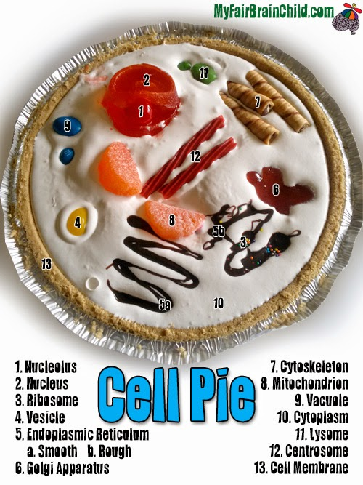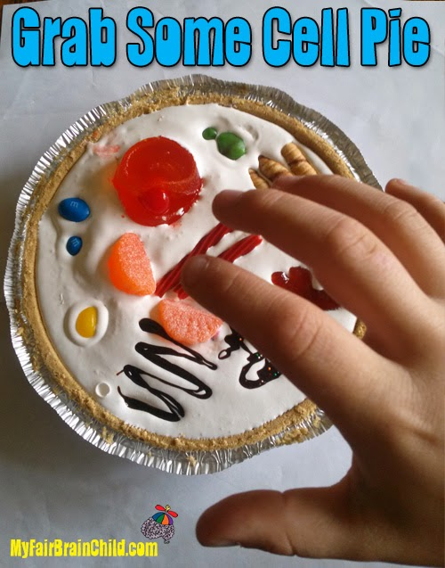

If the model is an ANIMAL CELL it must contain the following organelles: | If the model is an ANIMAL CELL it must contain the following organelles:
- cell membrane  - cytoplasm  - nucleus  - nucleolus  - mitochondria  - lysosome  - endoplasmic reticulum  - ribosome | - cell wall  - cell membrane  - cytoplasm  - nucleus  - nucleolus  - mitochondria  - mitochondria  - endoplasmic reticulum  - ribosome  - central vacuole  - chloroplast

Activity III-- Oil & Water Cell Membrane Properties
Hydrophilic & Hydrophobic properties of a Cell Membrane
The Cell Membrane is a double membrane composed of lipids and proteins. Present both in plant and animal cell. Thin covering that protects cell.

The Cell membrane provides shape, protects the inner organelle of the cell and acts as a selectively permeable membrane.

It protects the cell, performs active transport and passive transport, moves materials in and out of the cell, communication

Hydrophilic means “water loving” which are the phosphate heads of the phospholipid. They face outward the (large pink circles below)

Hydrophobic means “water hating” which are the fatty acid tails of the phospholipid. They face inward the tails attached to the large pink circles below.
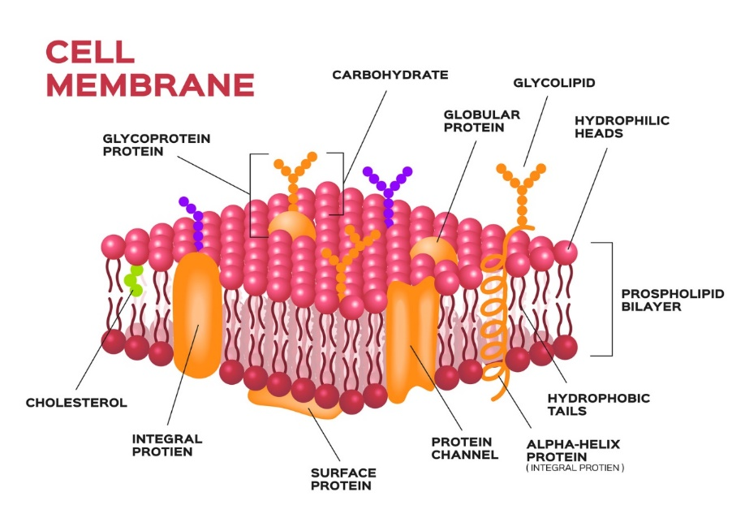

Materials
A pie pan (or similar)
Oil about 1 cup for each student, can be baby oil, cooking oil etc.
Water
Food coloring 2 boxes for the class should contain (red, yellow, green, blue) they can mix for orange & purple.
Pipettes 5 for each student, or one for each color
Dixie Cups 5 for each student

Method
Step 1: Begin by filling a pie plate with oil. You can use baby oil here, but other oils will also work. Set this aside.
Step 2: In a cup combine about ½ cup of water with 3-5 drops of food coloring & mix, using one cup for each color of water that you wish to make.
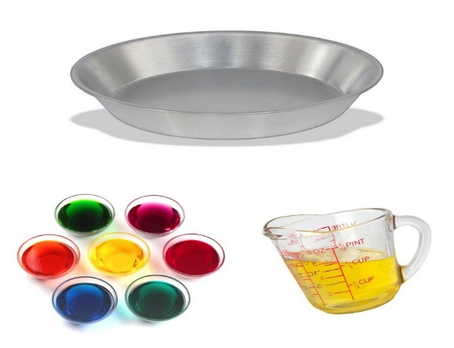
Step 3: Students use pipettes and squirt the varying colors of water into the pan of oil.

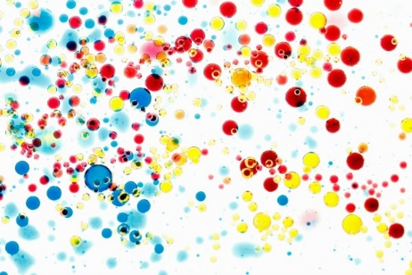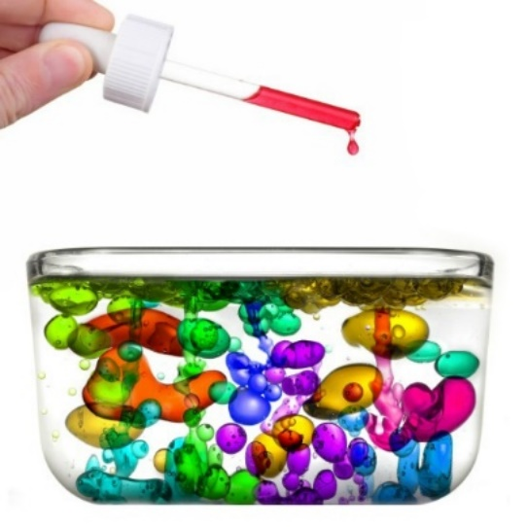

The Science
What did you observe?
What solution was hydrophilic?
What solution was hydrophobic?
Why doesn’t the water mix with the oil?
Answer: Oil is less dense than water. Given the variance in densities the two liquids cannot mix.
Oil and water also do not mix because water molecules are more attracted to each other than to oil molecules.

Activity IV— Magnetic Slime…….. Cytoplasm
A jelly-like substance, which consists of water, dissolved nutrients and waste products of the cell.

Responsible for the cell’s metabolic activities. Pads and supports organelles inside the cell.
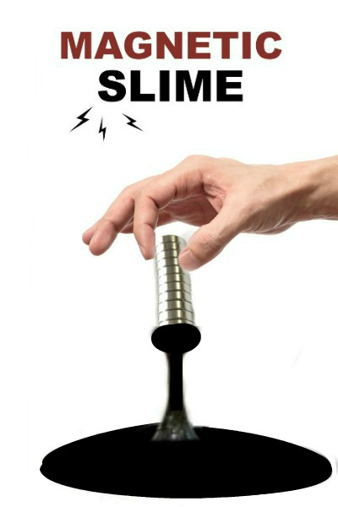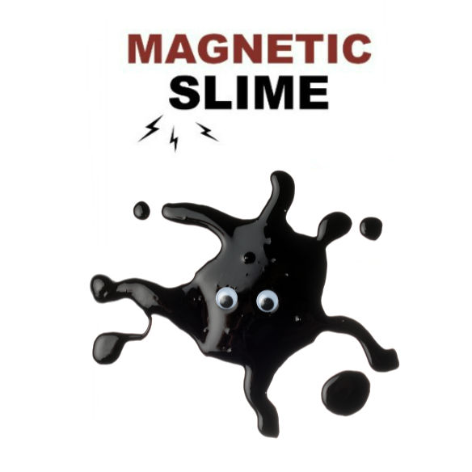

Magnetic Slime Recipe
1 bottle of school glue (about 2 oz. per student)
Craft Stick (Popsicle stick) 1 per student
3 tbsp of magnetic powder per student
Up to 2-4 oz of liquid starch….( about 2 oz. per student)
Neodymium magnets for each student (K&J Magnets: Sample Package SP1 cost $34.95 all different sizes) link: https://www.kjmagnetics.com/proddetail.asp?prod=SP1

Method
Step 1: Combine the glue and the magnetic powder in a bowl, and stir until well mixed.
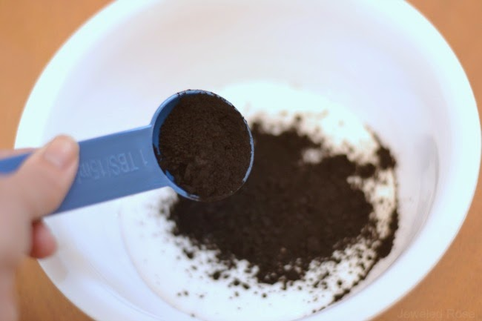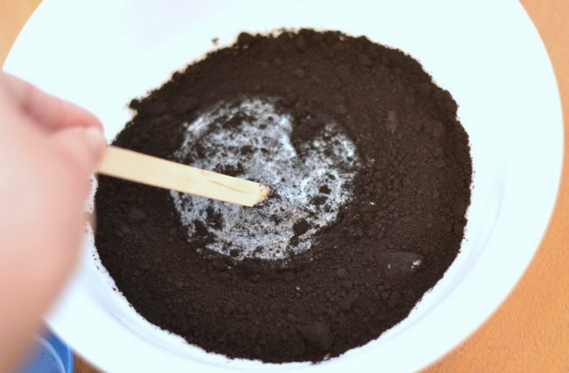
Step 2: Once combined slowly add small amounts of liquid starch to the bowl and mix well.
a. Continue to slowly add the starch & mix until the desired consistency is reached.
b. For most slime recipes we use equal parts of glue and starch, but for this particular recipe we needed more glue than starch, so I definitely recommend adding the starch SLOWLY.
c. We used roughly 2 ounces of starch in total, and that gave us the perfect consistency for this slime.
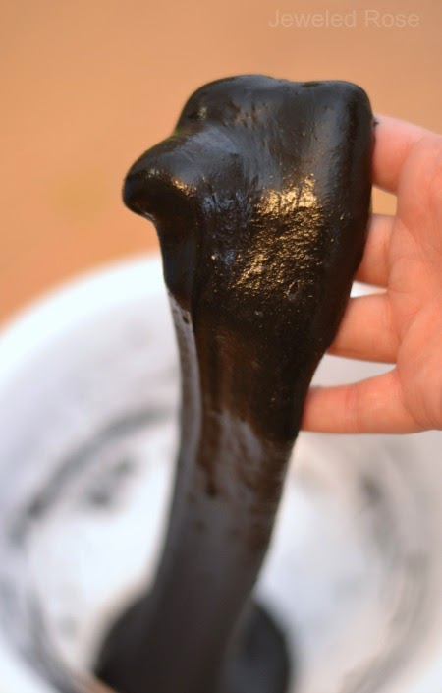
Step 3: Once you have the consistency down remove the slime from the bowl and knead it with clean, dry hands. After a bit of kneading the slime will be ready for play!
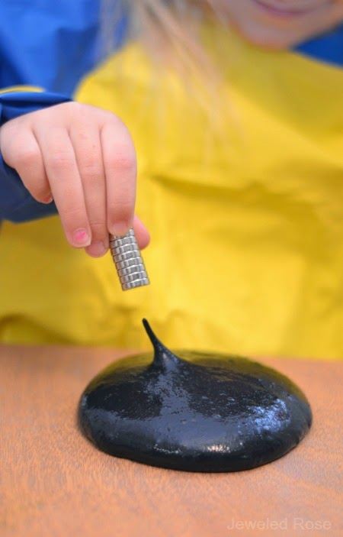
Note: You need neodymium magnets for the slime to react, because traditional magnets aren't strong enough on their own, but you can still add other varying magnets to extend the fun.
Question:
What is the function of cytoplasm?

Activity V-- The Microscope
Materials and Equipment:

• Microscope Worksheet
• Light Microscope if in-person
• Any fixed slide if in-person

Method:

Step 1: Go over power point and introduce students the different types of “Microscopes”.
Step 2: Go over magnification
Step 3: Go over the parts of a microscope with the students
Step 4: Complete the Microscope Worksheet: have students fill out and label the parts of the microscope down below.
Step 5: Allow students to use the microscope to observe a fixed slide that you have in your labs.

Types of Microscopes
Light Microscope - the models found in most schools, use compound lenses to magnify objects. The lenses bend or refract light to make the object beneath them appear closer. Common magnifications: 40x, 100x, 400x
Stereoscope - this microscope allows for binocular (two eyes) viewing of larger specimens.
Scanning Electron Microscope - allow scientists to view a universe too small to be seen with a light microscope. SEMs do not use light waves; they use electrons (negatively charged electrical particles) to magnify objects up to two million times.
Transmission Electron Microscope - also uses electrons, but instead of scanning the surface (as with SEM's) electrons are passed through very thin specimens.

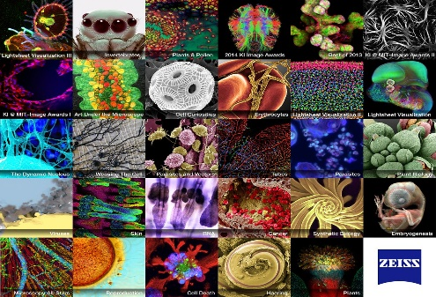

Parts of the Microscope:

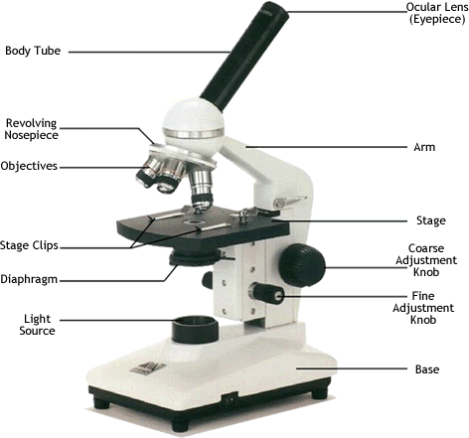

Magnification
Your microscope has 3 magnifications: Scanning, Low and High. Each objective will have written the magnification. In addition to this, the ocular lens (eyepiece) has a magnification. The total magnification is the ocular x objective
 | Magnification | Ocular lens | Total Magnification
Scanning | 4x | 10x | 40x
Low Power | 10x | 10x | 100x
High Power | 40x | 10x | 400x

Activity V—The Microscope

Now let’s identify the parts of the microscope. Complete the following worksheet.

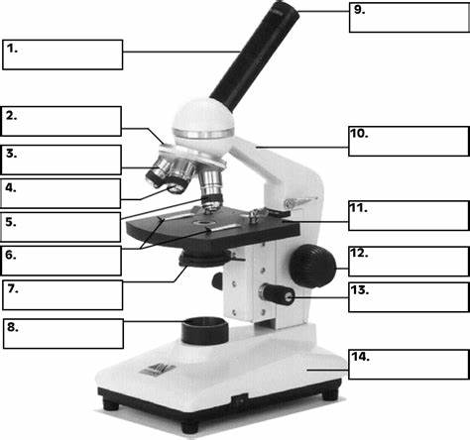

General Procedures:

STEP 5: Focusing Specimens
1. Always start with the scanning objective. Odds are, you will be able to see something on this setting. Use the Coarse Knob to focus, image may be small at this magnification, but you won't be able to find it on the higher powers without this first step. Do not use stage clips, try moving the slide around until you find something.
2. Once you've focused on Scanning, switch to Low Power. Use the Coarse Knob to refocus. Again, if you haven't focused on this level, you will not be able to move to the next level.
3. Now switch to High Power. (If you have a thick slide, or a slide without a cover, do NOT use the high-power objective). At this point, ONLY use the Fine Adjustment Knob to focus specimens.
Activity VI— Animal and Plant Cell Simple Stain

A. Simple Stain of an Animal Cell (Cheek)

Materials
- Glass microscope slides
- Plastic cover slips
- Methylene Blue solution (0.5% to 1% (mix approximately 1 part stock solution with 4 parts of water)
- Plastic pipette or dropper
- Flat toothpick

Methods
  - Add a drop of methylene blue solution to the slide in the center.
  - Take a flat toothpick and gently scrape the inside of your mouth.
  - Smear the toothpick in the solution on the microscope slide for 2 to 3 seconds. Add a coverslip.
  - Place the slide on the microscope, with 4 x or 10 x objective in position and find a cell. Then view at higher magnification and draw what you see below.
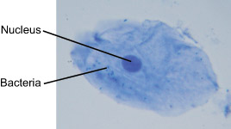

Draw the Cheek Cell in the circle below at both 10X and 40X

Methylene blue stains negatively charged molecules in the cell, including DNA and RNA. This dye is toxic when ingested and it causes irritation when in contact with the skin and eyes.
The cells seen are squamous epithelial cells from the outer epithelial layer of the mouth. The small blue dots are bacteria from our teeth and mouth.

B. Simple Stain of an Plant Cell (Onion)
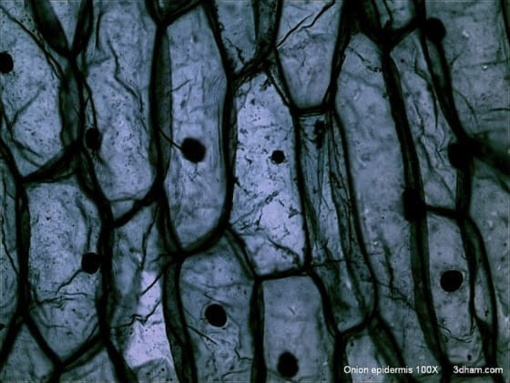

Materials Required:
- Glass microscope slides
- Plastic cover slips
- Methylene Blue solution (0.5% to 1% (mix approximately 1 part stock solution with 4 parts of water)
- Plastic pipette or dropper
- Flat toothpick
- Fresh onion
- Knife
- Water
Method:
- The first step is, of course, to cut and peel a fresh onion, ensuring you cut as small as possible. Once cut into small portions, peel some onion skin away for analysis.
- The next step here is to put a few drops of clean water onto the slide using a dropper; this is required to prevent the onion specimen from getting dry
- Next, use your tweezers to collect a piece of the thin membrane from the onion; it is the transparent layer or part of the onion under the skin
- Now, use your tweezers to put the samples or thin layers of onion onto the slide with a few drops of water; it is optional to put a few drops of methylene blue onto the sample to stain the specimen and make its internal structures more visible, however, you should still be able to make out cell structures such as the nucleus
- Put the coverslip on the specimen or the slide; press it gently to make sure that there are no bubbles or air on the sample that you will use
- Place the slide on the microscope, with 4 x or 10 x objective in position and find a cell. Then view at higher magnification 40x and draw what you see below.
Questions
Draw the Onion Cell in the circle below at both 10X and 40X.

Did you observe any differences between the cheek and plant cell? If so, what did you see?

Activity VII-- Central Dogma: Translation & Transcription

DNA and Genes
DNA is an essential molecule for life. It acts like a recipe holding the instructions telling our bodies how to develop and function.
What does DNA stand for?
DNA is an abbreviation for deoxyribonucleic acid.
What is DNA made of?
DNA is a long thin molecule made up of something called nucleotides.

A nucleotide is made up of a sugar, phosphate group and nitrogenous base.

There are four different types of bases in DNA: adenine, thymine, cytosine, and guanine.

They are usually represented by their first letter: A binds only with T and G binds only with C.
- A- adenine
- T- thymine
- C - cytosine
- G - guanine
Holding the nucleotides together is a backbone made of phosphate and deoxyribose. The nucleotides are sometimes referred to as "bases".
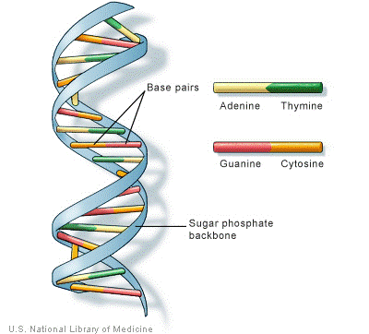
The basic structure of the DNA molecule
Different Cells in the Body
Our bodies have around 210 different types of cells. Each cell does a different job to help our body to function. There are blood cells, bone cells, muscle cells, nervous cells etc…..
How do cells know what to do?
Cells get their instructions on what do to from DNA. DNA acts sort of like a computer program. The cell is the computer or the hardware and the DNA is the program or code.
The DNA Code
The DNA code is held by the different letters of the nucleotides. As the cell "reads" the instructions on the DNA the different letters represent instructions.

Every three letters makes up a word called a codon. A string of codons may look like this:

ATC TGA GGA AAT GAC CAG
Genes
Within each string of DNA are sets of instructions called genes. A gene tells a cell how to make a specific protein. Proteins are used by the cell to perform certain functions, to grow, and to survive.
Shape of the DNA Molecule
Although DNA looks like very thin long strings under a microscope, it turns out that DNA has a specific shape. This shape is called a double helix.
On the outside of the double helix is the backbone which holds the DNA together.
There are two sets of backbones that twist together.
Between the backbones are the nucleotides represented by the letters A, T, C, and G.
A different nucleotide connects to each backbone and then connects to another nucleotide in the center.
Only certain sets of nucleotides can fit together in DNA
A only connects with T A = T
G only connects with C G = C
Interesting Facts about DNA
- About 99.9 percent of the DNA of every person on the planet is exactly the same. It's that 0.1 percent that is different that makes us all unique.
- DNA was first isolated and identified by Swiss biologist Friedrich Meischer in 1869.
- The double helix structure of DNA was discovered by Dr. James Watson and Francis Crick in 1953.
- If you unraveled all the DNA molecules in your body and placed them end to end, it would stretch to the Sun and back several times.
- DNA is organized into structures called chromosomes within the cell.
Central Dogma
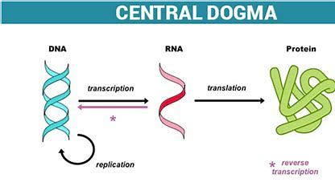
What does RNA stand for?
RNA is short for ribonucleic acid.
What is RNA made of?
RNA is a single chained molecule made up of something called nucleotides. There are four different types of nucleotide bases: adenine, uracil, cytosine, and guanine.
- U- uracil
- C - cytosine
- G – guanine
- A- adenine

Only certain sets of nucleotides can fit together in RNA
- A only connects with U A = U
- G only connects with C G = C
The RNA Code
The RNA code is held by the different letters of the nucleotides.
- Every three letters make up a word called a codon. A string of codons may look like this: as you can see there is NO thymine in RNA

AUC UGA GGA AAU GAC CAG
Each mRNA codon has an anticodon found on tRNA and the tRNA understands the amino acid
Each codon codes for one amino acid such as valine, leucine, glutamine
There are only (20 amino acids) in a cell.

A long chain or polymer of amino acids = a protein

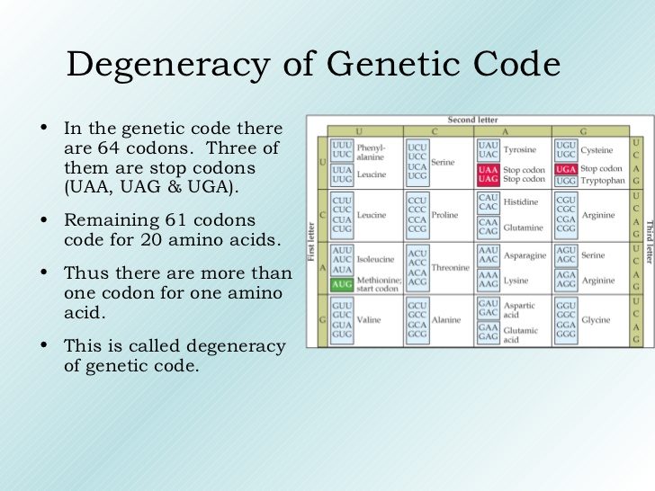

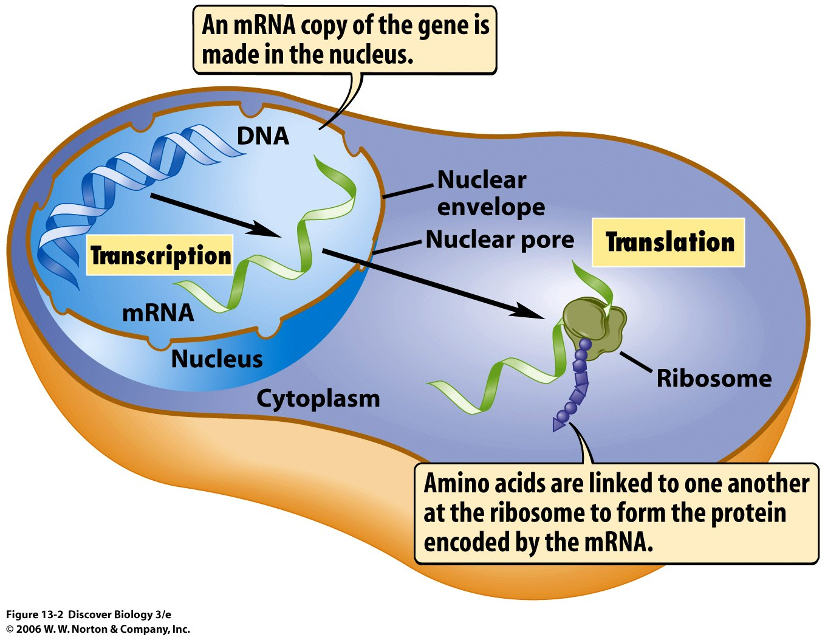

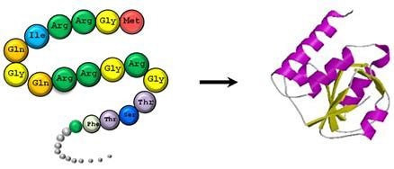

Let’s Practice the Central Dogma: Transcription & Translation

Transcription takes place in the nucleus: DNA à mRNA

Example: Fill in the missing nucleotide base and change the DNA to RNA.
DNA ATC TGA GGA AAT GAC CAG
Answer: mRNA UAG ACU CCU UUA CUG GUC

Your turn
DNA CTG ACG CCG TTC GTC AGC
mRNA

Your turn
DNA CGC GAC TTA TGC CGA ATA
mRNA

Translation takes place in the cytoplasm: mRNA à tRNAàProtein

Example: Fill in the missing nucleotide base and change the RNA to Protein. **You will need the degenerate code (above) for amino acid.

mRNA UAG CCU UUA CUG GUC ACU

Step 1 tRNA AUC GGA AAU GAC CAG UGA

Step 2 Protein isoleucine-glycine-asparagine-aspartic acid-glutamine-stop

Your turn
mRNA UCA GGA AAU GAC CAG UGA
Step 1 tRNA
Step 2 Protein
References:
- Petro, P. (2002) Native American Symbolic Circles. Inspiration for the Spirit Retrieved June 9, 2020 from http://www.inspirationforthespirit.com/native-american-symbolic-circles/
- Ward, J. (2019) What is the Medicine Wheel? Retrieved June 9, 2020 from https://www.bing.com/videos/search?q=Teachings+of+the+Medicine+Wheel&&view=detail&mid=1C8EE93735B7227491291C8EE93735B722749129&&FORM=VRDGAR&ru=%2Fvideos%2Fsearch%3Fq%3DTeachings%2Bof%2Bthe%2BMedicine%2BWheel%26FORM%3DVDMHRS
- Unknown, (2020) Biotechnology and Bioengineering News, Science Daily Retrieved on June 9, 2020 from
https://www.sciencedaily.com/releases/2019/07/190718112434.htm
- Unknown (Unknown) How to Use the Microscope. Biology Corner. Retrieved April, 2, 2021 from https://www.biologycorner.com/worksheets/microscope_use.html
- Unknown, (Unknown). Oil and Water Experiment. Retrieved on April 2, 2021 from https://www.growingajeweledrose.com/search/label/Science
- Anderson, H. (2010-2020). Different Cell Organelles and their Functions. Retrieved March 29, 2021 from https://www.microscopemaster.com/organelles.html
- Unknown, (2014) My Fair Brain Child. Science is Sweet-How to Make Cell Pie. Retrieved March 16, 2021 from http://www.myfairbrainchild.com/2014/04/science-is-sweet-how-to-make-cell-pie.html
- Unknown, (Unknown). Magnetic Slime. Retrieved on April 2, 2021 from https://www.growingajeweledrose.com/search/label/Science
- Unknown, (2021). Human Cheek Cells. Microscopes for Schools. Retrieved March 28, 2021 from https://www2.mrc-lmb.cam.ac.uk/microscopes4schools/humancheek.php
- Latham, K. (2021). DNA vs. RNA. Biology Dictionary. Retrieved March 28, 2021 from https://biologydictionary.net/dna-vs-rna/
- Cornell. B. (2021). Central Dogma. BioNinja. Retrieved March, 28 2021 from https://ib.bioninja.com.au/standard-level/topic-2-molecular-biology/27-dna-replication-transcri/central-dogma.html
- Jahn, W. (2016) Genetic Code is Degenerate. YouTube Retrieved March 28, 2021 from https://www.google.com/search?q=degenerate+code&rlz=1C1CAFB_enUS617US645&sxsrf=ALeKk00QFw0CCn2BhRepiknhq5iE_1S7Ag:1617394958472&source=lnms&tbm=isch&sa=X&ved=2ahUKEwij59ffseDvAhUWVs0KHUsHDmcQ_AUoAXoECAEQAw&biw=929&bih=921
- Unknown. (Unknown). Lecture 8-9 Preview. Organelles etc. Retrieved March 31, 2021 from https://www.csus.edu/indiv/l/loom/lect8.htm

