ND EPSCoR Lesson Plan
Smart “PIGs” in Pipes

Overview

Lesson Title:

Smart “PIGs” in Pipes

Lesson Overview:
The half-day long active learning STEM modules will include four to five lessons but not limited to:
Lesson 1: Presentations on pipes and smart PIGs.
Lesson 2: Creating different health conditions on pipes.
Lesson 3: Building smart PIG using DIY robot.
Lesson 4: Inspecting pipe conditions using the built smart PIGS and developing maintenance plan.

Lesson Objectives:

In this project, we will demonstrate how to build a smart PIG using DIY robot and camera in a smart PIG for water/wastewater pipe health condition inspection.

NSF Subject Classification:
Civil engineering 315 Transportation and Highway Engineering 14.0804
National Next Gen Standards:
HS-ETS1-3 Engineering Design
North Dakota Standards:

Science K-12 Standards - 2019, MS-ET1-4
Grade or Grade Band:

K12: 8-12 Grades (Middle and High School)
Time Needed (estimate):

A duration of 3 hours of lessons without break is the estimated time needed, which consists 45, 45, 45, 45 minutes consumed by Lesson 1 to 4, respectively. A 15 minutes break is considered in between each lesson, resulting in one hour break time. The total class time is estimated to be 4 hours with all break time considered.
Lesson Author:
Dr. Ying Huang, Civil, Construction and Environmental Engineering Department, North Dakota State University (contact email: ying.huang@ndsu.edu, CIE201F)
Scientist/K12 Collaborator & University:
North Dakota State University, Other Collaborators listed as below:
September 20, 2020 Turtle Mountain Community College (TMCC)
October 4, 2020 Sitting Bull College (SBC)
November 15, 2020 Cankdeska Cikana Community College (CCCC)
December 6, 2020 Nueta Hidatsa Sahnish College (NHSC)
March 7, 2021 United Tribes Technical College (UTTC)
Scientist Bio:

Prof. Ying Huang currently is an associate professor and a Welch Faculty Fellow at the Department of Civil, Construction and Environmental Engineering, North Dakota State University. She obtained her Ph.D. from Missouri University of Science and Technology in 2012. Since 2012, Dr. Huang joined North Dakota State University as a faculty till now. Dr. Huang teaches or taught nine civil engineering undergraduate and graduate courses with high student rating, including CE204 (Surveying, offered in fall semester), CE303 (Materials, offered in spring semester), and CE303L (Materials Laboratory, offered in spring semester), etc., which have more than 100 enrollment each year, in addition to CE456/656 Railroad Planning and Design, CE452/652 Introduction to Pipeline Design, CE 458/658 Bituminous Materials and Mixtures, CE441/641 Finite Element Analysis, CE782 Introduction to Intelligent Infrastructure. She was or currently is a major advisor for 18 graduate students (12 Ph. D.s and 6 Masters), and more than 12 undergraduate research assistants, in addition to advisory committee member for 52 graduate students from civil engineering, computer science, electrical engineering, construction engineering, and statistics, etc. Dr. Huang’s research backgrounds are in steel corrosion protection and mitigation, smart cities and autonomous systems, smart materials and structural health monitoring, intelligent transportation systems, pavement and traffic monitoring, railroad damage and defect assessment, big data for civil engineering application, and emergency evacuation for multi-hazards.
Summary of Research and/or Problem Being Studied:
In this project, we will present the students smart “PIGs” in pipes and their working principles. After this lessons, students are expected to have basic knowledge on pipes used in water and wastewater transportation and smart PIGs for pipe inspection. Problems being studied include but not limited to 1) pipe damages may be generated by different conditions; 2) different types of pipe damages; 3) how a simple smart pig works; 4) how to construct a “camera” based smart pig using provided DIY robot pieces; and 5) how to use the images obtained from the robot camera to develop a maintenance plan of pipes by analyzing the images.

Preparation/Materials

Background knowledge students must have to be successful:

Necessary knowledge about water and wastewater transportation, pipes and essential meaning to structural health inspection.
Essential Terminology:

Pipe smart PIGs, water/wastewater transportation, health condition inspection
Resources:

Fact Sheet: In-Line Inspections (Smart Pig)

About Pipes (Inside the smart pigs)

Examples and case study on Smart Pigs (NDT Global)
Websites:
- https://primis.phmsa.dot.gov/comm/factsheets/fssmartpig.htm
- https://www.aboutpipelines.com/en/blog/inside-the-smart-pig-detecting-potential-pipeline-problems-before-they-happen-part-2/#:~:text=Quick%20pipeline%20pig%20facts&text=Pigs%20move%20with%20the%20product,have%20intelligent%20onboard%20flow%20control.
- https://www.ndt-global.com/?gclid=Cj0KCQjww_f2BRC-ARIsAP3zarEweLdUsSWmIsBYo4mA2nk_xPFnrDttEVF0MjA4YXzpDz2H9MMJ-30aAh17EALw_wcB
Materials needed:

All the needed materials for this project will be provided by the lesson author. However, the supports of computer, project, and Wi-Fi, and other facility supports are needed to be provided by the lesson facilitating sites.

Lesson 1: Computer and project to facilitate the presentation and educational videos about background of pipelines and smart PIGs;

Lesson 2: 1) two PVC pipes (two different sizes including 8 inches diameter and 2-ft long, and 10 inches diameter and 12 inches long); 2) PVC fittings (several different fittings such as elbow, T, or others available) connecting the two PVC pipes; 3) Acetone; 4) Washable paint with different colors and paint brushes; 5) Different levels of grinding (4 levels); and 6) Electrical drill powered by battery (with different size of drill head).

Lesson 3: Option 1, DIY robot vehicles “mBot Ranger kit” and Wi-Fi camera with smartphone app, and glue to attach the camera to the robot; Option 2, DIY smart video car kits which consist ranging and inspecting components.

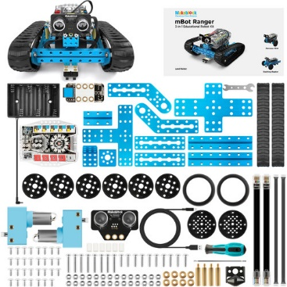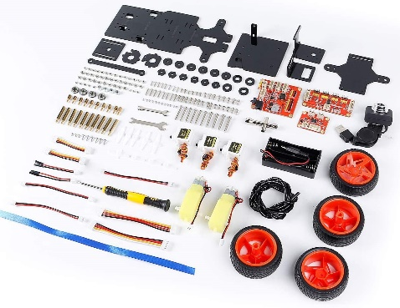

mBot Ranger kit SunFounder Smart Video Car Kit V2.0 PiCar-V

Lesson 4: 1) Smart phones/pad for photographic needs with needs of Wi-Fi available; and 2) Long pipe samples with known made damages for inspection.

PowerPoint – found as separate attachment

Procedure/Activities

Lesson 1: Presentations on Pipeline industry, pipeline, smart PIGS (45 minutes).
In this lesson, presentations and videos on the background of water/wastewater pipes and smart PIGS will be provided. Fact Sheet-1 with fun facts of pipes and smart PIGs will be provided. Some questions will be given at the end of the Fact Sheet-1. Answering Fact Sheet-1 questions will get rewarded with stickers.
Activities: 1) Presentations/videos of the smart pigs;
2) Introducing the lessons and rules of activities (emphasize safety rules);
3) Question answering;
4) Dividing students into teams.
-- Break: 15 minutes

Lesson 2: Creating different inner surface health conditions on pipelines (45 minutes).
In this lesson, students will be provided with PVC pipes with different sizes. The students will need to create three different damages on the inner surfaces of the PVC pipes using provided tools or guided chemical reactions for demonstrating how damages are initialized inside a pipe. Fact Sheet-2 with facts of pipe damages will be provided. Some questions will be given at the end of the Fact Sheet-2. Answering Fact Sheet-2 questions will get rewarded with small pins.
Activities: 1) Dividing into teams with four members per team (2-6 teams) and deciding the Team name (each team needs a team name);
2) Selecting one size of the pipe the team and one type of fittings the team would like to work with and taking two 2-ft pipes and one fitting to the team work space;
3) Making three types of damages inside the PVC pipes (examples shown below) or the combination of the damages for at least 6 damages on the two pipes:
-- First damage (Damage #1) is made by using one course grinding to make a rough surface on the inner surface of the pipe, the level of grinding can be selected from the available four levels provided and using another paint color (color 1) to mark this damage;
-- Second damage (Damage #2) is made using an electrical drill using different sizes of drill heads to be selected to make different sizes of damages (maybe small-sized holes), and using a different color to mark it (color 2).;
-- And third damage (Damage #3) is made by using acetone chemically reacting with PVC inner surface, after the damage made, using one certain paint color (color 3) to mark this damage. Acetone can be left on the pipe during lunch time.
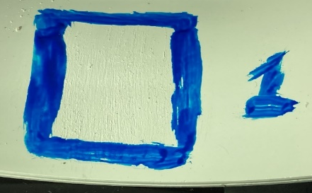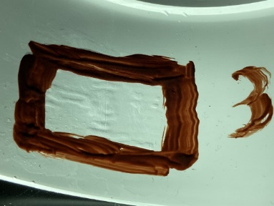
-- More damages can be made with combinations of these three tools if more time than needed.
Safety rules: In this lesson, acetone and electrical drills will be used. Please following the safety rules of these tools. For acetone, use only a small amount and use a wrap to put the acetone on the surface of pipe, please also avoid direct contact of acetone on skill, eyes, mouth, or ect. For electrial drills, please remove the drill heads when not using and do not face the drill head close to hands, face, or any body parts. Please following the instructions when using these tools.
4) Connecting the two pipes with damages by the selected fitting and naming (team name) the made connected pipes using the provided paint;
5) Switching the made pipes with another team for damage diagnosis.
-- Break: 15 minutes
Lunch Time

Lesson 3: Building smart PIG using DIY robot (45 minutes).
In this lesson, the students will be provided with DIY robot pieces with a small sized camera to build a “smart PIG” by themselves and install a small-sized camera on the “PIGs”. Fact Sheet-3 with facts of technologies on a smart PIG will be provided. Some questions will be given at the end of the Fact Sheet-3. Answering Fact Sheet-3 questions will get rewarded with small margent.
Activities: 1) Build the robot with different sizes (two levels of DIY robot vehicles will be available: Level 1 will be the mBot Ranger kit, for above-average students, they can make different shapes of the robot according to the size of the pipes which requires more time and Level 2 will be for students not successfully built the robot using Level 1, the SunFounder Smart Video Car kit, which has the camera integrated);
2) Install the camera;
3) Adjust the camera positions to best picture taken inside pipes;
4) Documenting the locations, size, and types of the made damages on pipes from other team using rulers and smart phones with pictures for comparison;
5) Documenting the locations, size, and types of the made damages on long pipes provided by the instructor using rulers and smart phones with pictures for comparison.

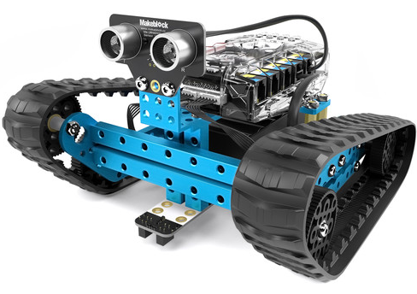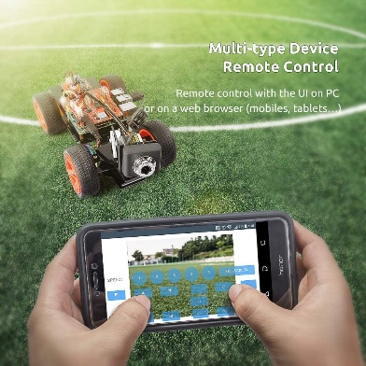

mBot Ranger kit SunFounder Smart Video Car kit V2.0 PiCar-V
-- Break: 15 minutes

Lesson 4: Inspecting pipe conditions using the built smart PIGS and developing a maintenance plan for pipelines (45 minutes).
In this lesson, students will use the built “Smart PIG” to take pictures of PVC pipelines with different sizes and conditions from other teams from lesson 2 to investigate the conditions of the pipelines and also the provided long pipe segments with made damages. With the taken pictures, students will need to analyze the obtained images of different pipeline conditions to provide a substantial maintenance plan for the provided pipes. Fact Sheet-4 with facts of pipe maintenance plan according to different damages will be provided. The maintenance plan developed can refer to these facts. Some questions will be given at the end of the Fact Sheet-4. Answering Fact Sheet-4 questions will get rewarded with pencils.
Activities: 1) Completing the installation and adjustment of the camera if not done yet in Lesson 4 (separate LED lights will be provided to investigate the influence of different levels of LED lights for images to above-average students if needed and have extra time);
2) Program the DIY robot and run the robot inside the pipes;
3) Taking pictures using the built robot in Lesson 3 for the damages inside the pipes from other times with made damages in Lesson 2 and also the provided long pipe segments with made damages;
4) Analyzing the pictures to determine different damages;
5) Comparing the determined damages with the documents made by the team who made the damages to check how the technologies work;
6) Developing a pipe maintenance plans based on the pictures taken for the pipe conditions.
-- Break: 15 minutes
End of Lessons

Extensions for above average students:

Materials prepared for 6 teams, with 3~4 members in each team, this project can host participators of 16~24 students. For the above-average students, in Lesson 2, students can make more damages in the pipe surface with combinations of the three damages mentioned; in Lesson 3, students will be able to build a robot with different shapes than recommended; in Lesson 4, students can investigate the influence of LED lights on the robots if more time available than needed.

Mediation/Support for students that need it:

The students are asked to follow the safety instructions and encouraged to bring their smart phones if they have any.

Lesson Outline (for research-based lessons) :
- Observe Phenomena
- What questions should we be able to answer?
- Write a Hypothesis
- Come up with a Research Plan
- Carry out investigation
- Revisit the Background Research
- Construct Explanations. (TASKS-Publish/Communicate Findings)

Standards Alignment

ND Science Standard(s):
Science K-12 Standards - 2019, MS-ET1-4
Disciplinary Core Idea:
ET1.B: Developing Possible Solutions -A solution needs to be tested, and then modified on the basis of the test results, in order to improve it. Models of all kinds are important for testing solutions.
North Dakota DPI Standards:
Science K-12 Standards - 2019, MS-ET1-4, ET1.B
Next Gen Standards:
HS-ETS1-3 Engineering Design

Science and Engineering Practices:
1. Asking questions and defining problems
2. Developing and using models
3. Planning and carrying out investigations
4. Analyzing and interpreting data
5. Using mathematical and computational thinking
6. Constructing explanations and designing solutions
7. Engaging in argument from evidence
8. Obtaining, evaluating, and communicating information

Cross Cutting Concepts:
Cause and Effect -Cause and effect relationships may be used to predict phenomena in natural or designed systems.

Unit Objectives:
Students will be able to develop a tool to detect and inspect the surface conditions of a pipe

Assessment:
Students could develop a tool to inspect different surface conditions (damages) of inner surfaces of pipes and based on the pictures taken from the designed and constructed tool, the students could develop a maintenance plan for the pipes. The maintenance plan developed will be compared with common practices to address the pipe maintenance needs.

Daily Plans and Assessments

Learning Target for each day/activity
In lessons 1 to 4, students will learn:
- How pipe works for transporting gas/oil, water, and wastewater, etc.;
- What typical damages pipes suffer under practical use conditions;
- What is smart pig and why smart pigs are needed;
- What types of smart pigs and how does smart pigs work for pipe inspection;
- How to use the technologies in smart PIG to develop maintenance plans for pipe;
- How to improve the safety of pipe operations and why it is important to maintain a pipe in a good health condition.

Criteria for Success/Assessment for each activity:
Lesson 1: After this lessons, students are expected to have basic knowledge on pipes, and smart PIGs.
Small prizes will be given to students who participate question answers in class, and a fun fact sheet with all the most important points about pipes and smart pigs will be given to the students.
Lesson 2: With this lesson, students are expected to know that pipe damages may be generated by different conditions and understand some types of pipe damages. Students will learn to fabricate different damages using different tools.
Lesson 3: In this lesson, the students are expected to understand how a simple smart pig works and construct a “camera” based smart pig using provided DIY robot pieces.
Lesson 4: From this lesson, the students are expected to know how to use the images obtained from the robot camera to develop a maintenance plan of pipes by analyzing the images.
We will use the NATURE program survey results to assess the success of each activity for potential future improvements.

Additional Lesson Resources / Materials

References:
- https://primis.phmsa.dot.gov/comm/factsheets/fssmartpig.htm
- https://www.aboutpipelines.com/en/blog/inside-the-smart-pig-detecting-potential-pipeline-problems-before-they-happen-part-2/#:~:text=Quick%20pipeline%20pig%20facts&text=Pigs%20move%20with%20the%20product,have%20intelligent%20onboard%20flow%20control.
- https://www.ndt-global.com/?gclid=Cj0KCQjww_f2BRC-ARIsAP3zarEweLdUsSWmIsBYo4mA2nk_xPFnrDttEVF0MjA4YXzpDz2H9MMJ-30aAh17EALw_wcB

Websites for purchasing materials
Materials for this project will be provided by the lesson author for each activities.
www.menards.com
www.amazon.com
https://www.bhphotovideo.com/

